Regional Angels Programme

Early Assessment

May 2024

british-business-bank.co.uk
@britishbbank

Contents
1. Executive summary 5
1.1 This study 5
1.2 The need for intervention and RAP funded firm characteristics 6
1.3 Rigorous application process was time consuming but appropriate for the initial cohort applicants and improved Partner professionalism 7
1.4 FCA regulated status partially restricted participation to angels 8
1.5 Partners leveraged RAP investment 8
1.6 Finance is flowing relatively to underrepresented regions and compared to similar schemes. 9
1.7 Fuller value for money assessment to be completed with more data 9
1.8 Lessons learnt and recommendations 11
2. Progress against objectives 13
2.1 Progress against objectives tables 13
3. Introduction 18
3.1 This study 18
3.2 The Regional Angels Programme objectives 19
3.3 Market conditions under which RAP was launched 22
3.4 Methodology 23
4. The need for intervention 25
4.1 Key Findings 25
4.2 Regional inequalities in the angel investment ecosystem 25
4.3 A lack of government intervention in the angel investment ecosystem 27
4.4 Assessment of the merits and disadvantages of the RAP model 28
5. Rigorous application process improved professionalism 32
5.1 Key Findings 32
5.2 Programme design and implementation 32
5.3 Overview of the Partners and geographic spread 36
5.4 The application process is rigorous and time consuming 38
5.5 The process allowed Partners to develop their professionalism and reputations 39
6. Partner journey and experience 41
6.1 Key Findings 41
6.2 Partners noted an increased ability to deploy more capital 41
6.3 Partners spoke positively about governance and reporting processes 42
6.4 Partners were satisfied with the speed, clarity and flexibility of the RAP team 42
7. RAP funded firms showed considerable geographic and sector reach 44
7.1 Key Findings 44
7.2 RAP has mobilised more private sector funding 44
7.3 RAP funded firms from all regions across the UK – comparatively more funding went to regions outside London 45
7.4 RAP funded firms are concentrated in high growth industries 50
7.5 Recipient firms’ growth stage 51
8. RAP early performance assessment 53
8.1 Key Findings 53
8.2 Early indicative evidence of funding additionality 54
8.3 Post-money valuations suggest weaker expected growth trajectory of RAP funded firms 57
8.4 Valuation to sales ratio shows similar story to post-money valuations 59
8.5 Impact on turnover is likely limited at this early stage 60
8.6 Employment trend proxy for business investment – salary payments/ IP production 62
8.7 Value for Money assessment 64
9. Lessons learnt and recommendations 71
9.1 Lessons learnt and recommendations 71
Annexes 73
Annex A: Research Tools 73
Annex B: Regional Angels Programme eligibility criteria 103
Annex C: Theory of Change 106
Annex D: Regional Angels Programme funded firms Management Information (MI) data analysis 117
Annex E: KPI trend analysis 126
Annex F: Mapping of other schemes 131
Annex G: Technical Methodology 140
Annex H: Econometric DiD Modelling 159
Annex I: Abbreviations 160
Legal notices and disclaimers 163

1. Executive summary

1.1 This study
RSM UK Consulting was commissioned to undertake an independent evaluation of the Regional Angels Programme (“RAP” or the “Programme”). The scope of the work covers the need for intervention, the application process and emerging early impacts for the scheme. The methodology is based on a review of monitoring information, desk research, secondary data sources, interviews and econometric impact modelling.
RAP was announced in the Autumn Budget (2017) and launched in October 2018. One of the Programme’s primary aims is to help reduce regional imbalances in access to early-stage equity finance for smaller businesses with high-growth potential across the UK. The Programme, through its investments, also aims to raise the profile and professionalism of angel investment activity and to attract further third-party private capital, as well as generating a commercial rate of return for the British Business Investments (BBI) on each commitment it makes, in line with its expected market rate of return.
The three key programme objectives are:
- Supply: To increase the aggregate amount of early-stage equity capital that is available to small businesses with high growth potential throughout the UK.
- Diversification & Regionality: To promote angel investing across the UK, particularly in areas that are currently underrepresented and to drive the professionalism of angel investing across the UK.
- Managing public money: Generate a market rate of return.
As of June 2022 (Q2) Management Information (MI) data shows that 372 companies received funding through 10 Partners.

1.2 The need for intervention and RAP funded firm characteristics
The Interim Evaluation of the British Patient Capital (BPC) review highlighted the disparity across the regions and the need for such an intervention. The review found that only 34% of early-stage, Venture Capital equity investment flowed into the regions outside of London, the South East and the East of England since 2013, with 54% of all VC deals only from London and the South East. The number of deals completed were also low at 1,955 compared to 2,266 in London and the South East (of which 1,731 only in London – providing further evidence of the prominence of London in the VC market) since 2013.
Furthermore, data from 2018/19, at the time of the launch of the Programme, highlights that London not only had the largest share of investors utilising the Enterprise Investment Scheme (EIS) and Seed Enterprise Investment Scheme (SEIS) schemes (with 38% of known investors residing in the Capital), but it was also the region where EIS and SEIS investment is predominantly concentrated, accounting for 49% of the total activity.
These regional inequalities in the angel investment ecosystem have also been highlighted by stakeholders in interviews conducted between January and March 2023. Policy stakeholders reported a lack of wide-scale government intervention in the angel investment ecosystem.
Data on firms funded by RAP indicate that their diversity levels are comparable to or even higher than those observed in the broader market for firms funded by angel investors, as stated by the latest UK Business Angels Market report. On average, around 20% of founders in RAP funded firms are female – 21.8% in London and the South East, and 18.4% in the rest of the UK.
According to data from Companies House, sourced from Beauhurst, RAP-funded SMEs were established, on average, five and a half years before 2020 - the year when the first RAP funding was issued. They also commenced trading, on average, three and a half years before 2020, as per MI data provided by BBB. There were cases of some funded firms that had been established more than 20 years before receiving RAP funding but still remained smaller than their peers before 2020, with a median turnover of £97k and an average turnover of £332k. These firms also remained small in employment size, with a median of 6 employees and an average of 15 employees. Furthermore, RAP-funded firms had lower market valuations compared to other firms in the market and their counterparts in the counterfactual group.

1.3 Rigorous application process was time consuming but appropriate for the initial cohort applicants and improved Partner professionalism
As part of the application process, Partners were required to undertake a due diligence processes with BBI to ensure operational confidence and that their partnering investors from the private sector had investment strategies and commercial track records that aligned with the aims of the scheme.
Partners found positive impacts of this rigorous process, improving their professionalism, and allowing them to develop their own due diligence processes of prospective investments. Some Partners noted a marked improvement in the approach to screening potential investment opportunities as well as the ability to attract co-investors which may not have been possible without participation within the RAP. Some Partners also mentioned their reporting frameworks and data collection methods helped to build confidence in the wider market as a sign of improved professionalism.
Some partners also described the end-to-end process as time consuming, lasting over a year in some cases. However, the majority of Partners suggested the information requested from BBI was clear and that they understood the need for a rigorous process. Furthermore, some initially unsuccessful Partners highlighted the bespoke feedback provided by the RAP delivery team which guided them towards successful future applications to the RAP or other support.
Turning to the scheme design and implementation, Partners spoke positively about the governance and reporting processes within the scheme and were satisfied with the speed, clarity and flexibility of the RAP team.

1.4 FCA regulated status partially restricted participation to angels
A frequently noted barrier to scheme participation came through the eligibility criteria in the need for Partners to be (Financial Conduct Authority) FCA regulated or to partner with a regulated entity in order to manage BBI’s capital. This was cited as a concern by industry bodies and unsuccessful applicants.
The Programme’s request for proposals, refers to Partners providing a managed solution. A managed solution allows BBI’s capital to be automatically and seamlessly invested along the partner’s own capital, without the need or requirement for BBI to approve each investment if it meets the pre-agreed investment criteria (e.g. investment size, region, match funding etc.). As the Partner is therefore managing BBI’s capital, there is an element of regulation required by law. BBI gain comfort that partners invest BBI capital appropriately, through the due diligence process undertaken pre-commitment, and through quarterly reviews once the commitment is live. The model differs from other initiatives, such as the Scottish Enterprise co-investment programme – which requires the approval or rejection of each investment on a case by case basis, which is time consuming and difficult to scale at pace.
Government department stakeholders described this requirement as necessary for protecting tax-payer interests. FCA regulated status provided a degree of assurance that investors were authorised and regulated by the FCA and would be governed by best practices in investment markets. This would also include the handling of taxpayer money as part of the RAP.
It was noted that alternative solutions were also accepted by British Business Investments. For example, some participants partnered with angels or investors who had FCA regulated status to participate in the programme.

1.5 Partners leveraged RAP investment
Partners mentioned that they were able to leverage their investment into firms across the regions. In some instances, Partners were able to unlock new investment opportunities across the regions – providing an opportunity for firms outside of London to access finance which may not have been possible without the RAP. This access to finance may have wider benefits other than supporting immediate business development in that it signals to follow-on investors expected future growth, potentially making it easier for firms in unrepresented regions to access follow-on funding.

1.6 Finance is flowing relatively to underrepresented regions and compared to similar schemes.
78% of RAP capital has been invested into companies based outside of London. As RAP invests proportionately more into non-London businesses, some of its partners invest relatively more into London based companies compared to RAP. As such, 75% of capital from RAP, its delivery partners and other investors in the funding rounds has been to businesses based outside of London and 68% outside of London and the South East.
Analysis of RAP funded firms indicates that 75% of total RAP funding volume went to firms based outside of London and 68% went to firms based outside London and the South East (BBI investment + delivery partners investment + third party investor contribution). By means of comparison, 41% of funding allocated under the Future Fund went to firms outside of London. Turning to the BBI specific contribution around 79% flowed to firms outside of London and 72% to firms outside London and the South East.
While the scheme's KPI focuses on investment outside of London, it is also important to consider how investment was allocated beyond London and the South East as well. As indicated throughout the report, the South East also receives a substantial amount of equity investment. This is because it is known to be an attractive region for angel investments, partly due to its proximity to London.There is evidence that funding from RAP Partners has been directed towards R&D intensive and high-tech firms. Approximately 47% of RAP-funded firms belong to the information and communication sector, one of the major contributors to the economy’s productivity growth. As detailed in section 7.4, the proportion of funded firms with a focus on R&D increased to 23% in 2022 from 5% in 2019.

1.7 Fuller value for money assessment to be completed with more data
To assess Value for Money at this early stage we considered the four E’s model – Efficiency, Effectiveness, Equity, and Economy. We have identified preliminary evidence and the type of data that can be used in future fuller Value for Money assessments.
- Efficiency: The Partner journey was referred to as positive, but Partners described the application process as rigorous and time consuming, lasting over a year in a few cases – suggesting potential inefficiencies or scope for improvement. However, it must be noted that the delivery team have introduced new, more efficient process which has significantly reduced the time between application and funding.
- Effectiveness: A substantial proportion of funding has gone towards early-stage SMEs in underrepresented regions and we find that this has better positioned these firms to leverage future funding, invest in their development and scale. Wider benefits such as experienced investors guiding commercialisation efforts are yet to be realised but are in scope. No data was available on any Intellectual Property developments that have been realised due to RAP.
- Equity: The scheme was designed to address the issue of unequitable allocation of early-stage angel investments across underrepresented regions. Data analysis shows that 79% of BBI only investment (75% when including BBI + delivery partners investment + third party investors) of funding went to small businesses trading outside of London. This is almost double the distribution of funding to small business outside of London seen in the wider angel market and under the Future Fund. More however could have been done to ensure further benefit to regions that have a greater need for the Programme.
- Economy:
  - Direct: Early evidence suggest short-term scheme outcomes are in reach. This assessment is made in consideration of the indicative fundraising uplift of up to 76% of RAP funded firms compared to the counterfactual on a national level.
  - Indirect benefits: Dissemination of knowledge gains has been made possible because of RAP investment and this can also lead to spill over benefits to other businesses and increase competition/ productivity regionally.
For a fuller assessment, further data outturns and collection would be required.

1.8 Lessons learnt and recommendations
At the time of reporting, the RAP is still in the early stages of post financing and impacts are unlikely to be fully realised – especially when considering the performance of early-stage businesses that have higher risk profiles. Many firms are focused on R&D activities rather than commercialisation and many operate in high-intensity R&D sectors and it will take relatively long for such firms to reach maturity and become profitable.
We found that the application process was thorough, and, in some cases, the application process (from initial conversation at early application stage to go-live) of Partners took over a year to complete. Whilst this saw a positive improvement in the professionalism of these business angels, the process could be simplified. Efficiencies could be gained through streamlining the application process, built on the previous experience of engagement with the original 10 Partners. As mentioned above, the delivery team have already implemented a new streamlined investment process which has yielded significant time savings and efficiency benefits to both BBI and the applicants. The design of the scheme could consider changing the FCA regulated status requirement to allow a broader range of angels to access support. Alternatively, other support could be provided such as, introducing a collaborative angel community for knowledge sharing where unregulated angels can learn from existing syndicates, who are regulated, to gain FCA status. To some extent this does exist through associations such as the UKBAA, but could be expanded. More recently, the RAP delivery team have already incorporated support for newer applications where FCA regulated investors are supporting unregulated RAP angels in the capacity of “investment managers”.
We also found early signals of potential funding additionality. This highlights that there is likely a gap in the angel funding across the regions and the scheme has provided support to underrepresented regions across the UK. However, the need for finance will likely persist and the scheme should continue offering support – potentially extending the amount of support available. One recommendation would be to offer leverage (additional incentives i.e., through the matched funding or terms and conditions, for example) to angels to encourage more inter-regional investments by the angels who dominate funding supply in places like London and the South-East. Rich entrepreneurial ecosystems (EE) such as London and Scotland took many years to develop, and the British Business Bank should consider how it could support this longer-term shift for broader regional ecosystem development. For example, the Scottish Government has worked repeatedly to help build the Scottish EE for 25 years or so since the mid-1990s. Incentivising non-local investors and building syndicates are crucial to the formulation of this process.
Finally for a fuller evaluation, there needs to be a consideration of timing. As mentioned above, it is still too early for impacts to have emerged, and projections should not be drawn on the relative RAP funded business performance in 2022.

2. Progress against objectives

2.1 Progress against objectives tables
Table 1 below provides a summary of the stated Programme objectives and
Table 2 provides an assessment against the Bank’s wider objective. Against the objectives we have provided evidence snapshots from our various research methods: In-depth interviews, case studies, data analysis and econometric modelling. This provides a high-level summary of the results and our assessment of whether the objectives have been met. The modelling results relate to the earliest funded cohort of firms only (between 2020/21) so the 2022 figure could then reflect some follow-on impacts from the RAP funding.

Table 1: Performance against Programme objectives
Objective | Supporting evidence | Objective met?
- Supply: Increase the aggregate amount of angel investment available. | - RAP funded firm’s average fundraisings outperformed in 2022 declining 17% compared to a steeper decline in the counterfactual of 45%.  - Partners able to access other support to accelerate their growth due to participation in RAP.  - Modelling signalled between a 15% to 76% increase in funding for RAP funded firms compared to the counterfactual – result is marginally insignificant (76% estimate) and insignificant (15%). | There are signals to suggest that short-term objective appears to have been broadly met – additional supply of equity finance flowing to the regions. However, we only have one data outturn.
- Diversification & Regionality: Promote & drive the professionalism of angel investing across the UK. Increase the amount of angel investment available particularly in underrepresented regions. | - Almost 79% of BBI only RAP funding went to firms outside London – London prominence (21%) challenges the “regional” nature of the funding. 498 deals were deployed by the Partners to 372 firms.  - Total investment (BBI investment + delivery partners investment + third party investors) outside London was £164m.  - Application process was rigorous and time consuming, however this improved Partner due diligence processes and data collection for a more professional approach to deals.  - Beauhurst classification indicates that RAP funded firms were predominantly characterised as early-stage (69% venture, 14% seed, 11% growth) – this was supported by Partners in interviews as they confirmed the business investment stage of their portfolios.  - Key policy stakeholders and industry body members acknowledged the need for intervention to develop regional early-stage investment ecosystem.  - FCA regulated status requirement hindered opportunity for nascent angels.  - Some Partners highlighted that participation in RAP improved their reputations and professionalism – increasing the confidence of other investors to invest alongside them.  - RAP funded firms show some diversity (20% of founders are female, and 14% of founders come from an ethnic minority backgrounds) with firms based in London and the South East showing greater diversity compared to the Rest of the UK.  - Modelling signals a relative marginal increase of between 110% to 150% for funded firms based in the rest of the UK on average fundraisings – Results are marginally insignificant (150%) and insignificant (110%).  - Many Partners mentioned an increased ability to deploy more capital across the regions outside London and the South East, with some referencing improved connections within the regions and access to different industries. | An improvement in the professional approach to deals has been noted; however, there is a scope to provide more support for nascent angels to professionalise.  In the short-term, there is early evidence to support the achievement of this objective. However, the one data outturn in 2022 is not enough to infer whether this will be achieved longer-term.
- Managing public money: Generate a market rate of return. | - As of June 2022, BBI RAP had invested £59.5m which was valued at £65.6m, indicating a 10% or £6.1m uplift in the portfolio. | Although the Programme is in its infancy, performance to date is strong.
Source: British Business Bank: (2018) Final Programme objectives, RSMUK

Table 2: Performance against wider British Business Bank objective
Wider objective | Supporting evidence | Objective met?
- Economic outcomes: Programme will result in additional economic output in the UK economy. | - The post-money valuations KPI suggests that RAP funded firms relatively underperformed when it comes to valuation growth, experiencing a 23% growth in post-money valuation in 2022, whereas the counterfactual group saw a 76% increase from the previous year – it is however crucial to exercise caution when interpreting this figure as valuation figures are an estimate based on existing transactions and reflect the volatility of market sentiments, as highlighted in section 8.3.  - Median turnover growth showed a positive performance in 2022, with RAP funded firms experiencing an 84% increase compared to a 35% increase for the counterfactual group. However, it is still too early to observe the full effect of turnover realisation in RAP funded firms due to the limited time elapsed.  - RAP funded firms’ employment outperformed, with a 24% increase in 2022, while the counterfactual group saw a 14% increase. Similarly, it is still too early to gauge the complete impact of employee realisation in RAP funded firms. | Still too early – Expectations derived from valuations data signals an underperformance of RAP funded firms. The limited data and time cloud this result.
Source: British Business Bank, RSMUK

3. Introduction

3.1 This study
The Regional Angels Programme (RAP) was announced in the Autumn Budget (2017) and launched in October 2018 by the British Business Bank and its subsidiary, British Business Investments. RSM UK Consulting LLP was commissioned to undertake an independent evaluation of the RAP. British Business Investments initially had £100m of available capital to commit to Partners. This amount was subsequently increased to £285m. As of June 2022, RAP had made commitments totalling £130m. This study evaluates the first deployed investments made between 2020 and June 2022 from BBI and the RAP partners, which totals £212m.
This report sets out the conditions under which RAP was set up, evidence what has worked well and identifies emerging outcomes and early impacts. The seven study objectives are listed below.

Table 3: Study objectives
Study objectives | Chapter
Contextualise the wider market conditions in which RAP was set up and wider role of the scheme within the UK angel and early-stage equity markets | Chapter 3 and Chapter 4
Assess the merits and disadvantages of the RAP model | Chapter 4
Assess to what extent did scheme setup meet objectives and expectation, including cost, time and governance | Chapter 5, 6, 7
Examine the ‘customer journey’ and satisfaction with the scheme, including the application process and requirements | Chapter 6
Characterise recipient firms’ growth stage, products, innovation, and exports | Chapter 7
Assess emerging impacts of the funding on business performance | Chapter 7
Assess financial additionality, estimate deadweight and leverage | Chapter 7

3.2 The Regional Angels Programme objectives
RAP aims to help reduce regional imbalances in access to early-stage equity finance for smaller businesses with high-growth potential across the UK. It also aims to raise the profile and professionalism of angel investment activity and to attract further third-party capital alongside business angels while generating a market rate of return. The Programme has three core objectives.
- To increase the aggregate amount of early-stage equity capital that is available to small businesses with high growth potential throughout the UK.
- To promote angel investing across the UK, particularly in areas that are currently underrepresented.
- To generate a market rate of return.

Figure 1 sets out the Programme Theory of Change (ToC) and Key Performance Indicators (KPIs). These are:
- Early-stage firms in underrepresented regions access financing through RAP Partners. The realisation of this is a precondition for reaching objectives 1 and 2 referenced above.
- Businesses are less likely to fail as they are able to meet working capital commitments. The realisation of this is the expected outcome from reaching objectives 1 and 2.
- Generate a market rate of return for British Business Investments/British Business Bank and costs of the Programme are outweighed by returns from GVA, employment, production, and profitability. These measures align with objective 3.

Figure 1: RAP Logic Model and Theory of Change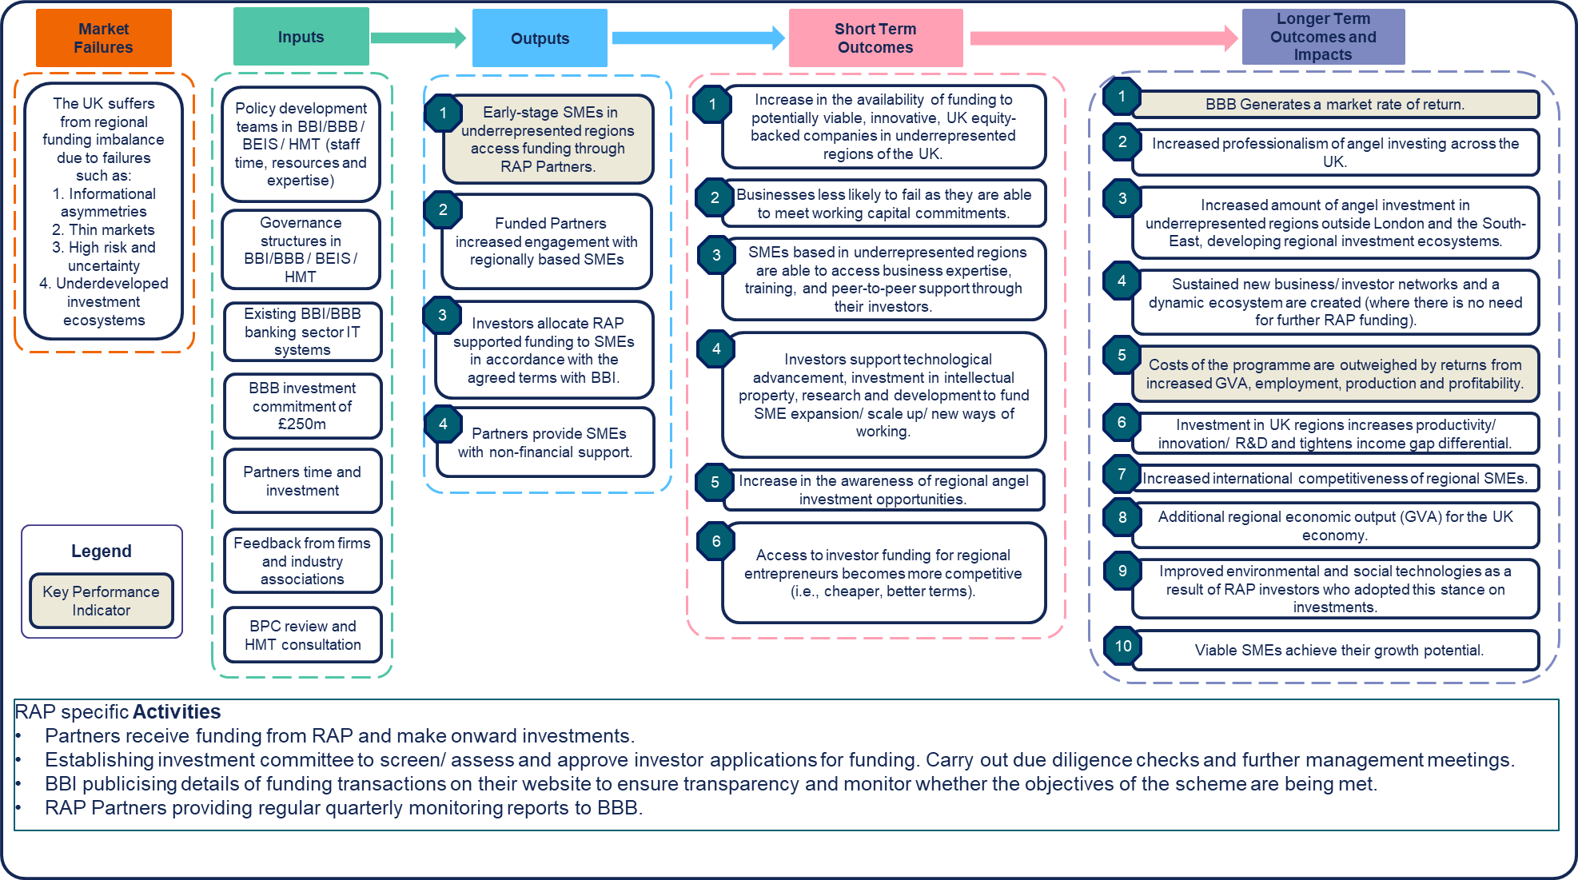

3.3 Market conditions under which RAP was launched
In 2017/18 the UK investment market conditions were characterised by volatility driven by uncertainty surrounding the EU-Exit negotiation outcomes following the UK’s historic vote to leave the European Union in July 2016. The 2018 UK Business Angels market report highlights EU-Exit as a key challenge for business angels, more so for those based outside London and the South East. The other a main challenge was also identifying good investment opportunities and raising sufficient capital for investment.
More recently, the Covid-19 pandemic which saw three UK lockdown periods (during 2020/21), hindered economic growth. Investors were cautious and reluctant to supply equity to the markets, which would have exacerbated the shortage of equity finance, especially to underrepresented regions across the UK. The Government did however launch several Covid-19 support schemes (Future Fund, CBILs, BBLs, Furlough, etc.) which would have eased the pressure on early-stage firms, especially across the regions, which in a business-as-usual scenario would have found equity investment markets relatively thin compared to those based in London and the South East.
Turning to the equity market structure in the UK, access to finance in the UK is unevenly distributed across regions, resulting in inconsistent opportunities for businesses. The concentration of equity angels in London, the South East, and established clusters like Oxford and Cambridge has left many regions without access to their benefits.
The RAP scheme was designed to have a strong impact in fostering an equity ecosystem and supporting early-stage businesses seeking smaller investment sizes, particularly in science and technology sectors. Angel funding and reducing regional disparities, can help the UK nurture innovative industries like Biotech, Deeptech, and Clean Renewable Energy, sustaining its position as a global technology hub and stimulating economic growth.

3.4 Methodology
Early evidence about the Programme’s approach to implementation and outcomes are collected based on monitoring information (MI), desk research, in-depth interviews, and econometric impact modelling, which is outlined in detail in Annex G: and summarised in Figure 2 below. The in-depth interviews were conducted with:
- 3 interviews with policy stakeholders from relevant departments (e.g., BEIS and HMT)
- 3 interviews with industry body members from organisations such as the UK Business Angels Association (UKBAA)
- 5 interviews with key stakeholders from the British Business Bank and British Business Investments (including members of the RAP delivery / management team)
- 11 interviews with representatives from the RAP Partners (11 out of 12 RAP Partners)
- 2 interviews with unsuccessful applicants to the RAP scheme
- 8 interviews with non-applicant angels
Monitoring data on quarterly reports was available for all 372 firms funded in 2020, 2021, and by June (Q2) 2022. Data from Beauhurst and the Inter-Departmental Business Register (IDBR) was used to profile these firms and draw a comparison group that enables comparing differences in performance. To note that the IDBR data or BSD for turnover and employment is updated from a range of different ONS sources including some surveys conducted every two years. There could be a maximum two-year lag in the employment and turnover data presented from the IDBR data which should be considered. This was possible for a sub-set of the total sample of treated firms which includes 19 firms in London and 65 firms in other regions (or 25 in London and the South East and 59 in the regions outside of London and the South East). Figure 2 below summarises the methodology used and cross references the chapters where evidence is presented.

The qualitative research was completed in three steps:
- Data frame development
- Matching modelling
- Econometric modelling
Data frame development involved sourcing data from various databases (IDBR, Beauhurst, RSM Tracker and directly from the Bank) and consolidating the data into one large data frame to run the impact modelling. This included applying database filters (streamline the search for counterfactual firms with similar characteristics), cleaning data, testing sample representativeness to the population of RAP funded firms and matching data across databases.
Once the data frame had been developed, a matching exercise was undertaken to statistically refine the counterfactual sample, based on a set of firm characteristics, to the representative RAP funded firms. The resulting matching exercise reduced the sample considerably as firms were removed that fell outside of the caliper ranges according to the characteristics used for the matching. See Figure 2 below for sample sizes at each stage.
Econometric modelling techniques (DiD/ DiDiD) were then applied to the matched data set to estimate the RAP specific impact on fundraisings, both at a national and regional level of impact.
Figure 2: Overview of the methodology:
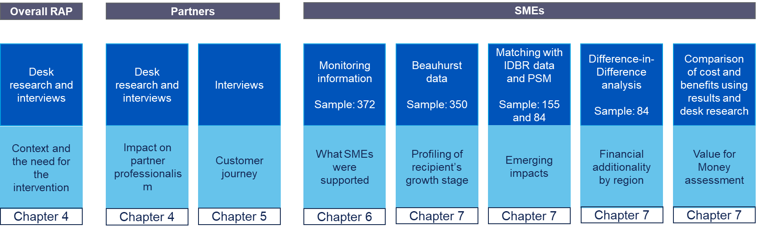

4. The need for intervention

4.1 Key Findings
- Regional inequalities confirmed with further research throughout the literature and the latest data extracts – there exists an uneven concentration of business angels (34% in London and 22% in the South East of both VC and angel investors) and business angel deals in London and the South East.
- Policy stakeholders supported this research, highlighting clear regional inequalities and the lack of a defined angel ecosystem in some regions.
- Policy stakeholders reported a lack of wide-scale government intervention in the angel investment ecosystem, with interventions such as the Angel CoFund not contributing sufficiently to the development of the regional angel investment ecosystem – in line with the wider objective of the government’s levelling up agenda.
- Stakeholders noted the importance of angel investment to the overall health of the UK investment landscape as it acts as a ‘starting point’ for later investment.

4.2 Regional inequalities in the angel investment ecosystem
British Business Bank research highlighted that most UK angels were located in London and the South East (57%), with a substantial majority of them (80%) making at least one investment in London. Angels based outside this region were also attracted to investing in London, with 63% of them making at least one investment in London (as shown in Figure 3). Research indicates that early-stage finance is hugely skewed in terms of its spatial distribution, not just in the UK but in most other major economies such as the US, China, Canada and Germany (Fritsch and Schilder, 2008; Chen et al, 2010; Harrison et al, 2020; McNaughton and Green, 1989). Importantly, this acts as a major determinant of regional productivity differentials within these economies (Gardiner et al, 2012).
Figure 3: Number of business angels and business angels deals per region - 2017 (pre-RAP)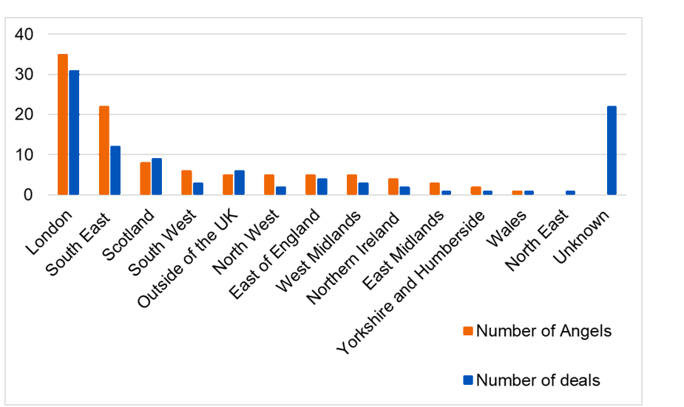
Source: The UK Business Angels market report 2018
Findings from this research were supported by stakeholder views during interviews, with key policy and industry body personnel acknowledging this regional inequality and noting the need for intervention due to the underdeveloped nature of the angel ecosystem in many regions outside London and the South East.
A policy stakeholder involved in the conceptualisation of the Programme went as far as to state that the issue in certain regions was not the regional gap, but instead “the lack of a market at all”. It was agreed that an intervention was required to develop and foster the early-stage investment ecosystem in these regions by not only increasing the supply of investment, but also by professionalising the landscape.
The importance of this intervention was further highlighted by stakeholders who recognised the critical role of angel investment in a healthy investment ecosystem, acknowledging angel investment as the “starting point” for later-stage investment and therefore crucial to the successful development of UK companies and future of innovation and productivity.

4.3 A lack of government intervention in the angel investment ecosystem
Stakeholders highlighted the lack of wide-scale government intervention to support angel investment in the UK. One of the most commonly cited sources of government support for early-stage firms cited by Partners are tax incentive schemes like EIS/SEIS which have shown increases in the quantum of investment in early-stage companies over time. Most RAP funded Partners claimed to have benefitted from EIS/SEIS and suggested the RAP funding was complementary to this. Partners cited the biggest limitation with the SEIS scheme being the cap on investment amounts, although a few welcomed the government’s decision to increase the cap from £150,000 to £250,000. Other tax-relief schemes include Social Investment Tax Relief (SITR) and the Venture Capital Trust (VCT) schemes. The Angel CoFund was cited as the strongest intervention aside from RAP in terms of supporting angel investment. However, stakeholders largely felt that these interventions prior to RAP had not had the required structural impact on the regional angel investment ecosystem.
Whilst stakeholders spoke positively of the Angel CoFund, they noted that its design does not allow it to influence the structure of the angel investment ecosystem as it is a “deal-by-deal” Programme focused on co-investing alongside angels into specific firms rather than RAP which was designed to support the broader development and professionalisation of the angel investment ecosystem. An industry body stakeholder noted that the Angel CoFund’s emphasis on engaging with more experienced business angels further limits its influence on ecosystem development as angel groups in underserved regions tend to be more nascent.
This further demonstrates the need for RAP due to the lack of intervention taking place with sufficient scale to address such distinct regional inequalities across the UK – as well as the underserved tranche of nascent investors.

4.4 Assessment of the merits and disadvantages of the RAP model
The RAP was developed following the BPC which identified a gap in funding supply across underrepresented regions across the UK. In terms of other schemes offered for small businesses, the model for the RAP is unique with limited/ no substitutable scheme. Some schemes are region specific, such as the “Investment Fund – North of England” which is only available for firms based in the Northwest, Yorkshire, the Humber, and Tees Valley. Other schemes, such as the Future Fund, were in response to market shocks (Covid-19) where there was concern that viable early-stage business survival was at risk. Annex F provides a non-exhaustive list of other schemes that may share some similarities to the RAP but are modelled differently depending on the required aim the scheme is trying to address. The Angel CoFund model shares similarities in terms of structure with the RAP, however, this scheme did not have an explicit focus on the regional underrepresentation of angel investment.
Below we have listed some schemes similar to the RAP for a comparison.

Table 4: Finance schemes comparison
Scheme | Product/ Instrument | Scheme owner(s) | Finance amount per investment round (GBP) | Regional focus | Investment recipient
Regional Angels Programme | Equity/ Quasi-equity (e.g., CLN) | British Business Bank | £100k - £1,500k | Yes | Angel investor/ syndicate – they had discretion over where to invest.
Angel CoFund | Equity | British Business Bank | £100k - £1,000k | Not explicitly defined | Angel investor/ syndicate – they had discretion over where to invest.
Future Fund | Quasi-equity (CLN) | British Business Bank | £125k - £5,000k | Not explicitly defined | Lead investor applies, but funding flows to businesses.
Investment Fund - North of England | Microfinance, Equity or Loan | Northern Powerhouse Investment Fund – delivered by British Business Bank | Microfinance (£25k - £100k)  Loan (£100k - £750k)  Equity (£50k - £2,000k) | Yes – North of England based firms only. | NPIF has appointed fund managers who are responsible for evaluating applications and allocating funds to businesses.

An example of a comparative scheme that was not regionally targeted is the range of Covid-19 lending support programmes and loan guarantee schemes introduced by the UK government to address the liquidity crisis firms may have faced during the pandemic. Recent studies on these schemes found that while they were national and unaligned with regional policy, firms in poorer regions were favoured in terms of access to this finance. Moreover, loan guarantee schemes provided crucial support to smaller businesses outside the wealthy South East of England. Despite falling short of complete levelling up, this ensured the survival and continued operation of smaller businesses across the UK as the Covid-19 crisis was diminishing.
While this doesn’t provide evidence against the need for regionally targeted programmes, there may be key lessons learned from the roll-out and delivery of the loan scheme that RAP could benefit from.

A number of RAP funded firms benefitted from other British Business Bank schemes.
- The Angel CoFund scheme invests alongside syndicates of business angels to support businesses with strong growth potential - a small proportion of RAP funded firms (1.9%) participated in this scheme.
- The Bounce Back Loan Scheme (BBLS) provided financial support to businesses across the UK that were losing revenue, and seeing their cashflow disrupted, as a result of the Covid-19 outbreak – around 40% of RAP funded firms have benefitted from this scheme.
- Coronavirus Business Interruption Loan Scheme (CBILS), which was designed to “provide financial support to smaller businesses across the UK that were losing revenue, and seeing their cashflow disrupted, as a result of the Covid-19 outbreak” - based on data available, 6.5% of RAP funded firms benefitted from this.
- The Future Fund was a scheme supporting innovative companies facing financial difficulties due to the Covid-19 outbreak. Based on data available, a small proportion of RAP funded firms (1.9%) participated in this scheme.
Table 5: RAP funded firms’ participation in other schemes (N = 372)
Scheme | % of RAP funded firms | Number of firms
Angel CoFund | 1.9% | 7
BBLS | 39.5% | 147
CBILS | 6.5% | 24
Future Fund | 1.9% | 7
Source: Data on other schemes provided by the British Business Bank

5. Rigorous application process improved professionalism

5.1 Key Findings
- Angels/ syndicates (applicants) located in London were not excluded from participation.
- Applicants able to demonstrate that their strategy has an impact in underdeveloped regions were viewed favourably.
- Applicants needed to demonstrate ability to leverage between 50% and 80% in co-funding, and it was expected that each investment would range from £100k to a maximum of £1.5m per investment round.
- Requirement for FCA regulation limited participation to more developed angel groups.
- Partners described the process as rigorous and time consuming, lasting over a year in some cases, but appropriate.
- Partners noted positive impacts of this process, improving their professionalism, and allowing them to develop their due diligence processes.

5.2 Programme design and implementation
Figure 4: Overview of RAP stakeholdersoutlines the key stakeholders involved in design, development, and delivery of the Programme. As shown in the methodology, consultations were carried out with representatives from key stakeholder groups.

Figure 4: Overview of RAP stakeholders
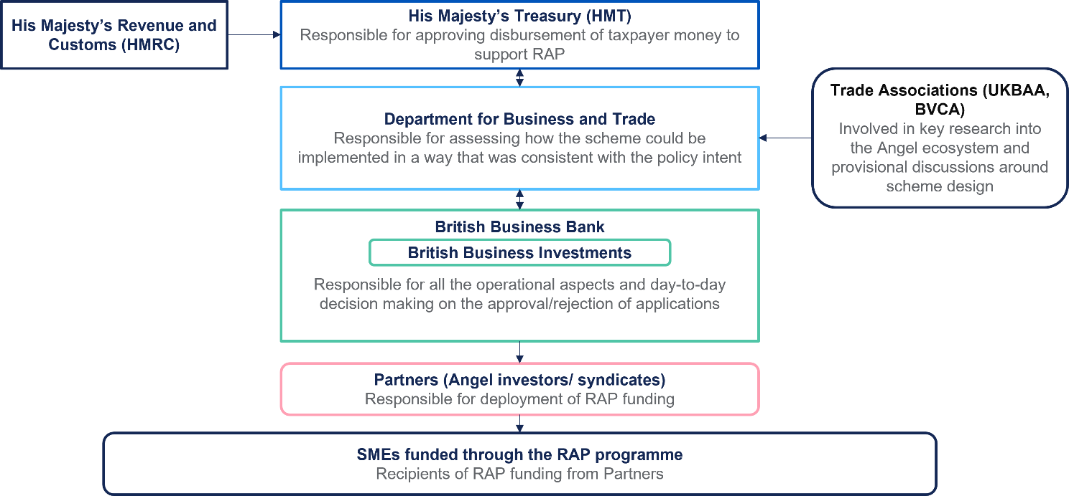
Source: RSM, British Business Bank
The British Business Investments assessment team selects proposals from Partners based on a review against eight criteria. Applicants need to demonstrate ability to provide and/or facilitate early-stage equity investment in smaller businesses. Applicants located in London are not excluded from the Programme, however, those that “can demonstrate that the target market they operate in is in areas of the UK that are currently underrepresented in the provision of such funding, will be viewed favourably”.

Case study C: Investment Director, RAP Partner B
Partner B was introduced to the programme via the UK Business Angels Association (UKBAA), and senior members of the fund approached the RAP team directly to propose involvement in the scheme. When asked to identify the reason for their interest, the investment director noted a synergistic fit with the RAP scheme due to its focus on targeting underserved regions in the UK and increasing the quantum of investment available to business angels (as shown below).
“The objectives of the programme mirrored our objectives of investing in a far-flung region of the UK and enabling business angels to raise larger investment rounds.”
Applicants need to demonstrate ability to leverage between 50% and 80% in co-funding. Proposals that can demonstrate integration of ESG factors into the investment process are viewed favourably. The selection criteria have no sector or industry focus, and funding is deployed by successful applicants with the expectation that each investment would range from £100,000 to a maximum of £1,500,000 per investment round.
The requirement for applicants to possess all relevant FCA permissions/ regulations formed a core part of the eligibility criteria referenced above. Stakeholders noted that this was a required element of the Programme due to the need to implement clear due diligence frameworks when providing significant amounts of public funding to private organisations.
However, key policy and industry stakeholders highlighted the limiting nature of this requirement for FCA regulation on the type of angel groups that are able to participate. Stakeholders noted that more traditional angel groups, as well as those that are less developed or focused on niche investment strategies, are far less likely to have these permissions than more developed, institutional groups.

Case study A: Non-applicant angel
The syndicate was established in 2021 as a co-investment tool to support investment into innovation and creativity-based sectors providing capital for early-stage female and diverse founders…
…The syndicate managers noted that they have been aware of the RAP scheme since its launch but were not ready to apply as they were in the inception phase. The syndicate has communicated with the RAP team but were informed that their structure did not meet critical application criteria / checkpoints (e.g., FCA regulation).
As a result of this, questions were raised around the Programme’s ability to support more nascent angel groups that do not have the required permissions. This is a particularly important point to consider when assessing the Programme as one of its core objectives is to professionalise the angel investment landscape, with some stakeholders questioning whether this can be achieved if such limitations are placed on angel groups arguably most in need of support.
When interviewed, the RAP team acknowledged this limitation as part of the Programme and, whilst maintaining that such regulatory requirements are important due to the involvement of significant public funding, recognised the need to become more inclusive of these angel groups. As a result, the team has introduced a ‘workaround’ for angels without these permissions allowing them to apply for the Programme as an appointed representative of a directly authorised and regulated entity. The rationale for this is to enable angel groups that have a good track record to be able to invest in underrepresented regions or target specific types of investment (e.g., investing in women-led or BAME-led businesses) to access RAP funding.
Whilst this limitation remains present, and questions around the Programme’s ability to achieve core objectives are still relevant, this highlights the RAP team’s efforts to broaden the reach of the Programme and its flexible approach.

Case study A: Non-applicant angel
…they have since had positive engagement with the RAP team, with members of the team offering guidance on how the syndicate can navigate the onboarding process to address structural issues (e.g., applying alongside a regulated Partner that can counteract the regulatory / structural limitations). This highlights the RAP team’s focus on supporting more nascent angel syndicates despite the inclusion of regulatory requirements in the RAP criteria, with the syndicate managers acknowledging the RAP team has a “clear focus on how they can support further diversity in their investment strategy”.

5.3 Overview of the Partners and geographic spread
12 Partners were admitted onto the Programme, with these listed in Table 6 below. Recent additional syndicates that have drawn down finance include Archangels and Eos listed at the end. Two have headquarters in London and one other also has a London representation. This level of London representation is lower to that of other Active Angel Networks in the UK. Not represented are Wales, The North East, West Midlands, and the South East which could be a result of the criteria with which Angels/ syndicates were accepted onto the programme and there not being firms in those regions that could meet these criteria. Written evidence submitted to the UK government by the UKBAA states that:
“… the current RAP parameters preclude many angel groups across the regions and devolved nations that do not have the experience, track record or relevant funding structures to take advantage of these co-investment funds.”
These requirements are likely making it difficult for Angels/ Syndicates within unrepresented regions to show up due to them not fulfilling the criteria. However, these requirements as part of the application process are included due to BBI’s commercial nature and to minimise the risk of failure and losses to taxpayer monies. The scheme was designed with this trade-off in mind. It must be noted that business supported by Angels/ Syndicates within these regions may not have met the minimum thresholds to access RAP finance.
The South East region however, has a relatively larger degree of angel activity and deals which would have made applicants potentially less favoured if investments were focused in this area, similar to those Angels/ Syndicates investing in London.
Table 6: RAP Partners by Region
Partner | Head Office | Other UK Offices Geography
DSW Ventures | Manchester (North West)
Praetura | Manchester (North West)
Newable | London/South-West | N/A
Clarendon Fund Managers | Belfast (Northern Ireland) | N/A
Deepbridge Capital | Chester (North West) | London, Bristol (South West), Edinburgh (Scotland)
SyndicateRoom | Cambridge (East of England) | N/A
24Haymarket | London | Edinburgh (Scotland)
Par Equity | Edinburgh (Scotland) | N/A
SFC Capital | Cheshire (North West) | Northwich (North West)
Green Angel Syndicate | London | N/A
Science Creates | Bristol (South West) | N/A
Haatch | Lincolnshire (East Midlands) | N/A
Archangels | Edinburgh (Scotland) | N/A
Eos Advisory LLP | St Andrews (Scotland) | N/A

5.4 The application process is rigorous and time consuming
Partners agreed that the process is rigorous, with some stating it took over one year from start to finish (one Partner noted that it took 20 months in total). Whilst each application was treated differently due to individual circumstances of each applicant, the process followed four distinct stages. This is outlined in detail in Annex B: Regional Angels Programme eligibility criteria, with an overview of the process provided in the Figure 5 below.
Figure 5: Overview of legacy RAP application process:
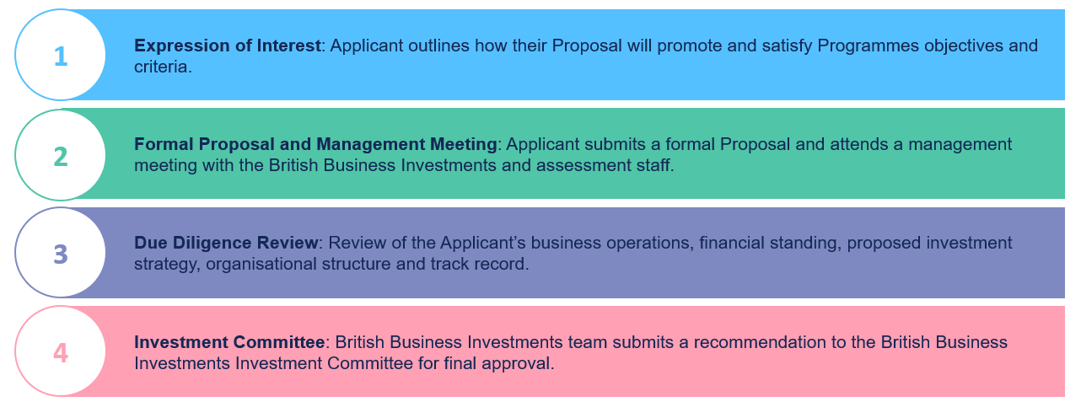
Partners most commonly referenced the due diligence stage as time consuming, noting that a lot of time was required to bring together the data and information required. This was amplified for some early applicants as the information requested was not something they had previously thought to collect, causing long periods of time to lapse between requests for information and submission.
“At the time, all parties would have liked [the due diligence] to be faster. There were long cycles between them asking for data, us having to go off and pull it all together, and then hearing from them again.” – RAP Funded Angel
Some Partners felt this level of due diligence was overly extensive, with one describing it as “on-par with, or higher than, a sales process”, and many at the time would have preferred the process to move quicker. However, the majority accepted that it was largely in-line with expectations when applying to a publicly funded scheme of this level and noted that the assessment team did not add extra time to the process or stall unnecessarily.
Case study B: RAP Partner A
Due to Partner A being one of the first applicants, a lot of attention was paid to the initial application process, with the founding partner noting that it was perhaps a case of the RAP team “constructing the railway line as [they] brought the locomotive down it”. This caused the process to take longer than expected (over a year from start to finish), but the interviewees were satisfied that the RAP team did not keep them waiting unnecessarily and understood the need to take the time to ensure everything went correctly.
To aid with this level of rigour/ information required, the RAP team noted that they spoke to applicants prior to beginning their formal application to guide them through the different stages and avoid confusion and unnecessary delays. Almost all Partners interviewed who suggested the process was lengthy also indicated that the information was requested in a clear way and that the process was straightforward. A few Partners indicated they initially found the process to be onerous but changed their mind having gone through the full due diligence process, citing they had benefitted from the process overall.
“At the time, I thought it was way too rigorous for what they were trying to do in terms of early-stage and angel programmes… as a result [of applying], we’ve tightened up our governance and regulatory framework. My perception of that whole process has evolved as I’ve moved out of it.” – RAP Funded Angel

5.5 The process allowed Partners to develop their professionalism and reputations
A distinct result of this rigorous application process was that it allowed successful applicants to further professionalise and develop their governance and data collection frameworks.
Partners reported that the process impacted positively on their development as syndicates as this extensive due diligence allowed them to develop datasets that they would not have previously had to hand, put themselves in a stronger position to comply with quarterly reporting requirements, and progress as syndicates because, for some Partners, this was their first experience of an intensive due diligence review.
Partners also noted that being able to demonstrate they were successfully subject to a rigorous due diligence review carried out by a governmental organisation had a positive impact on their reputation within industry, both from the perspective of investees and other potential investors, as it provided credibility and demonstrated their professionalism.

6. Partner journey and experience

6.1 Key Findings
- Partners noted an increased ability to deploy more capital in underrepresented regions as a result of their involvement in the Programme.
- Partners were able to lead funding rounds (where this was unlikely pre-RAP support) due to increased access to capital and build networks across regions outside of London as a result of participation in RAP.
- Partner reputations improved within industry, helping them to acquire more active marketing and HR services as well as complete deals more quickly due to participation in RAP.
- Partners spoke positively about the governance and reporting processes within the scheme.
- Partners were satisfied with the speed and clarity of the RAP team – providing bespoke feedback and support.
- Partners were satisfied with the flexibility of the RAP team and felt this was required due to the different circumstances faced by each (e.g., syndicate structure and size).

6.2 Partners noted an increased ability to deploy more capital
A majority of Partners interviewed noted increased ability to deploy more capital as a result of their involvement in the Programme. Though the level of this increase differed, it was broadly agreed that involvement in the Programme allowed them to increase the quantum of investment.
Partners noted benefits stemming from this increased ability to deploy capital, including improved reputation within industry, increased access to more active marketing and hiring processes, and being able to find and complete deals at a faster pace.
Partners were able to extend their investment opportunities to different types of companies and different regions, with examples noted by Partners including their ability to lead Series A funding rounds when they would have been less able to do so pre-participation and increasing their access to local accelerators and incubators to generate more investment opportunities.

6.3 Partners spoke positively about governance and reporting processes
The main governance requirement for Partners was a quarterly meeting with the RAP team to provide a breakdown of the portfolio structure, its performance, their near-term pipeline and any changes to their syndicate.
Partners were positive about these meetings, noting that they acted as a good opportunity to develop reporting and data collection frameworks for the portfolio and felt that the frequency of reporting required was the correct amount. Partners also noted positive changes to their data collection methods as a result of this governance. One Partner highlighted this has led to them including valuations of companies as part of the portfolio updates which was something they had previously shied away from.
One potential improvement raised by a Partner was that that more could be done to track key metrics moving forward (e.g., diversity metrics) to better showcase the demographic breakdown of the Partner portfolios.

6.4 Partners were satisfied with the speed, clarity and flexibility of the RAP team
In addition to the positive feedback on the governance requirements, Partners were generally satisfied with their communication with the RAP team. Partners noted that the team was very accessible, open, and clear when communicating and did not cause unnecessary delays in communication or confusion.
Several Partners acknowledged that this led to the RAP team’s positive influence on them being able to deploy capital investment at the appropriate speed, noting that they would be hindered in their ability to do so if the RAP team required Partners to go through a long process with them before a deal was completed. The extensive due diligence process outlined above potentially contributed to this, with the RAP team able to allow greater autonomy following such a rigorous process.
Additionally, Partners spoke positively about the level of flexibility offered by the RAP team, with some noting that the team successfully applied the spirit of the contract rather than “the specific letter of every clause”. This flexibility was particularly important to Partners due to the different circumstances faced by each.
Case study C: Investment Director, RAP Partner B
Partner B’s experience of the application process and engagement with the RAP team post-application was noted as being positive, acknowledging the application process as being extensive but proportionate to the level of investment, and described the RAP team as “very good on the flexibility front”.
“[The application process] was absolutely appropriate in terms of the amount of information. The rigour, the questioning was all fine. I didn’t think it was over the top.”

7. RAP funded firms showed considerable geographic and sector reach

7.1 Key Findings
- Geographic diversity was considerable, with RAP funding flowing to firms across all regions of the UK. Notably, 79% (BBI investment only), (75%, BBI + delivery partners investment + third party investor) of the funding was received outside of London, highlighting a more balanced distribution. While geographic diversity was evident, London remained a significant recipient of RAP funding, reflecting the concentration of business activity and investment opportunities in the capital.
- The industry scope of RAP funding was wide-ranging, benefiting firms active in sectors such as Information and communication, professional, scientific, and technical activities, as well as manufacturing. This demonstrates the programme's support for diverse industries and innovative sectors.
- The RAP funding demonstrated a commitment to gender diversity, with firms led by female leaders receiving similar support compared to the traditional male-dominated landscape.

7.2 RAP has mobilised more private sector funding
The private sector has significantly exceeded the funding provided by the RAP. This is a positive development as it demonstrates that the scheme has catalysed private investment.
The total third party investor funding from the private sector received from RAP firms was £307m – compared to a total Programme funding of £212m (£100m BBI commitment and £112m via RAP delivery partners) - up to June 2022.
Figure 6 illustrates the allocation of funding by the Partners of the scheme, highlighting the successful catalysation of private funding in conjunction with the Regional Angel Programme. RAP and delivery partners funding covers approximately 40% of the total funding, and this collaborative effort has effectively mobilised private funding, resulting in a substantial increase in overall investment.
Figure 6: Delivery partners, third party investors leverage and RAP BBI funding commitment
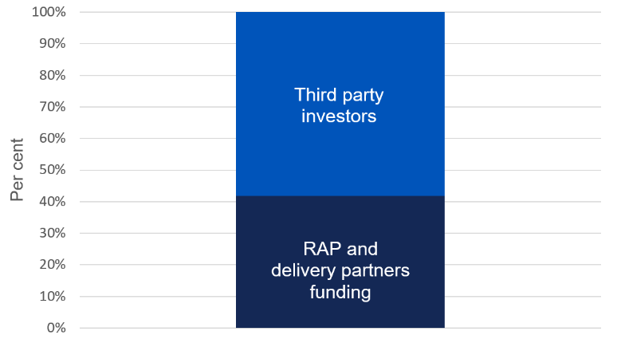
Source: British Business Bank RAP MI data up to Q2 2022

7.3 RAP funded firms from all regions across the UK – comparatively more funding went to regions outside London
Based on the MI data, approximately 79%, (75% = BBI + delivery partners investment + third party investors) of RAP funding went to firms based outside London. This is just below double the relative allocations provided by other comparator schemes. By means of comparison, the 41% of funding allocated under the Future Fund went to firms outside of London.
Turning to the aggregation of firms based outside London and the South East this figure drops to 72% (67% for BBI + delivery partners investment + third party investors).
RAP funding flowed to most UK regions. The region that received the most funding is London – 25% of total volume of funding (21% BBI commitment only as per Figure 9) and 30% of the number of deals (151 out of 497). Interviews with RAP policy and industry body stakeholders highlighted that a potential reason for this concentration is that the majority of firms have headquarters in London. Although firms may be headquartered in London, a significant proportion of their investments may be outside of London. 7% of the total funding was flowed to the South East (a region which also has a strong investor base).
Similarly, London not only has the largest share of investors using the EIS and SEIS schemes (with 38% of known investors residing in the Capital), but it is also the region where EIS and SEIS investment is predominantly concentrated, accounting for 49% of the total activity, highlighting how the Capital offers a favorable environment for attracting investment in early-stage and growth-focused ventures. London based firms, on average, received smaller funding but remains the region with the largest number of firms benefitting (123 of 372, 33%), and 8% (29 firms out of 372) of RAP funding went to firms based in the South East.
The region that received the second largest share of RAP funding is Scotland, receiving 18% of the volume of funding. Many of these firms received relatively large sums of funding (£870k on average) and only 8% (29 of 372) of the firms that received funding were based in Scotland. A high proportion of the funded firms are based in Northern Ireland (12%). Representation from Wales was lower than the other regions of the UK, with 4.3% of the firms (16 of 372) having benefitted from RAP. The Partners do not have a formal representation in Wales, the North East, West Midlands, and the South East, and this is somewhat reflected in the data. This could also be as noted above due to the scheme design permitting those Angels/ Syndicates that had proven track records and a history of investment, limiting the participation of nascent angels funding firms residing in the RAP unfunded regions. This may reflect a design constraint which should be considered when interpreting the graphs below.
Figure 7: Percentage of number of firms receiving RAP funding by region (N = 372)
Source: British Business Bank RAP MI data
London tops the chart with 33.1%, reflecting its role as the business and financial hub of the UK. This aligns with the concentration of investment opportunities and business activities in the capital. The data reveals a balanced distribution of funds across different regions, such as Northern Ireland, the North West, and Scotland. This aligns with the RAP’s objective of funds flowing to underrepresented regions across the UK. 41% of the total funding (BBI + delivery partners investment + third party investors) is flowing to London and the South East based firms.

Figure 8: Percentage of total value of RAP funding deals (BBI + delivery partners investment + third party investors) by region (Number of deals = 497)
Source: British Business Bank RAP MI data
Although London does not have the same overwhelming majority in the total volume of RAP funding received (25.3%), it continues to play a significant role, reinforcing its status as a primary investment destination.
Scotland and the North West show a strong presence with 17.8% and 16.5% of the total funding volume, respectively. This highlights the regions as growing centres for investment and business development.
The uneven distribution, particularly the low percentages in regions like the East of England (3.2%), the North East (2.9%), and the Midlands, highlight disparities in opportunities and the importance of examining regional strategies to boost investment in lagging areas.

Figure 9: Percentage of value of BBI only funding deals by region (Number of deals = 497)
Source: British Business Bank RAP MI data
Compared to the distribution of the combined private and public sector funding, BBI only funding shows a more equitable distribution across regions. London's share is only 21.3%, with greater relative investment in other regions like Scotland (17.0%) and the North West (15.6%), although still dominates as the primary investment region. A caveat to consider is that the regional distribution of firms is based on headquarter locations. For early-stage firms especially this is usually not the location of a majority of business activity which could have been located in other regions across the country. With Northern Ireland receiving 12.4% and other regions such as the North East and South West also being represented, this indicates BBI’s commitment to fostering growth and innovation in areas that may have been traditionally underfunded. Despite these positive signs, some regions like the East Midlands and West Midlands still receive relatively low investment.
The number of deals being made in London and the South East however is lower than the amount flowing to RAP funded firms based in those regions at just shy of 28%.

Figure 10: Number of RAP funded firms by region (N = 372) (LHS) and value of total investment by region in £m (RHS)
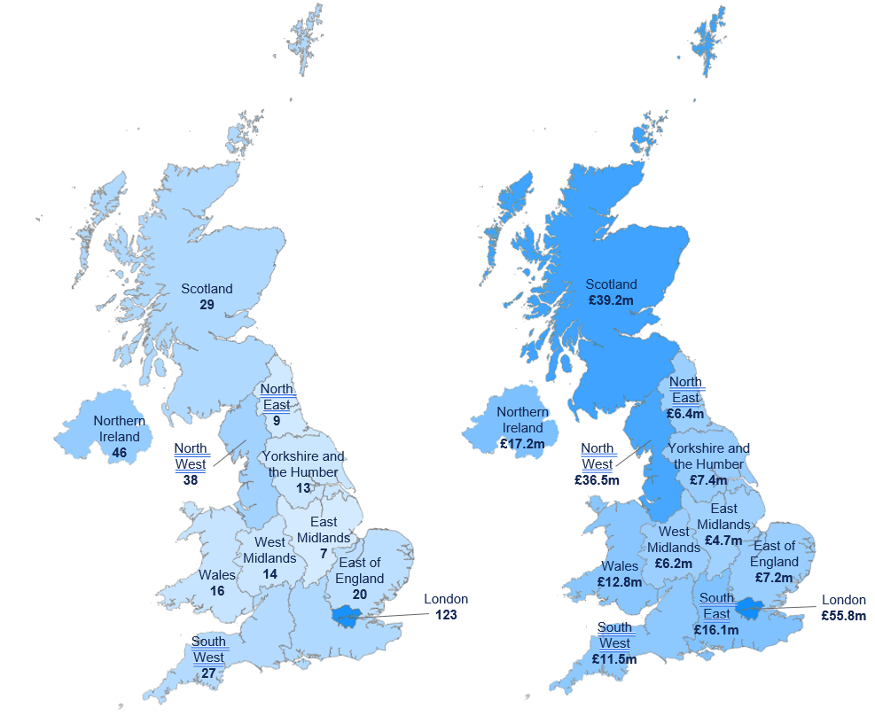
Source: British Business Bank RAP MI Data

7.4 RAP funded firms are concentrated in high growth industries
Close to half of the firms funded by RAP are active in the “Information and Communication” sector. 10% are active in “manufacturing” and close to 7% are active in “Wholesale and Retail”. ONS data suggests that these industries are among those that made the biggest contribution to productivity growth relative to the 2019 average. 22% of RAP funded firms are classified within the “professional, scientific and technical activities” sector, which represents a significant portion of the RAP investment going towards firms based in sector that requires a higher intensity of research and innovation. This will lead onto the development of new products or more efficient processes that improve productivity, open up new markets, and potentially create new jobs.
For example, firms in this sector often invest heavily in R&D, which can lead to technological advancements that have far-reaching impacts. The knowledge and skills developed by employees within these firms can spill over into other areas of the economy, fostering a culture of innovation that benefits across a wide range of industries.
However, it should be noted that while investment in this sector has the potential to drive economic growth through productivity enhancements, the exact impact can be influenced by a number of factors, including the broader economic climate, regulatory environment, and the specific strategies adopted by the firms. Further research would be needed to quantify the precise impact of this investment on the wider economy.
The proportion of funded firms with a focus on R&D increased from 5% in 2019 (9 from 182) to 23% in 2022 (59 from 257). This change suggests that RAP could have helped firms become more R&D focussed – given the nature of early-stage ventures is R&D intensive.
Figure 11: Allocation of RAP funding by sector (N = 350)
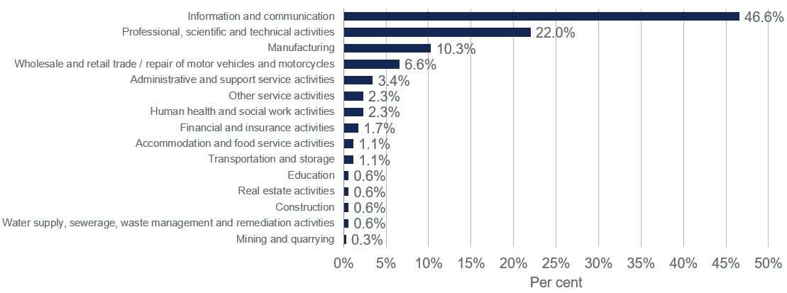
Source: Beauhurst

7.5 Recipient firms’ growth stage
When viewed through the lens of growth stage, close to half (45%) of the firms that received funding could be considered ‘start-ups’, meaning they were in the early stages of developing their businesses and products. Just over a third (32%) were slightly further along, being in the ‘early stage’ of growth, while around 10% were seeking expansion or growth capital. These business stages of investment were self-identified by the firms in the reporting requirement to their respective delivery partners within the MI data.
Figure 12: Number of RAP funded firms by investment stage (N = 372)
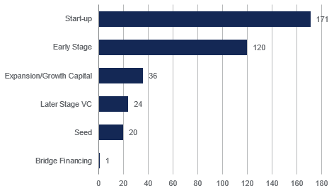
Source: British Business Bank Regional Angels Programme MI data
Contrasting to the MI data above an analysis of average years of incorporation has shown that at the start of 2020, the firms that received RAP funding had been in operation for an average of 5 and a half years, with the median of 4 and a half years. Some companies had only been formally launched months before receiving RAP funding, while others had been established as far back as 23 years prior.

8. RAP early performance assessment
The following results within this section provide an indication of the business performance of RAP funded firms compared to a match counterfactual. It must be noted that due to the early stage, post financing, the results are still too early to have fully fed through to the full business performance. We have used the earliest cohort only using data over 2020 and 2021 as these RAP funded firms would have been the only firms to have experienced one full year post RAP financing. Cohorts beyond this period may be mixed with some still receiving RAP funding. This assessment has been undertaken to provide indicative insights into the RAP funded firm performance and lay the foundations for future evaluations where a greater number of data points are available post-financing. These findings themselves are not sufficient to judge the overall success of the programme.

8.1 Key Findings
- RAP firms have exhibited better performance in fundraising growth in 2022 compared to the counterfactual group of firms, suggesting that the support provided by RAP may have had a positive impact with RAP funded firms facing a smaller decline in fundraising compared to the counterfactual in 2022 (17% against a 45% decline). Due to the limited sample size, it is challenging to make definitive conclusions about the overall effectiveness of RAP support.
- The modelling results suggest a potential uplift in fundraising for RAP funded firms in 2022 as a result of the Programme, further confirming the observed trend in fundraisings. The analysis also indicates a more pronounced funding uplift across regions outside London and the South East compared to the counterfactual group.
- The figures for post-money valuations and valuation to sales ratio growth trends indicate a relative underperformance of RAP funded firms in 2022 compared to their counterfactual counterparts, hence a lower expectation of improved future growth for RAP funded firms – with a smaller increase of 23% compared to a 76% variation in counterfactual. It is however important exercise caution when interpreting this figure as valuation figures are an estimate based on existing transactions and reflect the volatility of market sentiments.
- Employment figures indicate a relative outperformance of RAP funded firms in 2022 (24% vs 14% growth in the counterfactual). Even though early to assess, RAP may have contributed positively to increased investment activities for funded firms, including talent recruitment, salary payments, and intellectual property development.
- The positive relative performance observed for turnover in 2022 signifies positive business sustainability, with an 84% growth in turnover for RAP funded firms against a 35% increase for the counterfactual comparison. Assessing turnover will require further observation in the future, as it takes time to materialise.
- The assessment highlights potential for improvements in the efficiency of the application process for RAP funding. It recognised that there are positive outcomes and effectiveness of the programme in unlocking investment and supporting early-stage SMEs in underrepresented regions. The application process has been revised since the initial launch and it has resulted in a quicker process from application to receiving funding.
- Equity considerations are raised by stakeholders as to the current funding across regions has room for improvement. This suggest a need for further efforts to ensure equal access and representation across regions (i.e., access to Angels that aren’t FCA regulated) and to assess the long-term impact on regional investment dynamics.

8.2 Early indicative evidence of funding additionality
RAP funded firms marginally outperformed in fundraising growth in 2022, indicating that the early results in attracting fundraising for these firms have been positive. The modelling also partially supports this view.
These findings show that the portfolio firms outperformed the counterfactual in fundraising growth with a 17% decline in fundraising compared to a 45% decline, respectively. RAP funded firms may have had additional support (additional funding draw down from the RAP) in 2022, mitigating the decline in fundraising that the portfolio firms would have otherwise experienced. The matching also controlled for other scheme participation, isolating the RAP specific impact to an extent.
However, it is important to note that these results may not be representative of the entire population of RAP funded firms due to the limitations of the limited sample size.
Figure 13: Average fundraisings growth rate
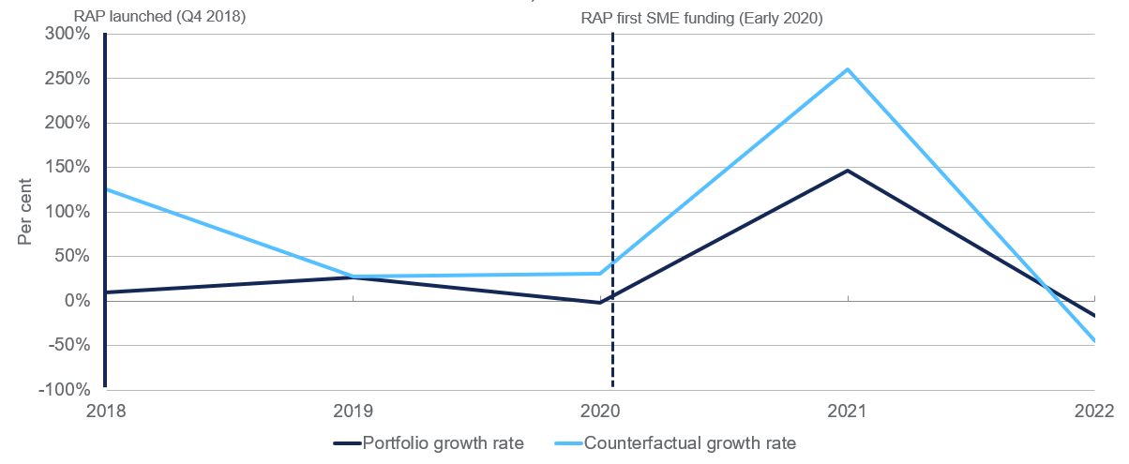
Source: IDBR data. N = 84 for the funded firms and N = 58 for the comparator group
A similar pattern emerges when examining the regional distribution of fundraising growth, where the decline in fundraising growth in 2022 compares favourably to the counterfactual group in the rest of the UK. Specifically, the portfolio firms experienced a decline of 69% compared to an 89% decrease for the counterfactual group. Moreover, in the London and South East region, RAP funded firms saw an increase of 30% in equity fundraising, while the counterfactual firms in the same region faced a steep decline of 56%. When London and the South East are excluded the rest of the portfolio seems to consistently resemble the performance of the counterfactual, albeit with a marginally better growth performance in 2022. The marginally higher performance of the London and South East portfolio group in 2022, compared to the counterfactual, is attributable to firms in the South East. When analysing fundraising growth separately for London in 2022, we observe an 18% decline for the portfolio group, in contrast to a 52% decline for the counterfactual.
Figure 14: Average fundraisings growth rate in London and South East (LHS) and in the rest of the UK (RHS)
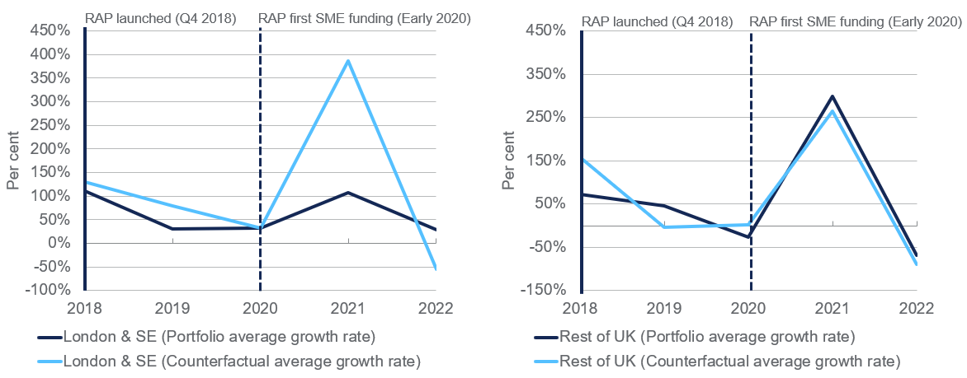
Source: IDBR data. N = 33 for London and South East funded firms, 25 for other regions and N = 25 for the London and South East comparator group and 59 for other regions
RAP funding additionality assessment
Results from the econometric modelling provides further evidence of the additionality of fundings associated with RAP funded firms when comparing 2020/21 (RAP funding intervention) to 2022 (fundraisings). Four models (see Annex H) have, two national and two regional, signalled a range of impacts associated with RAP. The lower estimates, which excludes two RAP funded firms, are more statistically insignificant compared to the upper estimates that are marginally insignificant. This evidences that positive outcomes are driven by a small number of outperformers.
Based on the modelling, RAP funded firms experienced between 15% to 76% funding uplift compared to the counterfactual at an overall national level. This suggests that RAP funded firms were able to raise more follow-on funding than the comparator group and invest more into business development through activities such as R&D. These results are preliminary and ranged from insignificant (15%) to marginally insignificant (76%) which makes it difficult to attribute results to the RAP. However, early-stage firms that focus on drawing down viable equity finance are likely to be predominantly engaging in R&D. This follows from the KPI comparison above where in 2022, the RAP funded firms outperformed the counterfactual group in securing follow-on funding. The RAP funded firms are smaller than the comparator group; this is controlled for in the model.
The regional funding uplift was stronger for RAP funded firms based in regions outside London and the South East. On average, RAP funded firms that were based in the rest of the UK experienced between 110% to 150% (insignificant 110% to marginally insignificant for 150%) increase in funding compared to the counterfactual group of firms based outside London and the South East (Rest of the UK) post-RAP financing. Therefore, across the regions, the uplift appears stronger, strengthening the case for achieving the short-term funding supply objective. RAP funded firms are larger in London and the South East and the regional control helps explain variation in fundraising activity.
The small sample size poses data limitations. As a result, some variables were excluded from the matching such as year of the establishment, number of employees as an indicator of size, and volume of RAP investment received. The RAP funding impact differentials are also insignificant, albeit marginally insignificant. Further data outturns and fuller data sets would be required to improve the matching and modelling significance. All-in-all, the results should be considered indicative of the expected impact. (See Annex H for full modelling results).

8.3 Post-money valuations suggest weaker expected growth trajectory of RAP funded firms
RAP portfolio firms have shown lower relative performance in terms of median post-money valuation figures in 2022 compared to the counterfactual group, with an increase of 23% compared to a 76% increase in valuation for the counterfactual.
Post-money valuation is an important estimate as it can incorporate investors' expectations of future cash flows, which is particularly relevant for younger firms lacking an extensive track record of business performance. However, this approach has its limitations, including the assumption that the investment price per share paid would be the same if the entire company were to be acquired and that this is an actual reflection of the firm’s value.
Moreover, it is essential to exercise caution when interpreting these trends due to potential inaccuracies in share allotments and other complexities such as shares tied to other companies or multi-layered corporate structures, as well as the inclusion of share issuance structures like options, which can impact this estimate. Therefore, it is crucial to approach this metric with caution.
Figure 15: Median matched cohort post-money valuation
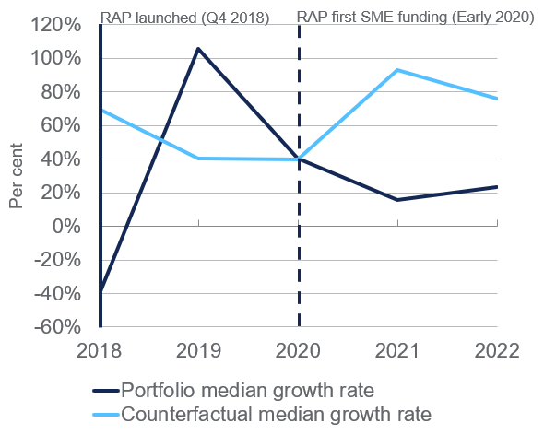
Source: IDBR, Beauhurst data. N = 84 for the funded firms and N = 58 for the comparator group
Figure 16 (LHS) illustrates that the median post-money valuation growth for firms located in London and the South East exhibit outperformance compared to their counterfactual peers, with a 54% increase in valuation compared to 44% in the counterfactual group. However, the overall performance observed in the national context, as depicted in Figure 15 above, is exacerbated by the significant underperformance of RAP funded firms in the rest of the UK. Specifically, there is a 22% increase in valuation for RAP funded firms in contrast to a substantial 102% increase for the counterfactual group in 2022.
Figure 16: Median matched cohort post-money valuation by region, London and The South East (LHS), Rest of the UK (RHS)
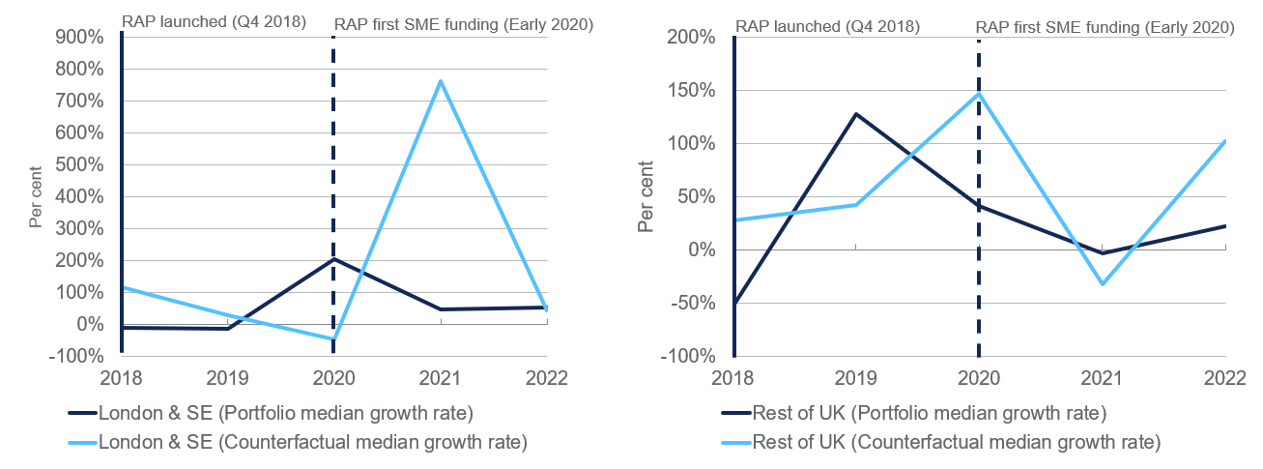
Source: IDBR, Beuahurst data. N = 33 for London and South East funded firms, 25 for other regions and N = 25 for the London and South East comparator group and 59 for other regions

8.4 Valuation to sales ratio shows similar story to post-money valuations
Similar to the post-money valuations trend in 2022, RAP funded firms exhibited a relative underperformance compared to the counterfactual group in terms of the valuation to sales ratio growth since the RAP intervention. The portfolio group experienced a decline of 33% in this ratio, while the counterfactual group saw an increase of 30%. It is important to note that the impact of the RAP Programme is still in the process of influencing revenue performance, and therefore, this ratio may not have captured any additional revenue generation experienced by RAP funded firms that would contribute to this metric.

Figure 17: Median matched cohort valuation to sales ratio
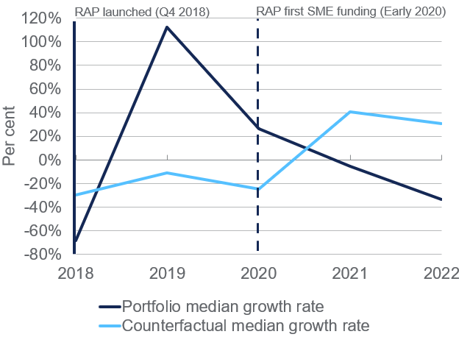
Source: IDBR, Beahurst data. N = 84 for the funded firms and N = 58 for the comparator group
The valuation to sales ratio serves as a valuable potential indicator of a firm's growth prospects as it quantifies the number of times an investor may be willing to pay for revenues as part of an acquisition. This ratio can signal the potential for future realisation of those revenues. However, it is important to recognise that this ratio is underpinned by the similar limitations as with the valuation figures prior.

8.5 Impact on turnover is likely limited at this early stage
The median RAP funded firm has shown a higher growth in turnover in 2022 compared to the median firm in the comparator group. RAP funded firms have outperformed the counterfactual group with an 84% increase in median turnover, while the counterfactual group experienced a 35% increase.
This encouraging trend indicates positive business health for RAP funded firms, although it is important to note that it is still too early to make definitive conclusions. Turnover takes time to materialise, particularly for early-stage firms like those funded by the Programme. Therefore, further observation and analysis will be necessary to assess the long-term impact on turnover and ascertain the sustained growth and success of RAP funded firms.
Figure 18: Median turnover growth rate
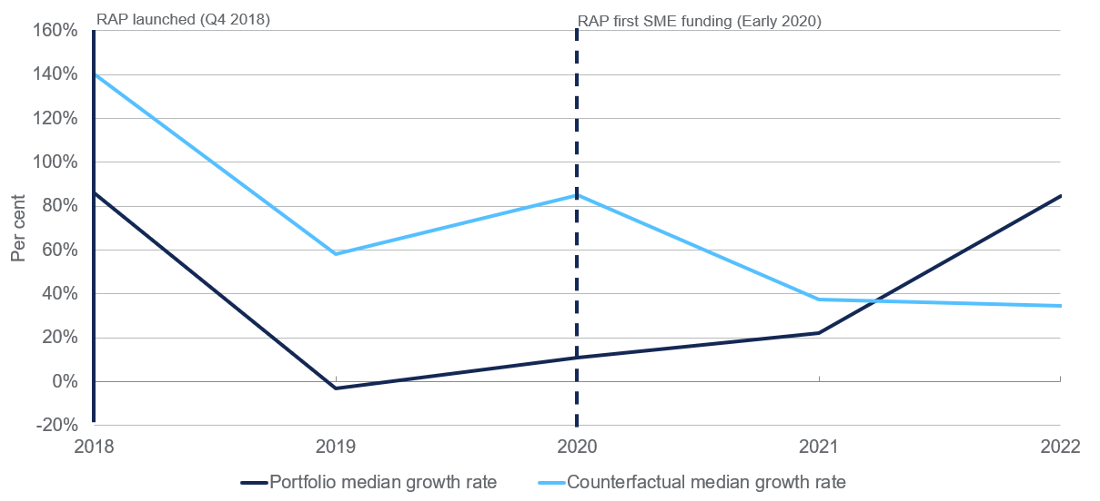
Source: IDBR, Beauhurst data. N = 84 for the funded firms and N = 58 for the comparator group
When examining turnover by region, it becomes evident that firms based in London and the South East experienced higher growth in 2022. However, RAP funded firms in the rest of the UK displayed an underperformance compared to the counterfactual group. In particular, the median growth rate for London and the South East exceeded 100%, while the median growth rates for other regions remained below 30%.

Figure 19: Median turnover growth rate by region, London and the South East (LHS), Rest of the UK (RHS)
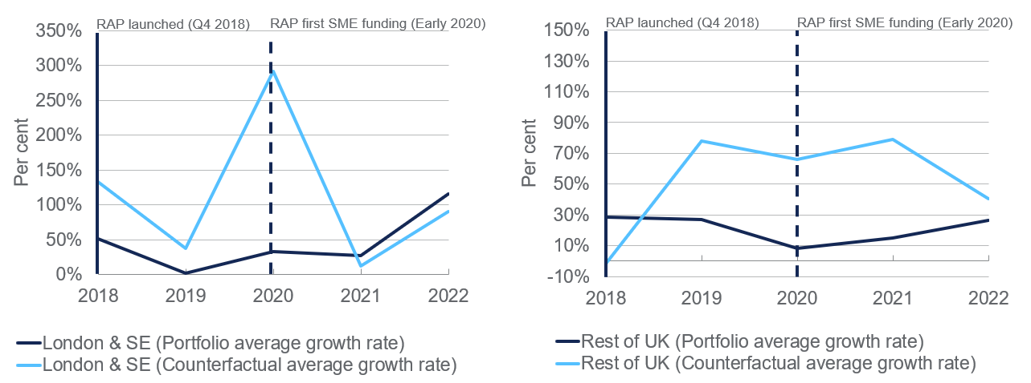
Source: IDBR, Beauhusrt data. N = 33 for London and South East funded firms, 25 for other regions and N = 25 for the London and South East comparator group and 59 for other regions

8.6 Employment trend proxy for business investment – salary payments/ IP production
Median employment for RAP funded firms demonstrated a stronger performance compared to the counterfactual group, with a growth rate of 24% in 2022 compared to a counterfactual growth rate of 14%. The median employment growth rate indicates even stronger relative performance outside of London and the South East, where it increased by 33% in 2022, outperforming the growth rate of the comparator group, which saw a mere 8% increase in 2022. In the London and South East group, the data shows a smaller gap between the two groups' relative performance, with RAP funded firms outperforming the counterfactual group with a 25% increase in employment in 2022, compared to an 18% increase for the comparator group. A similar picture emerges when analysing the 2022 performance of London RAP-funded firms compared to those in the rest of the UK.
These findings suggest that the RAP may have contributed to increased effective/de-facto investment activities for funded firms, including talent recruitment, salary payments, and intellectual property development. However, it is important to note that it is still too early to draw definitive conclusions, as the full effects of the RAP may take more time to materialise in terms of turnover and other key indicators.
Figure 20: Median employment growth
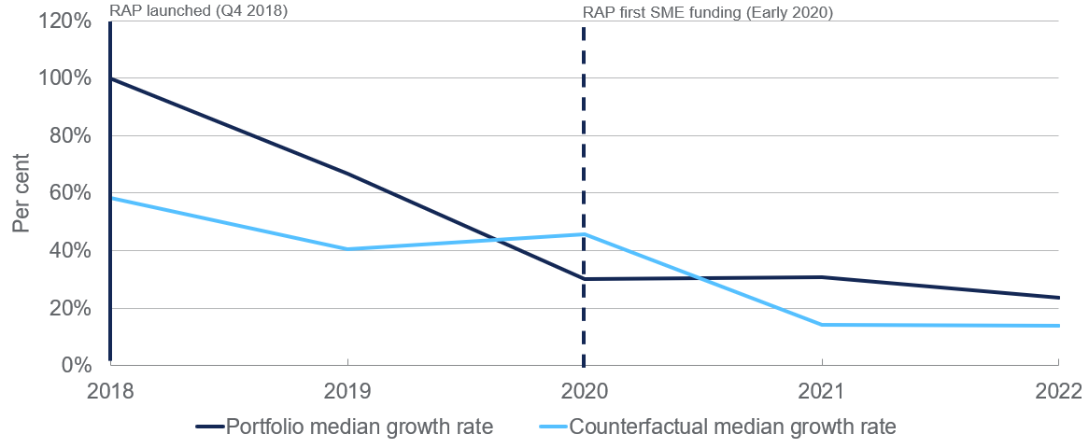
Source: IDBR, Beauhurst data. N = 84 for the funded firms and N = 58 for the comparator group
Figure 21: Median employment growth, by region, London and the South East (LHS), Rest of the UK (RHS)
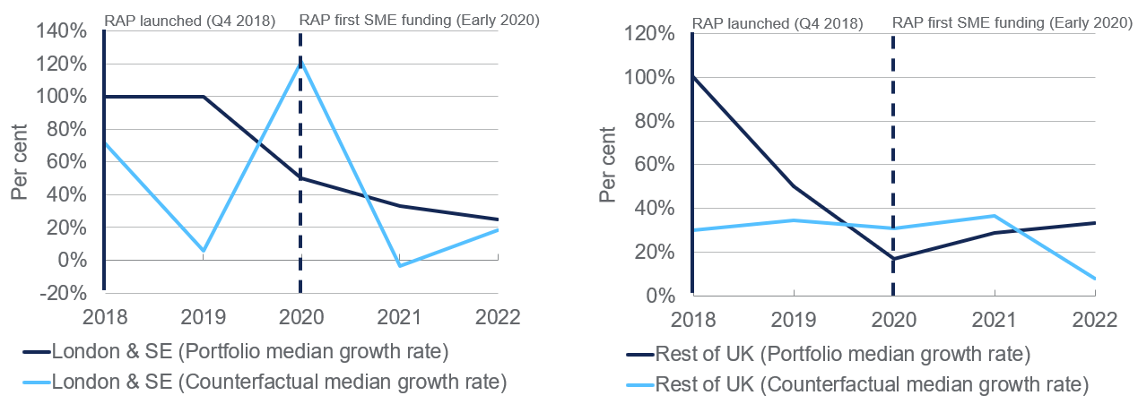
Source: IDBR, Beauhurst data. N = 33 for London and South East funded firms, 25 for other regions and N = 25 for the London and South East comparator group and 59 for other regions

8.7 Value for Money assessment
To assess Value for Money (VfM) we can look at the four E’s model – Efficiency, Effectiveness, Equity, and Economy. We have identified preliminary evidence and the type of data that can be used in future Value for Money assessments.
8.7.1 Efficiency
The Partner journey was referred to as positive, but Partners described the application process as rigorous and time consuming, lasting over a year in some cases. As such, the possibility of streamlining the process, without losing its effectiveness, should be investigated.
To the best of our knowledge, funding has been provided in accordance with the terms agreed with British Business Investments.
8.7.2 Effectiveness
In reviewing progress made against the programme Theory of Change, we find that planned activities have taken place and expected outputs have been realised. As envisaged, a substantial proportion of funding has gone towards early-stage SMEs in underrepresented regions. We find that the Programme has helped unlock investment and funded firms have been able to leverage future funding.
The added value of continued advice and support from investors over the next period will need to be captured as part of future evaluation activity. This will require looking at how the Partners are supporting companies to meet technological advancement and innovation and secure ownership of such innovations. We have no data on any Intellectual Property developments that have been realised due to RAP.
8.7.3 Equity
Equity can be assessed in terms of the regions (i.e., was access facilitated to firms in all underrepresented regions?), female leadership and representation of ethnic minorities of the funded firms, and diversity in Partners.
Pockets of funding have gone towards more established firms as well as to firms in regions that are represented in the angel investment space. With almost 21% of the £212m (BBI commitment only) having gone to London based firms, it is not clear how these investments aligned with the Programme scoring, and the amount in consideration is substantial. There may be scope for a future programme/ funding to restrict access to (larger) firms based in the London region (for example) to ensure greater equity. There may also be scope to ensure the portfolio of Partners can represent all regions of the UK appropriately.
Partners have said that the Programme has enabled them to engage with SMEs based in underrepresented regions and have supported these firms in their growth journey, and this may not have happened without the Programme.
Future evaluation is needed to investigate if this Programme has encouraged investors to increase their presence in underrepresented regions over the long term and if it has freed up financial means to invest more in such areas. The Programme was acknowledged by some interviewees to have made a difference to place-based developments, and more data will need to be collected to see if any impact place is sustained and enabled the creation of a local dynamic ecosystem where there is no need for future RAP funding.
Case study C: Investment Director, RAP Partner B
As a result of the Partner’s involvement in the RAP scheme, its average investment amount increased substantially, growing from around £125k to £215k per round. Additionally, the average total funding rounds per company increased from £500k to £1m. This highlights the positive impact of the scheme on the Partner’s ability to invest in early-stage companies, with this having a transformative impact.
“[RAP] funding has had a transformative effect in catalysing the angel investment ecosystem in [the region] over the last 2 years.”
RAP funded firms included representation from female founders and directors and ethnic minorities. Counterfactual firms sourced from the Beuahurst database had no data on inclusion metrics beyond gender and ethnicity as described below. The diversity of firms is greater in London and the South East (20%-25%) compared to other regions (14%-18%). Between 9% and 12% of the firms funded are female dominated and 8% is dominated by representation from ethnic minority groups.

Table 7: Diversity in leadership of RAP funded firms
 | Female Founders | Female Directors | Female Key People | Female Directors | Ethnic Minority
Source | Beauhurst  (n = 318) | Beauhurst  (n = 301) | Beauhurst  (n = 316) | Monitoring information  (n = 372) | Monitoring information  (n = 276)
London & South East | 21.8% | 21.5% | 25.3% | 25.6% | 20.6%
Rest of the UK | 18.4% | 14.1% | 18.4% | 17.7% | 9.6%
National | 19.9% | 17.5% | 21.4% | 20.9% | 13.8%

8.7.4 Economy
Direct economic benefits - We have collected early evidence that the expected short-term outcomes are in reach. Encouragingly, we find that only a small proportion (1.6% - 6 of 372) of the businesses have failed to date.
Evidence from secondary data analysis suggests that the funded firms have grown in turnover and in terms of fundraising value. A longer-term analysis of firms’ development relative to firms’ initial growth stage is needed to fully understand the extent to which the RAP funded firms are outperforming other firms that did not benefit form RAP funding. We have looked at turnover growth until 2022, which is only shortly after the firms benefit from RAP funding and thereby, the programme can only have had a limited impact on company performance.
Indirect economic benefits - The Programme also aims to generate additional regional economic output to the UK economy. It can do this through the dissemination of knowledge gains made possible because of RAP investment. It can also realise this when the economic success of the companies that benefitted spill over to other businesses. Estimations from Samila and Sorenson using a panel data set with US based firms show that increases in venture capital have a positive effect on the creation of new firms, employment and income in the region and these positive regional effects outweigh the cost of the venture capital investment.
The total economic benefits will need to be compared to the total cost.
Cost - The total cost of the Programme is £533.5m thus far. This includes the funding provided by the British Business Bank to the Programme beneficiaries, the total co-funding costs from Partners participating in the scheme and running costs from year 2020 to 2022. As part of a full CBA this should be discounted at 3.5% or an appropriate rate. This has not been carried out in the calculations below.

Table 8: Overview of available costs for RAP as of Q2 2022
Cost item |  | £m
BBI investment from 2020 – June 2022 |  | £59.5
Delivery partners investment from 2020 – June 2022 |  | £163.5
Running costs from 2020-2022 |  | £3.5
Third party funding |  | £307
Selective total costs |  | £533.5
Source: British Business Bank Regional Angels Programme MI data and Regional Angels Programme cost data

8.7.5 Requirements for a full VfM
There are a number of additional factors to be considered for a full VfM of the RAP. These stem from the economic transmission channels present within the ToC as shown in Figure 1 above. The key requirements are:
- Sufficient amount of time to pass for impacts to feed through to longer-term variables – turnover/ GVA (changes in productive capacity)/ Employment (job creation benefits)/ Average wages (to be used to derive GVA per firm) for the firms receiving funding.
- Sufficient time needs to pass to see whether there is evidence of the funding ecosystem taking place in the specific regions.
- Data on yearly allocations of government funding and private sector funding – share from private and public sources per RAP funded firm.
- Discussions on the appropriate time horizon to estimate impacts.
- Stream of dividend payments to Partners and government – can be used as a proxy or signal for yearly private sector returns and funds that can be redeployed by the government in other schemes to generate further added economic value.
- Tax revenue calculations based on increased economic activity measured through GVA and additional job creation.
- Time series of business closure data (administrations/ insolvencies). This data was extracted from Beauhurst but given the scheme is in the early stages, we would need to observe developments over time to forecast expected business closure rates – cost of the scheme in terms of investment write-off.
- Further evidence gathered on potential displacement of investment flowing to the regions. The modelling results within this report suggests there was a funding uplift across the regions. This could be confirmed with follow-up qualitative research or further econometric modelling.

8.7.6 Steps taken to conduct the RAP CBA
Obtaining the additional data above would provide a basic amount of input data, in addition to the currently available data on scheme monitoring and administration costs, to estimate the net present value of the RAP scheme.

Costs
Cost data should be spread over an agreed time horizon (intervention at time t to t+10, for example). In-line with Green Book best practice it is advised a 10-year time horizon is adopted. This is due to the economic property of diminishing marginal returns from the initial RAP investments. Data currently available on scheme design and running costs are available but should be reviewed for accuracy and updated if other costs have emerged.
Other costs of the scheme would be forgone investment with the funds that have gone to RAP. A baseline comparator to the RAP matched funding will need to be identified.
Administrations, insolvencies and value declines should be used as additional financial losses of the scheme and projected over the t+10 horizon, using actual outturns for the years post funding where the data is available.
Once these costs have been established, the standard Green Book assumptions would apply to the discounting costs to the present value (e.g., real 3.5% discount rate). This incorporates the social time preference (placing greater value on consumption today (t) compared to in the future (t+n)) as well as the wealth effect (the desire for income smoothing over an individual’s lifetime).

Benefits
The benefits from the RAP scheme can be derived through the ToC. The primary benefit would be the additional GVA produced through unlocking productivity across the regions through increased economic output and job creation. This would be calculated through running a PSM-DiD model on a national scale to estimate the additional turnover performance for RAP funded firms. The coefficient derived in the model for additional turnover can be used as primary input into GVA calculations.
To model the future expected GVA benefits, one could add a dynamic modelling approach to the PSM-DiD coefficient. This would entail applying time series econometric modelling techniques. Synthetic counterfactuals can be used, derived through macroeconomic funding variables (BoE SME fundraisings for example), to model the funding trajectory over a ten-year horizon. Other macroeconomic variables can be used, together with time series modelling techniques (ARIMA) to project benefits.
Other benefits would include additional job creation and associated social wellbeing benefits, tax payments etc.
A similar present value calculation would be applied to the one described in “Costs”.

Final VfM calculations
The final step would be to calculate the Net Present value (NPV) by subtracting the sum of the present value of costs from the sum of the present value of benefits.
Other representations such as benefit cost ratios can provide a per unit comparison i.e., a benefit of £x for every £1 of RAP funding.

9. Lessons learnt and recommendations

9.1 Lessons learnt and recommendations
For the most part, RAP angel investors were satisfied with the application process. However, some did highlight its complexity and stakeholders suggested this could be simplified, while balancing out appropriate risks for taxpayer funds. We found that the requirement for FCA regulation limited participation to more developed angel groups. Partners, including some who were satisfied with the application process, described it as rigorous and time-consuming, lasting over a year in multiple cases. However, there is early evidence to indicate British Business Investments has refined its due diligence process over time with later cohorts of applicants indicating more positive feedback and understanding of the process. We recommend that British Business Investments continues to refine the due diligence process in future to increase reach, while balancing out appropriate risks for taxpayer money. The British Business Investments should explore alternative avenues that can ensure quality in the selection but impose a lower barrier to investors. If FCA regulation is needed, British Business Investments could look to provide other support to investors to become FCA regulated and/or identify alternative means for investors that are not directly FCA regulated to work in partnership with those that are. It must be noted that various investment models are being explored to be more flexible around this requirement for perspective investors.
RAP aimed to encourage angel investment in firms in underrepresented regions. The Programme’s flexible eligibility criteria did not provide a hard requirement for the trading location of where investors are based or provide any caps on investment in London areas. While RAP has shown signs of achieving and encouraging investment outside of London and the South East – BBI angel investment has gone towards c.28% of firms that are based in London and the South East – performing favourably compared to other schemes and the angel market, there is potential for adding further guidance to encourage a greater proportion of investment to be made outside of London. British Business Investments can look to reinforce expectations and strengthening collaborations with existing Partners in the future to ensure they align with the Bank’s goals; as well as working with Partners that have a presence and focus on supporting start-ups and firms outside London in order to extend its reach and support businesses beyond the Capital.
The evidence shows that there could be a more clearly defined funding gap in underrepresented regions and a need for intervention. A comparison of the impact on growth in funding provides some/weak evidence suggesting that firms outside of London benefit more from the programme. Altogether, there is potentially greater additionality and Return on Investment from supporting angel investors and firms based outside London, the South East and other more affluent areas. Reinforcing the regionality angle of the programme can help build a case for continued support from Treasury. Such a case needs to be defined in view of the demand for investment in underrepresented regions and possible need for additional support action, as well as a profiling of risk and external mitigating factors.
One of the main considerations is the timing of impacts. It will take some time to grow an ecosystem meaning there will be a short-to medium term (at least) need for continued support to ensure a commercial rate of return can be experienced and sustained. This support will help to professionalise the market and set a standard required for early-stage equity investment across the UK. This will likely allow investors to continue to invest in other firms and support potentially viable business ventures in underrepresented regions across the UK. Given the scheme is still in the relatively early-stages, government support should be continued and a consideration for increasing the amount of investment in the subsequent tranches.

Annexes

Annex A: Research Tools

A.1 Interview Topic Guides

A.1.1 RAP Partner interview guide
Background
1. Can you please give a brief overview of your syndicate?
2. Can you tell us about your track record/experience of angel investing, with a focus on equity investments in SMEs?
Motivations for applying to RAP
3. Thinking about where the SMEs you have invested in are based, what are the challenges and opportunities associated with investing in SMEs / early-stage businesses?
4. Before applying for RAP funding, how difficult was it to find co-investors?
5. Can you tell us how you heard about the British Business Investments RAP scheme and what prompted you to apply?
6. What was the impact of deciding to apply for RAP on relationships with co-investors within your syndicate?
7. Have you previously applied/thought of applying to any other government-backed schemes?
8. Have recent economic events like Covid/cost of living crisis/fiscal instability prompted you to look to these government backed schemes?
Experience of the application process
9. Can you tell us about your overall experience with the RAP application process?
10. Can you recall if the terms and conditions around the funding were proportionate/appropriate?
10a. Can you tell us about your experience of British Business Investments’ due diligence process?
Experience of RAP
11. Can you tell us about your experience of reporting on your investments to British Business Investments?
12. Can you tell us about the level of engagement of British Business Investments personnel since receiving funding?
13. Can you tell us about your experience of seeking out investment opportunities with the RAP funding?
14. Can you describe your experience of making investments in SMEs with RAP funding?
14a. Thinking about your overall portfolio, can you describe at what stage companies are usually at when you invest in them?
Impact of investments
15. Once you received RAP funding, can you tell us about the impact of the funding on your angel syndicate?
16. In the absence of the RAP scheme, would you still have invested in the SMEs?
[IF WOULD HAVE INVESTED ‘LESS/NOTHING’ IN Q16]
16a. Why would you not have invested in the SMEs?
[IF WOULD HAVE INVESTED THE SAME IN Q16]
16b. Why would you have invested the same?
17. Thinking about your overall portfolio, to what extent did RAP support help SMEs you invested in in achieving their short-term and long-term goals?
18. Thinking across your portfolio, can you describe how SMEs intended to use the investment and if this changed once you provided the funding?
18b. Which of the following would be the main activities that companies in your portfolio engaged in after they received the funding?
19. Based on the performance/projected performance of your portfolio, would you say RAP improved investment outcomes in terms of expected returns for the companies/portfolio?
Legacy of RAP
20. Thinking about the wider angel investing landscape, has RAP addressed/potentially addressed these challenges in the long run?
21. Given that RAP is expected to continue in the future, what would you expect its lasting legacy to be?
22. If another scheme like RAP was offered in the future, would you consider applying again?

A.1.2 RAP team interview guide
Background
1. Can you please give a brief overview of your role?
Setting up the RAP
2. RAP was set up following the 2017 Autumn Budget in response to research that highlighted the continued challenges faced by early-stage firms in under-funded regions of the UK in accessing finance. To what extent do you agree with the rationale at the time the scheme was set up?
3. Were there any changes to the programme objectives or delivery either during the design stage or to the present?
4. Can you tell us about how the RAP opportunity was promoted to potential applicants?
5. What, if any, consultation work was done with angel investor syndicates/SMEs in underfunded areas to inform the design of the programme?
6. What, if any, consultation work was done with other government stakeholders / departments to inform the design of the programme?
7. What other, if any, sources of support were available at the time of programme setup to encourage investment in SMEs in under-funded areas?
Design
8. How appropriate is the design of the RAP scheme in increasing the aggregate amount of early-stage equity capital that is available to small businesses in underfunded regions in the UK?
The application process
9. Has the RAP attracted as many applicants as you expected?
10. Can you tell us about the due diligence process conducted on applicants?
11. Can you tell us how the regional focus of the fund is applied to your decision-making process for applicants?
12. Can you give some examples of any best practice and learning from the application process?
Delivering the RAP
13. Have there been any issues that arose during the rollout and monitoring processes?
14. Can you describe the governance process for the RAP and any reflections on how this worked in practice?
15. Can you tell us about your experience of engaging with investors once funds had been distributed to delivery partners?
16. How effective were the risk management processes for the RAP?
Performance
17. Are equity investments made by angel investors in line with your expectations around target market and return on investment at this point in the scheme?
Impact of investments
18. Can you tell us about your initial thinking around how the RAP was intended to influence deal flow in the short and long-term?
19. Have you seen evidence of the effectiveness of investors selected to participate in RAP?
20. Do you think recipients would have been able to obtain funding from other sources without RAP? Please explain.
Legacy of RAP
21. Thinking about the wider angel investing landscape, do you feel that RAP has encouraged other investors to take risks/invest in patient capital in both the short and long term?
22. Given that RAP is expected to continue in the future, what would you expect its lasting legacy to be?

A.1.3 Policy stakeholder interview guide
Background
1. Can you please give a brief overview of your role?
2. Can you describe your role in the setup and delivery of the RAP scheme?
Policy landscape
3. RAP was set up following the 2017 Autumn Budget in response to research that highlighted the continued challenges faced by early-stage firms in under-funded regions of the UK in accessing finance. To what extent do you agree with the rationale at the time the scheme was set up?
4. Can you tell us about any existing policies in 2018 that were intended to support investment in early-stage SMEs in underfunded areas in the UK?
5. How, if at all, did RAP complement or act as a substitute for other forms of support available to investors and SMEs?
Design
6. How appropriate was the design of the RAP scheme in increasing the aggregate amount of early-stage equity capital that is available to small businesses throughout the UK?

7. What was the target market of businesses in your view? Did other HMG stakeholders have the same view?
8. What was the extent to which your department was involved in any consultations during the setup phase of RAP?
9. Can you tell us how and to what extent the need to address regional inequities in funding factored into the decision-making process for designing the RAP scheme?
Legacy of RAP
10. What would you say are the key lessons learned from the design of RAP?
11. Given that RAP is expected to continue in the future, what would you expect its lasting legacy to be?

A.1.4 Industry body stakeholder interview guide
Background
1. Can you please give a brief overview of your individual role?
Awareness of RAP and uptake with membership
2. Have you heard about the British Business Investments RAP scheme?
3. How aware were your membership of the RAP scheme?
4. How effectively did BEIS / British Business Investments engage with industry stakeholders (Chambers of commerce, Angel Associations etc) in terms of:
- Market engagement with industry and investors both before RAP scheme launch and over the course of its delivery?
- Raising awareness of the scheme amongst the investment community?
- Providing clarity regarding the application process
5. How does RAP compare to other government-backed schemes that were/are available to your members?
Feedback on RAP design
6. Can you share any reflections on how appropriate the overall design of the RAP scheme was in increasing availability of finance to small and early-stage businesses in under-funded regions?
Experience of investors with RAP
8. What other competing sources of funding are available to your members compared to RAP? Please explain.
9. Based on your understanding of the design of the scheme, would you say RAP improved investment outcomes for investors and SMEs?
10. Do you think that RAP runs the risk of displacing other investment/fund manager activity?
Legacy of RAP
11. Thinking about the wider angel investing landscape, do you feel that RAP has encouraged other investors to take risks/invest in patient capital?
12. If another scheme like RAP was offered in the future, would you consider signposting to your membership?
13. Given that RAP is expected to continue in the future, what would you expect its lasting legacy to be?

A.1.5 Non-Applicant interview guide
Background
1. Can you please give a brief overview of your syndicate?
2. Can you tell us about your track record/experience of angel investing, with a focus on equity investments in SMEs?
3. Have you heard about the British Business Investments RAP scheme? Have you heard of other schemes similar to RAP?
[IF NO TO Q3 PROMPT AND THEN GO TO Q5]
[IF YES TO Q3]
4. Did you apply or consider applying to the scheme?
[IF YES TO Q4 – TERMINATE THE INTERVIEW]
[IF NO TO Q4]
4a. Why did you decide not to proceed with the application?
5. Have you previously used any other government-backed schemes after October 2018?
6. Have recent economic events like Covid/cost of living crisis/fiscal instability prompted you to look to these government backed schemes?
[ALL] Experience of investing in SMEs
9. Thinking about your overall portfolio, can you describe at what stage companies are usually at when you invest in them?
10. Can you describe your experience of making investments in SMEs, particularly those in the early stages of growth?
11. Thinking about your current portfolio, can you describe how SMEs intended to use the investment and if this changed once you provided the funding?
11a. Which of the following would be the main activities that companies in your portfolio engaged in after they received the funding?
12. Can you tell us about any factors that would help make you/your syndicate consider investing in or investing more in early-stage SMEs?
13. Can you tell us if there is any type of government-backed scheme that which would encourage you to invest in regional enterprises (outside of London and the South East) you would not have otherwise?
Impact of investments
14. Based on your experience of angel investing/patient capital, could you suggest some ways the government could support investment outcomes for SMEs in underfunded areas through investors like yourself?
[IF YES TO Q4] Legacy of RAP
15. Thinking about the wider angel investing landscape, do you feel that RAP, or similar government schemes, has encouraged other investors to take risks/invest in patient capital in the long-run?
16. What do you think the long-run funding ecosystem will look like for early-stage SMEs in the future?

A.1.6 RAP unsuccessful Applicant interview guide
Background
1. Can you please give a brief overview of your syndicate?
2. Can you tell us about your track record/experience of angel investing, with a focus on equity investments in SMEs?
3. Thinking about where the SMEs you have invested in are based, what are the challenges and opportunities associated with investing in SMEs / early-stage businesses?
Motivations for applying to RAP
4. Before applying for RAP funding, how difficult was it to find co-investors?
5. Can you tell us how you heard about the British Business Investments RAP scheme and what prompted you to apply?
6. How important was it for you to secure RAP funding?
7. What was the impact of deciding to apply for RAP on relationships with co-investors within your syndicate?
8. Were you able to secure other sources of funding?
9. Have recent economic events like Covid/cost of living crisis/fiscal instability prompted you to look to these government backed schemes?
Experience of the application process
10. Can you tell us about your overall experience with the RAP application process?
11. Do you think the feedback from British Business Bank/British Business Investments on why you were unsuccessful was appropriate/informative?
12. Can you recall if the terms and conditions around the funding were proportionate/appropriate?
13. Can you tell us about your experience of British Business Investments’ due diligence process?
Experience of investing in SMEs
14. [SKIP IF COVERED IN Q3] Thinking about your overall portfolio, can you describe at what stage companies are usually at when you invest in them?
15. Thinking about your current portfolio, can you describe how SMEs intended to use the investment and if this changed once you provided the funding?
15a. Which of the following would be the main activities that companies in your portfolio engaged in after they received the funding?
16. Can you tell us about any factors that would help make you/your syndicate consider investing in or investing more in early-stage SMEs?
17. Can you tell us if there is any type of government-backed scheme that which would encourage you to invest in regional enterprises (outside of London and the South East) you would not have otherwise?
Legacy of RAP
18. Thinking about the wider angel investing landscape, do you feel that RAP, or similar government schemes, has encouraged other investors to take risks/invest in patient capital in the long-run?
19. What do you think the long-run funding ecosystem will look like for early-stage SMEs in the future?

A.2 Small Business Survey

Survey data obtained from the Small Business Survey was not utilised in the quantitative analysis due to a low response rate, rendering it unsuitable for inclusion as it did not provide a representative and accurate sample for statistical analysis.
Background and Context
Firstly, about your organisation…
ALL
1. What is the name of your business?
ALL
2. What is the ethnic composition of your company’s management team? Does it include people from any of the following ethnic groups?
PLEASE CHECK ONE
White, includes any White background | 1
Mixed or multiple ethnic groups, including White and Black Caribbean, White and Black African, White and Asian, or any other Mixed or multiple ethnic group | 2
Asian or Asian British, including Indian, Pakistani, Bangladeshi, Chinese or any other Asian background | 3
Black, African, Caribbean or Black British, including African, Caribbean or any other Black background | 4
Other ethnic group, for example, Arab or any other background | 5
Don’t know | 6
Prefer not to say | 7

ALL
3. What is the gender composition of your company’s management team? Please add a value for the proportion of the fields below.
RESPONSES TO SUM TO 100%
PLEASE CHECK ONE
Male | %
Female | %
Other | %
If you don't know or prefer not to say, please type "Don't know" or "Prefer not to say" below:

ALL
4. In which region of the UK is your company located?
PLEASE CHECK ONE
West Midlands | 1
East of England | 2
Scotland | 3
London | 4
North East | 5
Northern Ireland | 6
Wales | 7
Yorkshire and The Humber | 8
East Midlands | 9
South West | 10
South East | 11

ALL
5. Which of the following descriptions best describes the stage the company was at when you received funding from your Investor?

PLEASE CHECK ONE
A company that had not yet made substantial commercial sales. | 1
A company that had been around for less than 3 years. Sales were growing rapidly but the company was not yet profitable. | 2
A company that had been around for more than 3 years. Sales were growing rapidly but the company was not yet profitable | 3
A more established company with steady revenue streams (some of which may have been profitable). | 4
An established business seeking funding to help recovery/turn around | 5
Other – please write in | 6
Don’t know | 99

Pre-Financing Environment
ALL
6. How was the funding environment before you engaged with your Investor?
PLEASE CHECK ONE
Very difficult | 1
Fairly difficult | 2
Neither difficult/nor easy | 3
Fairly easy | 4
Very easy | 5
Don’t know | 99

ALL
7. How did you come across your Investor?
PLEASE CHECK ONE
Have previously been financed by the Investor | 1
Prior relationship (other than being funded) | 2
Directly contacted by the Investor | 3
Directly contacted the Investor yourself | 4
Online research (AngelList for example) | 5
Associations (Angel Investor Association, Gust, etc.) | 6
Networks | 7
Social media | 8
Friends and/ or family introduction | 9
Other, please write in | 99

ALL
8. Before 2019, did you previously know your Investor?
PLEASE CHECK ONE
Yes | 1
No | 2
Don’t know | 99

ALL
9. In terms of the investment you received from your Investor after 2019, which of these options is most applicable with regards to the timing of the funding?
PLEASE CHECK ONE
The funding became available around the same time that we were looking for funding. | 1
We had been looking for funding 12+ months earlier. | 2
We had been looking for funding 6 – 12 months earlier. | 3
We had been looking for funding 3 – 6 months earlier. | 4
We were planning on raising funding in the subsequent 3 – 6 months. | 5
We were planning on raising funding in the subsequent 6 – 12 months. | 6
We were planning on raising funding 12+ months in the future. | 7
We weren’t looking for funding at all. | 8
Other, please write in | 98
Don’t know | 99

ALL
10. Did Covid-19 have an impact on raising funding through your Investor?
PLEASE CHECK ONE
Covid-19 encouraged me to raise funding | 1
Covid-19 had no effect in raising funding | 2
Covid-19 made me less likely to receive funding | 3
Don’t know | 99

ALL
11. Before receiving funding from your Investor, how difficult did you find it to raise equity finance within your region of the UK?
PLEASE CHECK ONE ONLY
Very difficult | 1
Fairly difficult | 2
Neither difficult/nor easy | 3
Fairly easy | 4
Very easy | 5
Don’t know | 99

ALL
12. What type of external funding sources, if any, was your company using prior to receiving funding from your Investor, if any?
By using, we mean there was a funding facility in place, even if not drawn down, or funding previously received from an equity investor.
PLEASE CHECK ALL THAT APPLY
Credit cards | 1
Equity funding from business angel (not from your Investor) | 2
Equity funding from crowdfunding platform | 3
Equity funding from Venture Capitalist or Private Equity | 4
Equity funding from another investor | 5
Invoice finance or factoring | 6
Leasing or hire purchase (asset-finance) | 7
Loans from directors, other individuals, organisations [can include loans from friends] | 8
Loans/mortgage from banks and other organisations | 9
Government backed loans | 10
Personal funds from owner(s) and/or any director(s) | 11
Revolving credit facility or bank overdraft | 12
Other [Please write in] | 13
None | 14
Don’t know | 15

ALL
13. Aside from the above, what sources of external funding did you seek or apply for but were unsuccessful in securing immediately prior to receiving funding from your Investor?
PLEASE CHECK ALL THAT APPLY
Credit cards | 1
Equity finance (equity from directors, individuals, friends, family, crowd funding platforms, Venture Capital or other investment organisations) | 2
Government backed loans such as Bounce Back Loan Scheme (BBLS), Coronavirus Business Interruption Loan Scheme (CBILS), etc. | 3
Invoice finance or factoring | 4
Leasing or hire purchase (asset-finance) | 5
Loans from directors, other individuals, organisations [can include loans from friends] | 6
Loans/mortgage from banks and other organisations | 7
Other government backed schemes such as the Angel CoFund, the Enterprise Investment Scheme (EIS) and the Seed Enterprise Investment Scheme (SEIS), the Future Fund, DCMS supported Creative Scale Up Programme, UKBAA / SETsquared funded Angel Investment Accelerator, etc. | 8
Personal funds from owner(s) and/or any director(s) | 9
Revolving credit facility or bank overdraft | 10
Applied/sought other finance – please write in | 11
Had not applied for/sought any | 12
Don’t know | 13

ALL
14. Please select from the following list any government backed loans / scheme that you received funding or assistance from (Please select Not Applicable if you have not received any Government funding).
PLEASE CHECK ALL THAT APPLY
The Angel CoFund | 1
The Enterprise Investment Scheme (EIS) / The Seed Enterprise Investment Scheme (SEIS) | 2
The Coronavirus Job Retention Scheme | 3
Statutory Sick Pay Rebate Scheme | 4
VAT Payments Deferral Scheme | 5
Business Rate Relief Due to Coronavirus | 6
COVID-19 Corporate Financing Facility | 7
Bounce Back Loan Scheme, Coronavirus Business Interruption Loan Scheme | 8
Self-Employment Income Support Scheme | 9
UKRI / Innovate UK funding | 10
Innovate UK’s SMART Competition | 11
DCMS supported Creative Scale Up Programme | 12
DCMS funded London Office for Rapid Cybersecurity Advancement (LORCA) | 13
Innovation Grants to Creative Industries Tax Reliefs | 14
R&D Tax Credits (SME R&D Tax Relief and the RDEC) | 15
Patent Box | 16
The Prince's Trust Enterprise Programme | 17
UKBAA / SETsquared funded Angel Investment Accelerator | 18
Other schemes promoted by the UKBAA such as the partnerships with Amazon Web Services | 19
Patient Capital Fund | 20
Other [Please specify]: | 98
Not applicable – have not received Government funding | 99

ALL
15. Prior to 2019, do you think you would have been able to obtain similar private sector funding compared to peer firms in your region of the UK?
PLEASE CHECK ONE ONLY
Yes, definitely | 1
Yes, probably | 2
My ability to obtain finance would be similar to my peers | 3
No, probably not | 4
No, definitely not | 5
Don’t know | 99

IF ABLE TO FIND SIMILAR FINANCE ELSEWHERE (Q13 = 1, 2)
16. If you could have not raised funding from your Investor, how much funding do you think you would have been able to raise from an alternative investor?

PLEASE CHECK ONE ONLY
The same amount | 1
Would have raised more | 2
We would have raised less than 25% of the finance received from our Investor | 3
We would have raised between 25% and 50% | 4
We would have raised between 50% and 75% | 5
We would have raised between 75% and 99% | 6
Don’t know | 99

ALL
17. Did you plan to raise funding through, or were you approached by your main investor after 2019?
PLEASE CHECK ONE ONLY
Yes | 1
No | 2
Don’t know/prefer not to say | 3

Reasons for Applying
ALL
18. What motivated you and your business to seek angel investment?
PLEASE CHECK ALL THAT APPLY
Terms and conditions relatively attractive compared to other funding sources. | 1
Most suitable source of funding for the stage of the business | 2
Could not obtain sufficient finance from other sources/only funding available | 3
To reduce use of debt finance | 4
Existing investors pulled out/unwilling to invest sufficient capital | 5
Other [Please write in] | 98
Don’t know | 99

ALL
19. If you had not been able to access funding from your Investor, how likely is it that your business would have been able to access similar alternative sources of equity funding?
PLEASE CHECK ONE
Definitely would have been able to access alternative sources of finance | 1
Very likely | 2
Fairly likely | 3
Fairly unlikely | 4
Very unlikely | 5
Definitely would not have been able to access alternative sources of finance | 6
Don’t know | 99

ALL
20. If you had not been able to access funding from your Investor, how likely is it that your business would have permanently closed?
PLEASE CHECK ONE
Definitely would have closed | 1
Very likely | 2
Fairly likely | 3
Fairly unlikely | 4
Very unlikely | 5
Definitely would not have closed | 6
Don’t know | 99

ALL
21. Do you think your business would have achieved the same level of short to medium term growth without the funding received from your Investor?
PLEASE CHECK ONE
Definitely would have achieved the same level of growth | 1
Very likely | 2
Fairly likely | 3
Fairly unlikely | 4
Very unlikely | 5
Definitely would not have achieved the same level of growth | 6
Don’t know | 99
ALL
22. Do you think your business would have achieved / will achieve the same level of longer-term growth without the funding received from your Investor?
PLEASE CHECK ONE
Definitely would have achieved / will achieve the same level of growth | 1
Very likely | 2
Fairly likely | 3
Fairly unlikely | 4
Very unlikely | 5
Definitely would not have achieved / will achieve the same level of growth | 6
Don’t know | 99

ALL
23. Which of the following factors has the investment received from your Investor contributed to the most?
PLEASE CHECK ALL THAT APPLY
Reducing costs | 1
Similar speed of business growth past the early stages | 2
Reaching a level of profitability | 3
Going to market with products / services | 4
Moving from R&D to commercialisation | 5
Improving operational efficiencies | 6
Starting to build brand recognition | 7
Gaining market share | 8
Expanding offices/ areas of business production | 9
Attracting higher quality talent | 10
Other [Please write in] | 98
Don’t know | 99

ALL
24. How did you use and how did you intend to use the funding provided by your Investor?
PLEASE CHECK ALL THAT APPLY
Options | a) Actual use of funds | b)  Intended use of funds
Maintaining fixed assets |  |  | 1
Paying existing staff |  |  | 2
Capital used in day-to-day trading operations (other than paying staff or maintaining fixed assets) |  |  | 3
Recruiting new employees |  |  | 4
Maintaining research and development projects |  |  | 5
Starting new research and development or innovation projects |  |  | 6
Creating intellectual property |  |  | 7
Purchasing new fixed assets |  |  | 8
To fill cash flow gap from declining revenue |  |  | 9
Expanding your business |  |  | 10
Taking on new clients |  |  | 11
Expanding abroad |  |  | 12
Other [Please write in] |  |  | 98
Don’t know |  |  | 99

ALL
25. Since obtaining the funding from your Investor, has your business undertaken or planned to undertake any of the following activities?
PLEASE CHECK ALL THAT APPLY
Options | a)  Have undertaken | b) Planned to undertake
Adoption/expansion of digital technologies  Examples include: video conferencing, online marketing, social media, website for selling products or services, artificial intelligence, machine learning etc |  |  | 1
Research and development (R&D) activities (excluding R&D related to the environment) |  |  | 2
Actions to reduce your business’s carbon emissions (including R&D related to the environment)  Examples include: increased reliance on renewable energy, training staff on environmental matters, conducting R&D relating to the environment |  |  | 3
The development of new or modified processes or business models |  |  | 4
The development of new or modified goods or services |  |  | 5
Building business resilience  Examples include: ringfencing funds for emergencies, developing resilience plans or a risk register |  |  | 6
None of the above |  |  | 97
Other [Please write in] |  |  | 98
Don’t know |  |  | 99

Medium Term Process
ALL
26. Other than providing the financial support, what additional non-financial benefits did you receive from your Investor?
PLEASE CHECK ALL THAT APPLY
Investor networking opportunities | 1
Training/ Coaching | 2
Financial advice | 3
Taking up board positions | 4
Mentorship | 5
Facilitation of business-to-business networking | 6
Environmental, Social and Governance support | 7
Technical Expertise | 8
Strategic business support (usually from prior sector experience) | 9
Business ideas/ product development | 10
Providing business credibility for follow on investment | 11
None | 12
Other, please write in | 99

Funding Process
ALL
27. Please describe your experience of the relationship with your Investor for each of the following aspects by specifying the extent to which you agree or disagree with each statement:
PLEASE CHECK ONE PER ROW

 | Strongly disagree | Disagree | Neither agree or disagree | Agree | Strongly agree | Don’t know/prefer not to say
The length of time between first contact with your Investor and receiving funds was as you expected | 1 | 2 | 3 | 4 | 5 | 99
The amount of information required by your Investor to make the funding decision was appropriate | 1 | 2 | 3 | 4 | 5 | 99
Amount of time and effort required to apply for the funding was proportionate with its value | 1 | 2 | 3 | 4 | 5 | 99
Communications from your Investor were clear and prompt | 1 | 2 | 3 | 4 | 5 | 99
The Terms and Conditions of the funding are fair and appropriate | 1 | 2 | 3 | 4 | 5 | 99

Other Sources of External Funding
ALL
28. Which of the following angel funding sources are most accessible to your business?
PLEASE CHECK ALL THAT APPLY
Local angel investors located within your region | 1
Angel investors located outside your region (e.g., London, East Midlands, South West of England, etc.) | 2
Angel investors located within your specific nation (England, Wales, Scotland, Northern Ireland) | 3
UK wide angel investors | 4
Angel investor located outside the UK | 5
No access to angel investors before you received investment from your Investor | 6
Don’t know | 99

Business Impacts
We would now like to ask questions on if and how the funding has impacted your company.
ALL
29. Did the investment from your Investor lead to access to other sources of equity funding?
PLEASE CHECK ONE ONLY
Yes | 1
No | 2
Don’t know | 99

ALL
30. Do you expect the funding from your Investor to make funding conditions generally easier for the long-term?
PLEASE CHECK ONE ONLY
Yes | 1
No | 2
Don’t know | 99

ALL
31. Did the funding from your Investor broadly result in any of the following non-financial benefits?
PLEASE CHECK ALL THAT APPLY
Increased human capital (Skills, knowledge exchange, experience etc.) | 1
Peer support | 2
Access to business networks | 3
Intellectual Property support | 4
Links to other investors | 5
Access to new customers | 6
None | 7
Other non-financial support [Please specify]: | 98
Don’t know | 99

Re-contact
ALL
32. This survey forms part of an ongoing evaluation that the British Business Bank/ British Business Investments is conducting on the Regional Angels Programme. Would you be happy to be contacted by RSM UK Consulting LLP for some follow up questions regarding the impact of the funding received from your Investor for your company?
PLEASE CHECK ONE ONLY
Yes | 1
No | 2

Annex B: Regional Angels Programme eligibility criteria
The Management Case for RAP indicates that the preparation for the launch of the Programme and the planning for the British Business Investments Business Plan had been assigned to key British Business Investments team members such as the British Business Investments’ Director at the time and the British Business Investments’ CEO. The latter has been closely involved throughout RAP early implementation stages whilst the former has led the delivery team and has been supported by one of the team’s Senior Managers.
Over the months following the release of the Request for Proposals, published in autumn 2018, British Business Investments received proposals for funding, which were considered on a first come, first serve, basis. The investment selection and approval processes for angels that have applied for funding through the Request for Proposal Form follows four stages:
- Expression of interest – here the applicant angel should set out how their proposal for funding will promote the objective and satisfy the criteria for the Programme.
- Formal Proposal and Management Meeting – building on the applicant expression of interest, an applicant angel would be invited to submit a formal proposal and attend a management meeting, which will lead to a decision from British Business Investments on whether proceeding onto the due diligence process.
- Due Diligence – at this stage British Business Investments will be assessing the angel applicant’s business operations, financial standing, proposed investment strategy, organisational structure and track record in order to verify whether the angel’s proposal could achieve the objectives and expectations of the Regional Angels Programme. At this stage, British Business Investments also undertake background and referencing checks.
- Investment Committee – at this stage the British Business Investments assessment team submits a recommendation to British Business Investments’ Investment Committee whether they think an angel application would be likely to be approved. If the Investment Committee does approve the application, the successful angel will be issued a non-binding offers letter and heads of terms.
Table 9: Conditions for RAP funding applicants
Criteria title | Conditions
Target market | - Smaller businesses  - Areas of the UK currently underrepresented in provision of early-stage equity funding  - Funding to be deployed in individual investment rounds between £100k – £1.5m
Investment Strategy | - Investment activities must be angel-led and include involvement in underlying businesses i.e., mentoring  - Must focus on early-stage equity investment into firms in target market  - Clear framework of procedures from origination to management  - Detailed due diligence process for investments  - Robust valuation methodology  - Strategy to deploy £5m - £15m RAP funding within agreed timescales
Track Record and Expertise | - Must include experience of early-stage equity investments  - Track record of investors working together successfully  - Overall rate of return from investments  - Non-financial resources, skills and competencies
Origination | - Must include detailed origination strategy  - Deployment profile of commitments made under RAP  - Pipeline of near-term investment opportunities  - Approach to portfolio diversification and risk management
Commercial Returns and Remuneration | - Evidence that investments will generate a market rate of return  - Appropriate fees and costs associated with making investments  - Any proposed incentive schemes
Private Sector Leverage | - Evidence of investors’ ability to attract other private sector funding  - Mechanisms to attract and utilise funding from private investors that can attract the appropriate level and diversity of private sector funding  - Evidence of being able to source between 50-80% of each investment round from other sources
Portfolio Management | - Description of process when making investments in small businesses  - Process for managing a portfolio of small businesses including descriptions of  - how the investor would facilitate an exit  - support investees becoming financially distressed  - make follow on investments  - Manage potential sale of investments on secondary markets  - Evidence of robust monitoring processes for funded businesses and capacity to generate reports and information for British Business Investments
Operational Structure, Legal and Regulatory | - Evidence of compliance with British Business Bank’s group-wide tax policy  - Evidence of permissions, registrations and authorisations to provide a managed solution  - Ability to carry out due diligence on other investors  - Compliance with GDPR and data protection laws
Source: British Business Investments – Request For Proposals for the Regional Angels Programme, British Business Bank

Annex C: Theory of Change
This section includes the Theory of Change which illustrates how the Programme intends to achieve outcomes over its lifecycle (and beyond), and the Data Sources which lists detailed individual indicators for each level of the ToC, along with how they will be measured and analysed.

C.1 Theory of Change
The ToC was developed based on the RAP objectives, an evidence review and the ITT. In line with good practice, we also included the activities linked to delivery of the RAP scheme. It includes short, and longer-term outcomes, as well as outputs, inputs and activities that are likely undertaken over the policy life cycle. Furthermore, we have designed it to illustrate causal links between the Programme and the desired outcomes.
The ToC identifies the economic transmission channels through which we have based the evaluation.
In addition to the Key Performance Indicators highlighted in grey, one (longer-term) outcome expected to be realised through the Programme is regional development. This is also at the heart of the Government’s levelling up agenda,.
- Increase regional competitiveness.
- Improvement in regional productivity through investment in research and development of high-growth potential firms across the UK
- Stimulate regional output and job creation where high-growth potential businesses grow and nurture new talent in regions across the UK.
- Creation of new or sustained business-investor networks and a dynamic ecosystem that does not require further government intervention. Investors play a key role to
  - Facilitate networking between high-growth firms and those just starting up.
  - Provide means to train and develop start-up/ scale-up firms who are new to the business world.
Moreover, the Programme was expected to indirectly facilitate growth of firms who have some association to environmental or social causes through their business operation, supporting the global agenda on climate change. ESG is favoured by British Business Investments on investors’ portfolios.

Figure 22: RSM RAP Theory of Change

C.2 Evidence Sources
The ToC used to develop indicators which will measure and assess performance against the ToC depending on the quality of the data and research tool outputs. In line with good practice, an evaluation approach was designed that has, for most indicators, at least two sources. This approach provided a robust evidence base which allows for triangulation of data sources and a combination of analytical techniques, including:
- Management Information (MI) data – used to obtain descriptive statistics of the RAP funded firms and inform the portfolio analysis which details an overview of characteristics of firms such as gender and ethnicity distribution, sector, and magnitude of turnover and employees.
- Secondary data sources – IDBR and Beauhurst database was used as the main secondary data sources. The former allowed us to complete a high degree of matching on RAP funded firms’ characteristics whilst the latter contained detailed equity information that was validated through primary research tools and MI data provided by the British Business Bank. Other data sources such as the RSM internal platform Tracker as well as Orbis by Bureau Van Dijk, supplemented by Companies House data were used for further matching/linking purposes.
- Econometric modelling – given the data analysis completed to date, we proposed a difference-in-difference modelling approach identified as the most appropriate quasi-experimental evaluation method. The pre-filtered funded and counterfactual samples are 351 and 415 firms respectively. To build our counterfactual, a sample from Beauhurst has was drawn down for those firms that did not receive funding in the UK, however, have comparable characteristics to RAP funded firms such as a) company stage of evolution at the time of funding, b) type of investors providing funding, c) other company’s characteristics such as turnover and range of employees.
The primary sources below were used to explore the process evaluation of the RAP scheme as well as plug any data gaps that emerge. This mix methods approach allowed us to explore the themes identified in the ToC.
- Firm surveys (pilot and full) – funded and counterfactual group;
- Partner interviews – RAP supported and non-applicant counterfactual group);
- Stakeholder interviews;
- Case studies;
- Contribution analysis.
The table below summarises the data sources and indicators used to inform the final evaluation.
Table 10: Data and Analytical approaches to investigating themes within the ToC and accompanying data sources
Indicator | ToC Statement | Evidence / Data Source(s) | Analysis Approach
Outputs
Requirement to fund regionally  Increased awareness of investment opportunities for early-stage businesses | Outputs 1 and 2 | Surveys (pilot and full) with funded firms to capture context of funding in their local region and the difference the funding made for them.  Management and monitoring data to capture company background information (geography, sector, size, demographics) and other relevant monitoring data.  Secondary data sources such as the IDBR and Beauhurst database to supplement for matching/linking purposes | Analysis statistics of regional spread of funded businesses  Comparison of firms counterfactual survey data on awareness/availability of investment opportunities  Case Studies outlining individual experience of funded businesses
Investors allocating finance as agreed under scheme objectives  Number of investors / size of deals | Outputs 1 and 3 | MI data on size and number of deals and profile of investors funded through RAP.  Investor interviews asked more about issues arising during the application, approvals, rollout, and monitoring processes. | Analysis of investor interviews on questions related to RAP funding allocation.  Analysis of statistics on profile of businesses funded compared against counterfactual firms, disaggregated by region, size of investment, etc.
Investors positive experience of RAP | Output 3 | Investor interviews asked more about issues arising during the application, approvals, rollout and monitoring processes.  Investors interview questions to understand enablers, barriers, and issues encountered. | Qualitative analysis of interviews  Triangulation of qualitative evidence from investors on Programme design and experiences of different aspects (design, application, monitoring, etc.)
firms’ satisfaction with support from investors  Requirement of angel investors to provide a managed solution | Output 4 | Firm survey questions on satisfaction with financial and non-financial support from investors.  Key stakeholder interview questions to understand enablers, barriers, and issues encountered in managing a portfolio of investments. | Quantitative analysis of survey results  Triangulation of satisfaction scores across different demographic filters i.e., region, investment size, etc.  Qualitative analysis of interviews
Short Term Outcomes
Regional business survival rates increase as a result of additional funding provided by the RAP scheme | ST Outcomes 1, 2, 4, 5 & 6 | firm survey and counterfactual survey questions on how investor support is used by businesses.  Monitoring and management information (Company House Status) and commercial databases such as Beauhurst for both firms funded by RAP and firms in the counterfactual group.  Macro-economic data, focusing on business statistics. | Descriptive statistics of firms funded through RAP and business closures in counterfactual group. KPIs currently available are likely too early stage to show any impact on survival rates. Qualitative analysis used to assess impact on survival rates.  Contribution analysis of evidence on contribution statement explored extent to which RAP prevented business closures.
Wider benefits experienced by firms (training, access to business expertise) | ST Outcomes 3 and 4 | Firm survey questions on satisfaction with non-financial support from investors and how RAP funding was used.  Investors / Stakeholders (Trade associations) interview questions on overall impact of RAP funding and portfolio management. | Quantitative analysis of survey data on satisfaction levels of firms with support from angel investors.  Analysis of firm representative interviews on wider benefits of Programme  Triangulation with qualitative interview data from angel investors and business associations.
Increased awareness of funding opportunities and the early-stage development of a funding ecosystem in underfunded regions | ST Outcomes 1 and 6 | Firm survey and counterfactual survey questions on their awareness of any other available ‘early- stage’ support, whether it was used or not, and why.  Policy Stakeholders interview questions on ability to source funding from other private investors and how funding was used by funded businesses. | Quantitative analysis of firm and counterfactual survey data to establish increased awareness of early-stage funding options.  Contribution analysis- assessment of the extent to which RAP contributing to any increased awareness of other supports
Longer Term Outcomes and Impacts
Less demand for schemes like RAP due to the development of a functioning angel funding ecosystem in underrepresented regions | LT Outcome 3, 4 and 10 | firm survey questions on legacy of RAP.  Investors / Stakeholders (Trade associations) interview questions on legacy of RAP.  MI data on size of deals and number and profile of investors funded through RAP including firm-level financial statements where needed.  Macro-economic data: ONS, IDBR, Orbis to assess financial indicators and relevant KPIs. | Case Studies of businesses funded through RAP in underfunded areas showing multiple funding rounds and those that are participating in fewer Government schemes in the more recent years for funding purposes.  Descriptive statistics of returns on investment, follow-on funding and reach of RAP funding in UK regions. KPIs currently available are likely too early stage to show any impact in closing the demand gap. Qualitative analysis used to assess the impact of changes in investment demand and supply.  Contribution analysis triangulating evidence around regional impact of RAP and extent to which it prevented businesses from closing
Generate a market rate of return for British Business Bank/ British Business Investments | LT Outcome 1 | Firm survey and counterfactual survey questions on rate of return and financial information.  Beauhurst, Capital IQ, Companies House, Pitchbook, Zephyr to assess pre- and post-investment activity.  Investor interviews to understand the focus/conditions of any follow-on investment raised. | Descriptive statistics on average rate of return across all RAP investments and disaggregated by region, type of organisation, etc.  case studies of angel investors with successful rate of return on their investments
Increased regional productivity gains  Increased regional employment opportunities | LT Outcomes 6-8 | firm survey and counterfactual survey questions on rate of return and financial and employment information.  Investor interviews to assess changes in regional productivity.  MI data on size of deals and number and profile of investors funded through RAP including firm-level financial statements where needed.  Beauhurst, Capital IQ, Companies House, Pitchbook, Zephyr to assess pre- and post-investment activity. | Analysis of employment created regionally by funded companies compared to sample of not funded companies, data permitting.  Econometric modelling of key economic KPIs, such as turnover.  Qualitative analysis of firm and counterfactual surveys responses, and investor interviews from the business impact section.
Increase in internationally competitive goods and services from regions outside of London and the South East | LT Outcome 7 and 8 | HMRC (Overseas Trade Statistics), Beauhurst and (potentially) Companies House. | Descriptive statistics on HMRC (Overseas Trade Statistics) and potentially other secondary data sources (given data availability) to assess the absolute change in regional international trade.
Regional improvements in environmental and social technologies | LT Outcome 9 | Firm survey and counterfactual survey questions on how investor support is used by businesses.  Beauhurst and Companies House.  Investor interviews questions on how funded firms used their funding and overall impact of RAP. | Analysis of survey data and public data sources to assess wider levels of R&D investment across different sectors and geographies.  Qualitative analysis of investor interviews where questions were asked around investment strategies.
Increase of professionalism of Angel investing across the UK | LT Outcome 2 - 4 | Firm survey and counterfactual survey questions on companies’ views of angel investors.  Stakeholder interview questions on overall impact of RAP. | Descriptive statistics around Angel investment in underfunded regions and of co-investment from other private sources.  Quantitative analysis of survey data on firms’ experience with investors.  Contribution analysis triangulating quantitative and qualitative data from interviews to show contribution of RAP to increasing professionalism of angel investing.

Annex D: Regional Angels Programme funded firms Management Information (MI) data analysis

D.1 Introduction
Analysing the portfolio companies that have received funding through the RAP contributes to the impact analysis, as well as feeding into the development of sample filters required for the counterfactual and firm surveys, and the linking to other databases containing secondary data such as the IDBR. Throughout this section, we provide key insights on the financial and non-financial characteristics of the RAP portfolio companies. Some of the characteristics we’ll be looking to include may cover stave of evolution; industry, sector; geography etc. This insight can also be used to drive forward the report’s economic narrative, in terms of the direct contribution of the RAP to the UK economy, especially the regional distribution of RAP funding as per the Programme regional component.

D.2 Investment stage at the time of funding
The figures below demonstrate the successful alignment of RAP funding with the intended target businesses. The majority of the funded companies are early businesses, as envisioned by the Programme.
Figure 23: Number of RAP funded firms by investment stage
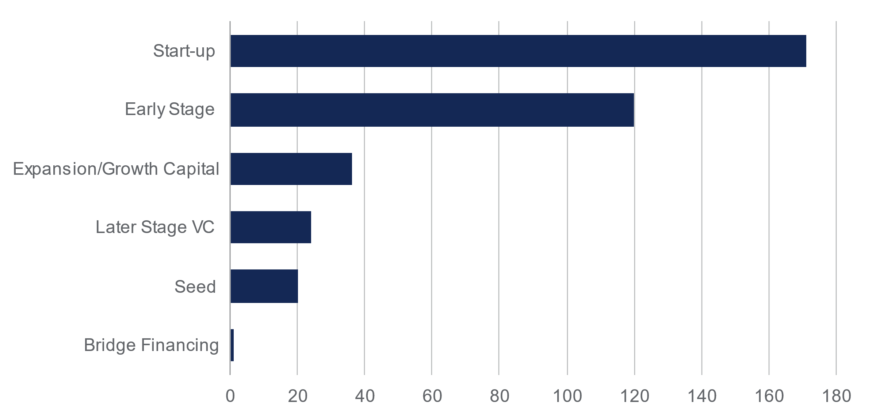
Source: British Business Bank data provided to RSM (November 2022), n = 372 firms
Figure 24: Number of RAP funded firms by investment stage per region
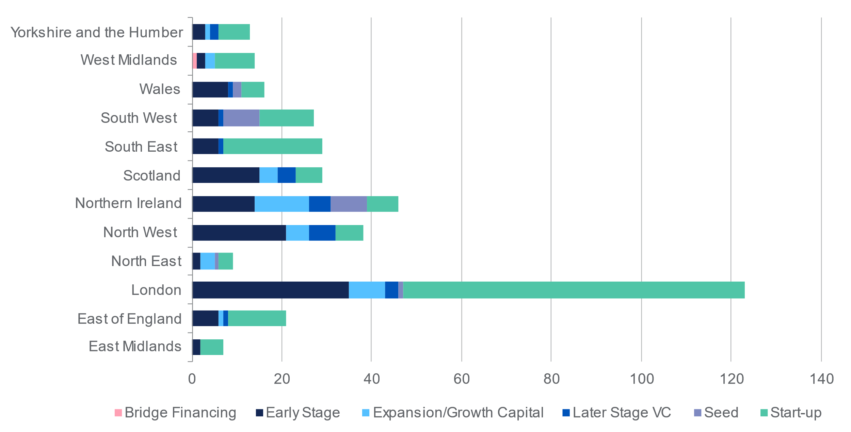
Source: British Business Bank data provided to RSM (November 2022), n = 372 firms

D.3 Turnover and employees count of funded firms
There’s a rather higher concentration of firm turnover recorded in regions in and around Greater London and the North West of England. More work still needs to be done to further the Programme’s aim of increasing the amount of early-stage equity capital that is available to small businesses throughout the UK. Apart from the four regions that recorded the highest turnover, nearly all other regions appear to be trending similarly.

Figure 25: Turnover concentration of RAP funded firms (GBP)
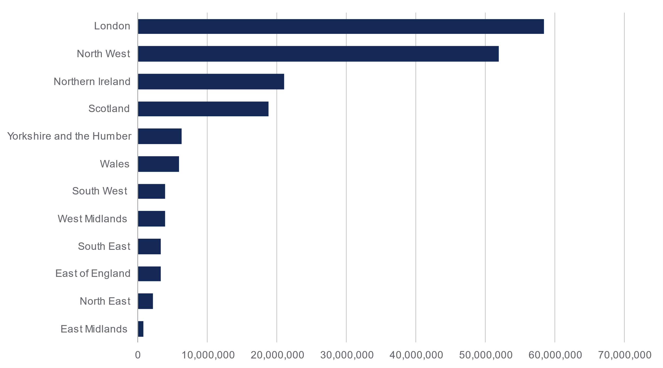
Source: British Business Bank data provided to RSM (November 2022), n = 372
Figure 26: Number of firms per region
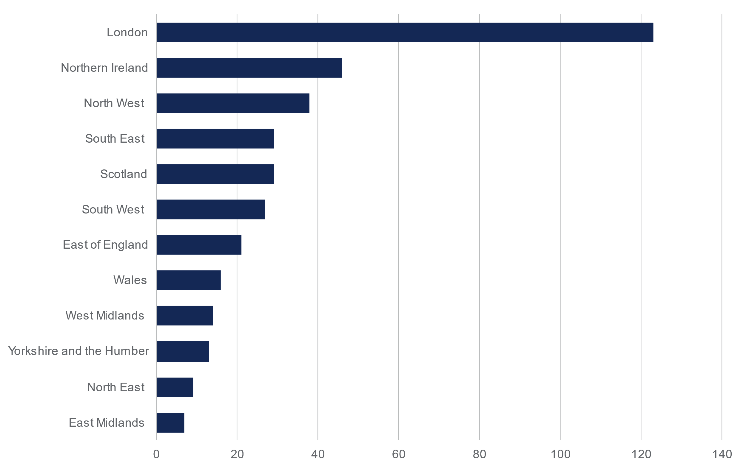
Source: British Business Bank data provided to RSM (November 2022), n = 372
The average turnover and employees count per region shown in the figures below provides a different picture of the size of firms supported through the Programme when compared to the national trend above. They reveal higher productivity per firm in regions such as the North West, Scotland, and Northern Ireland, where RAP appears to support larger individual firms in these regions.
Figure 27: Average per firm turnover per region (GBP)
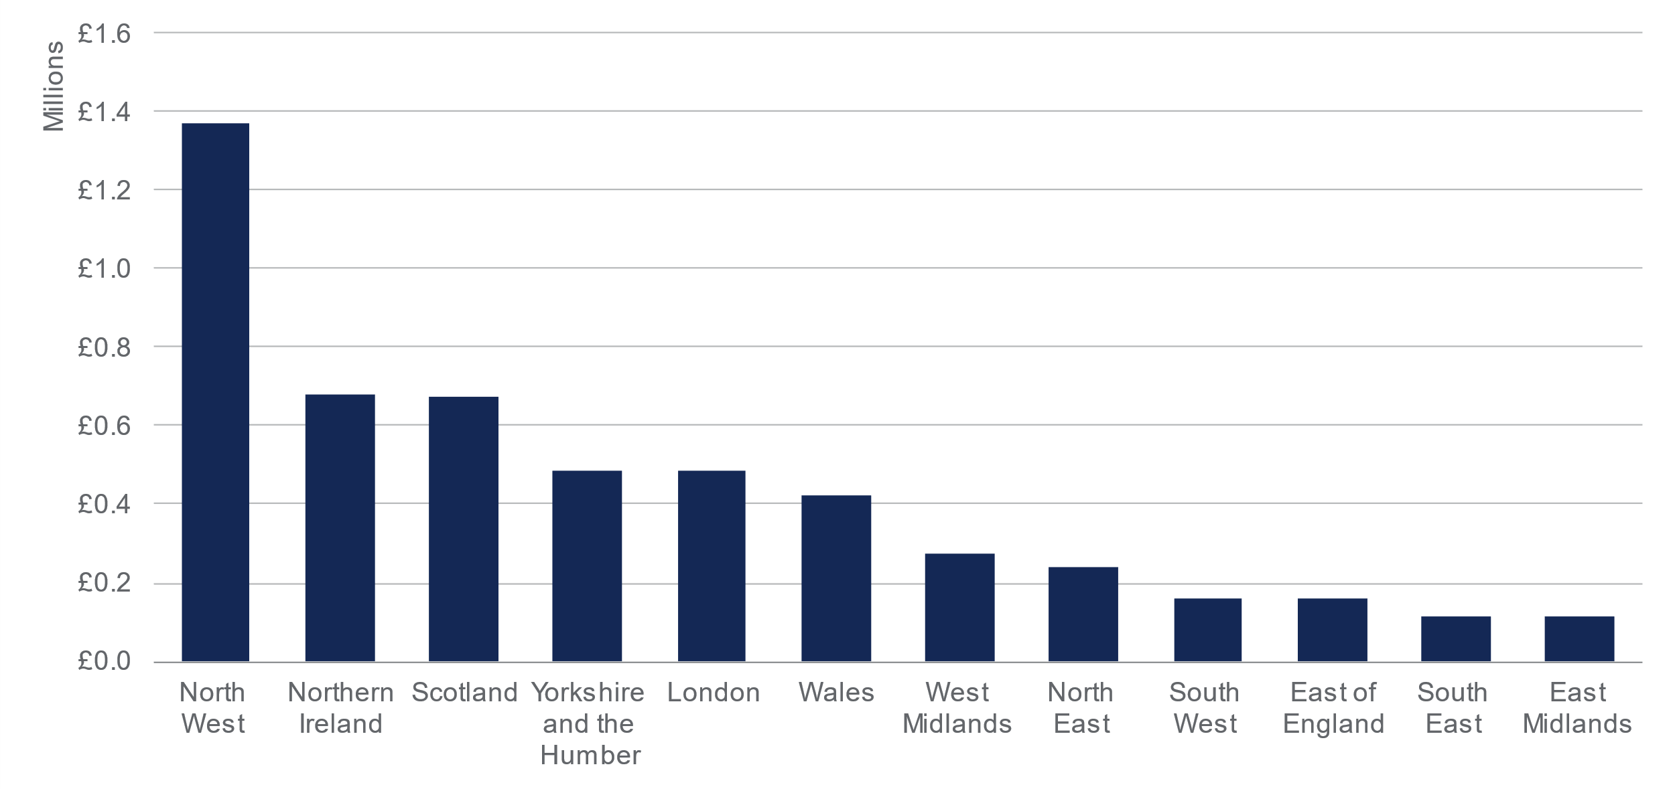
Source: British Business Bank data provided to RSM (November 2022), n = 372
Figure 28: Average number of employees per firm per region
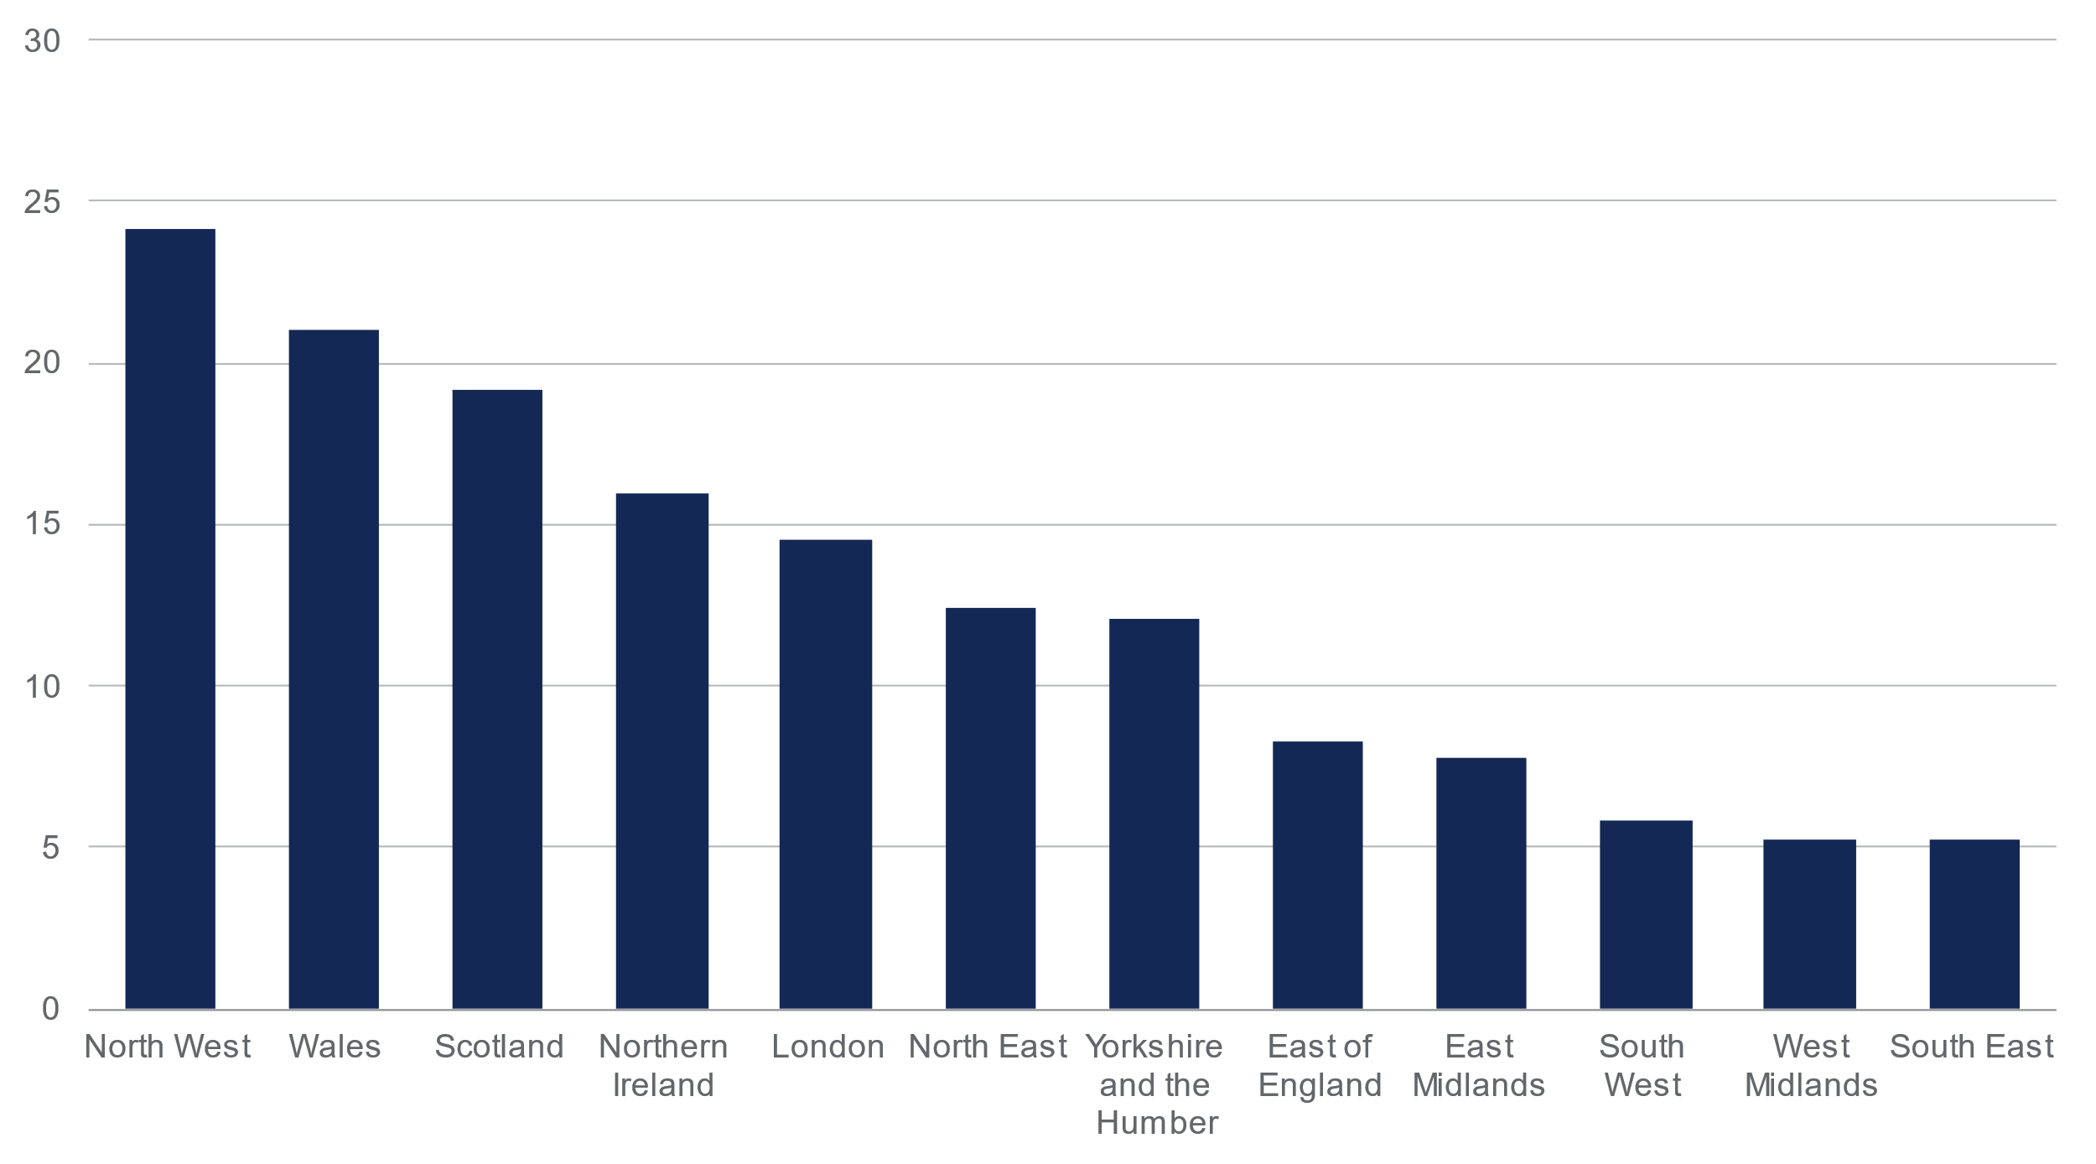
Source: British Business Bank data provided to RSM (November 2022), n = 372
Median figures below for turnover and employees paints a different picture in terms of magnitude of companies that have received the funding as London has bigger outliers compared to underfunded regions with a higher median turnover and employees’ number such as Scotland, Northern Ireland, and East Midlands.
Figure 29: Median turnover per region (GBP)
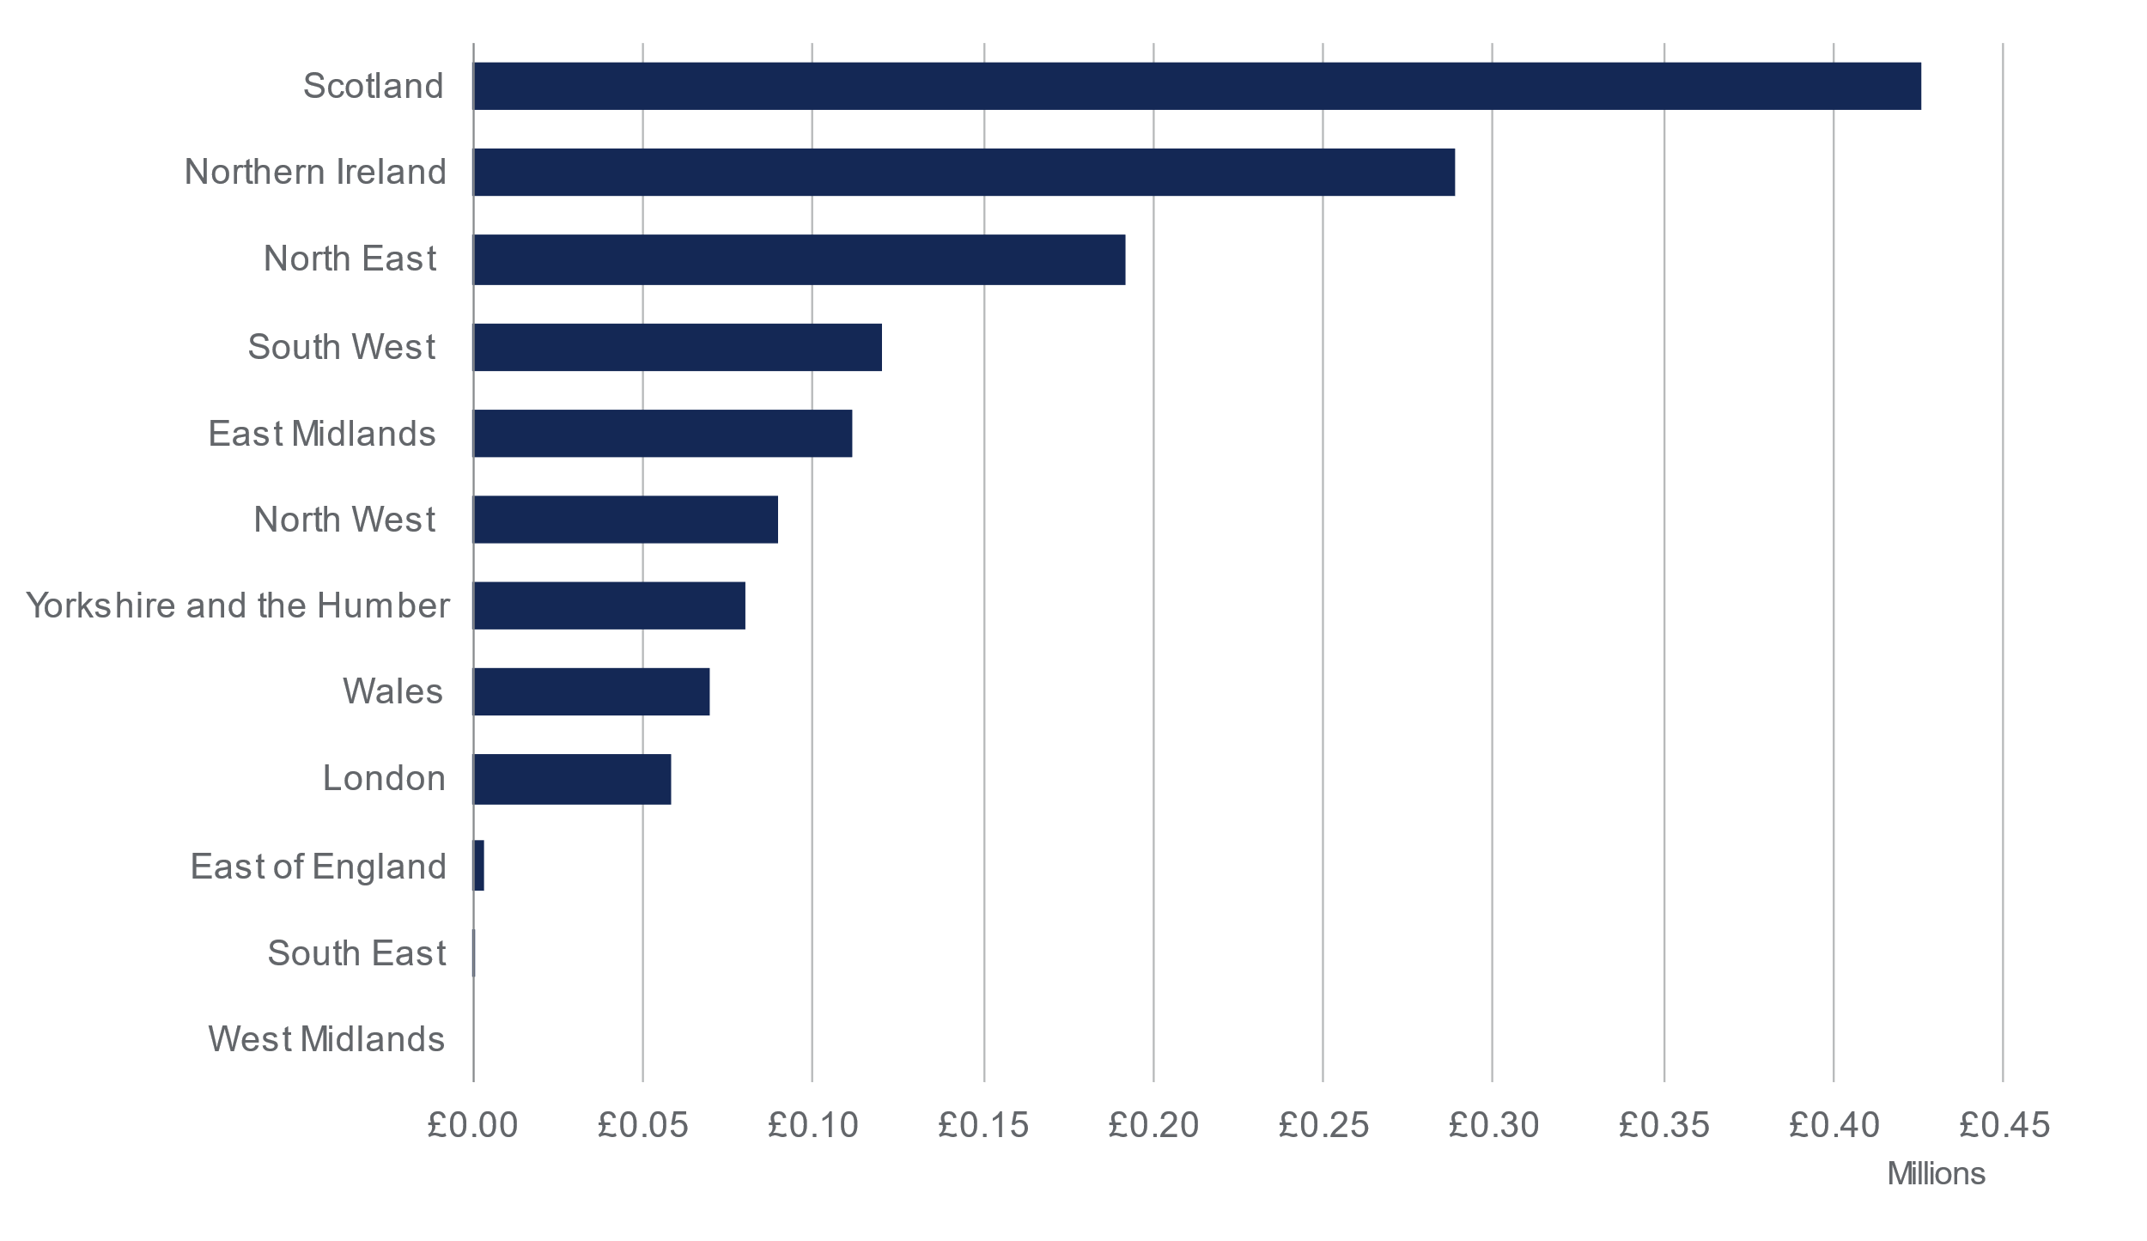
Source: British Business Bank data provided to RSM (November 2022), n = 372
Figure 30: Median number of employees per region
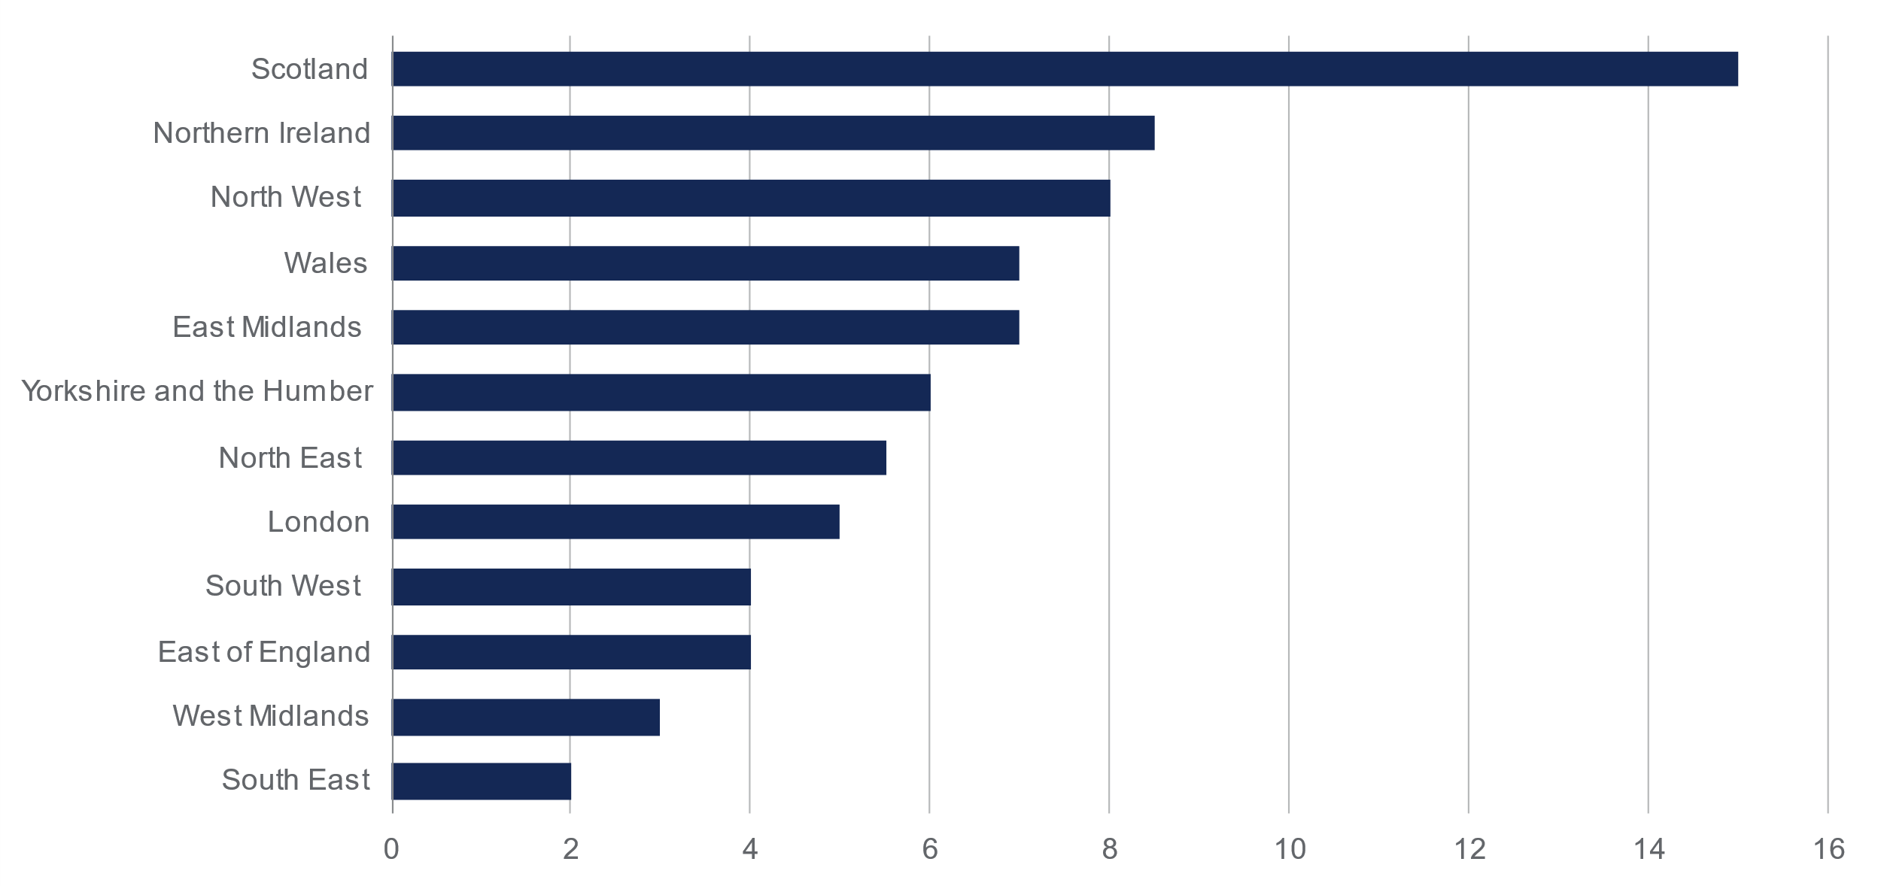
Source: British Business Bank data provided to RSM (November 2022), n = 372

D.4 Gender distribution of funded firms’ directors
Firms funded by the Programme do not show a significant amount of gender diversity within their directors, with higher absolute numbers of female directors in London, which could be explained by the fact that London has a more dynamic ecosystem compared to underfunded regions in the UK. Nationally, 83% of directors in RAP funded firms are male – slightly more gender diverse when looking more granularly at London & the South East as per Figure 31 belowFigure 31.
Figure 31: Firms directors’ gender by region
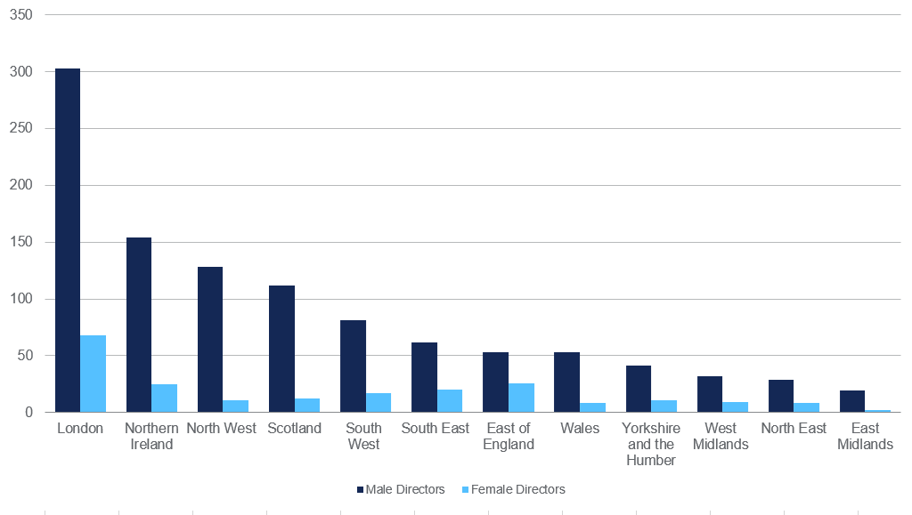

Figure 32 (LHS) & Figure 33 (RHS)
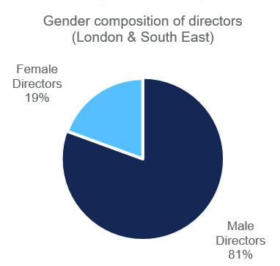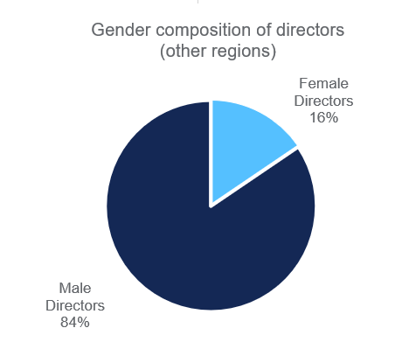
Source: British Business Bank data provided to RSM (November 2022), n = 372

D.5 Ethnicity of Directors
As can be seen from Figure 36, 19% of directors in the RAP funded firms are from ethnic minority backgrounds. There is an opportunity to increase overall diversity among the funded firms – especially given the early-stage of development of these businesses. Diversity is key to innovation, growth and productivity and a key driver of economic dynamism.
Figure 34 (LHS) & Figure 35 (RHS)
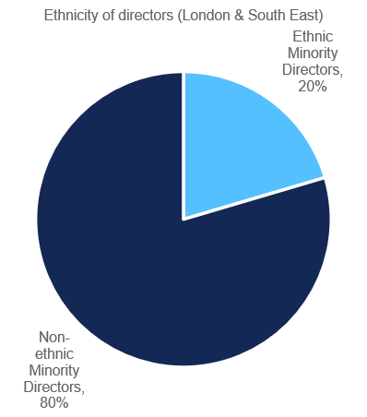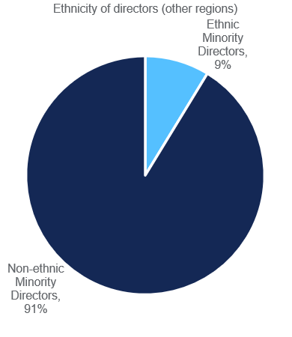
Figure 36: National breakdown of ethnic-minority directors within firms funded by RAP
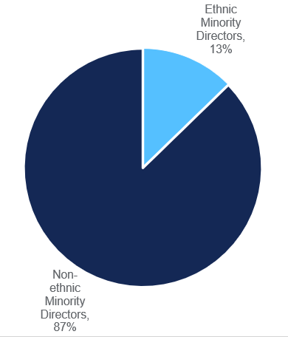
Source: British Business Bank data provided to RSM (November 2022), n = 372

D.6 Funded firms sector profile
Several industry sectors recorded very little investment while others appeared to be disproportionately invested in. It is interesting to note that the broad tech, information and communications sector shows up strongly when considering the funding distribution across the profile of UK economic activities. While the technology sector broadly accounts for approximately 6% of UK output, it makes an important ongoing contribution to UK growth, and has continued to do so during the Covid-19 pandemic, even where general economic activity has declined as times. Other parts of the UK economy, such as professional, scientific, and technological services, as well as manufacturing show up in terms of funding provided by RAP.
Figure 37: Profile of industry sector of Programme participation
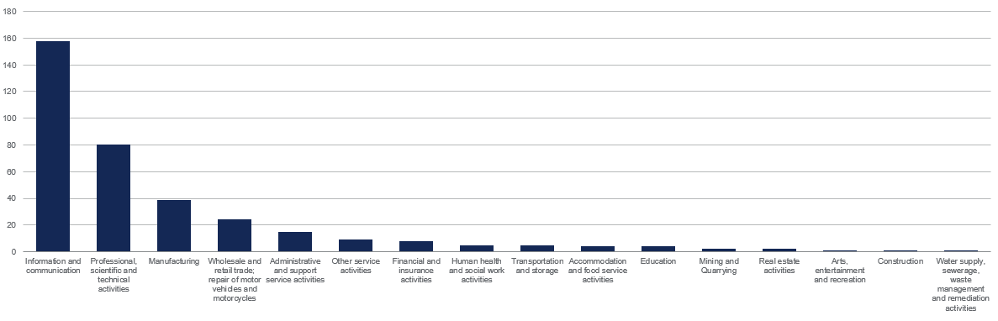

Annex E: KPI trend analysis

E.1 Fundraising activity

Table 11 below summarises fundraising activity of RAP funded firms relative to a counterfactual. We compare fundraising activity in 2019, pre-RAP, with activity in 2022 – the first-year post RAP financing for the first cohort of funded firms. Data is available for 350 funded firms and a sample of those (84) are matched to a counterfactual group.
Firms do not raise funds in all years. In 2019, 154 of 350 (44%) of the RAP funded firms raised funding, and three years later 207 of these firms (59%) raised funding. The average amount of funding raised doubles over this period from £9031k to £2,077k and half of the firms raised more than £500k in 2019. This figure doubles to £1,000 in 2022, and this is a positive sign suggesting that the RAP funded firms have become more mature over time. One of the RAP funded firms received £22m in fundraising activity in 2022, more than double the largest sum invested in 2019 (£9m).
A comparison with a counterfactual group is difficult and the fundraising data suggests that the majority of these firms are more established. The matching only partially corrects for these differences in firm maturity. The matched sample shows that these groups of firms are attracting larger sums of fundraising and that the average volume of fundraising of the matched firms has doubled since 2019. Beauhurst data on fundraising for the funded firms suggests that half of the RAP funded firms have not doubled their fundraising activity (change from £900k to £1,239k). The matched sample also shows a drop in the percentage of firms that have raised funds (73% to 50% for the funded firms and 66% to 47% for the counterfactual). This could indicate that many of these firms have sourced funding in previous years which has helped them grow, reducing the need to source funding on a year-on-year basis.

Table 11: Fundraising activity of RAP funded firms and a counterfactual
Group | Sample | Year | Number of firms that raised funds | Median (£k) | Average (£k) | Max (£k) | Min (£k)
RAP funded firms | 350 | 2019 | 154 | £500 | £938 | £9,031 | £10
 |  |  | (44%)
 |  | 2022 | 207 | £1,000 | £2,077 | £22,487 | £20
 |  |  | (59%)
Matched sample - RAP funded firms | 84 | 2019 | 61 | £900 | £1,250 | £9,031 | £10
 |  |  | (73%)
 |  | 2022 | 42 | £1,239 | £2,512 | £20,000 | £26
 |  |  | (50%)
Matched sample – counterfactual | 58 | 2019 | 38 | £2,190 | £7,231 | £78,125 | £52
 |  |  | (66%)
 |  | 2022 | 27 | £7,950 | £18,696 | £147,146 | £4
 |  |  | (47%)

E.2 Post-money valuation
The post-money valuation KPI is the equity value of a company after it receives funding and, because firms do not receive funding in every year, post-money valuation entries can only be provided for a sample of firms per year. In 2019, 27% of the RAP funded firms received funding and an average valuation of £4.1m. In 2022, 41% of the RAP funded firms received funding and an average valuation of £12.6m, triple that of 2019. Some firms have clearly done very well, and one was valued at £282.3m in 2022.
The average starting valuation of the counterfactual group was higher, £20.6m and increased to £163.9m by 2022 which suggests that firms in this group were already on a higher growth trajectory.

Table 12: Post-money valuation of funded firms and a counterfactual
Group | Sample | Year | Number of firms that have valuation entries | Median (£k) | Average (£k) | Max (£k) | Min (£k)
RAP funded firms | 350 | 2019 | 94  (27%) | £2,003 | £4,121 | £36,585 | £334
 |  | 2022 | 142  (41%) | £5,268 | £12,630 | £282,317 | £689
Matched sample - RAP funded firms | 84 | 2019 | 33  (39%) | £3,283 | £5,159 | £24,198 | £654
 |  | 2022 | 26  (31%) | £6,584 | £12,734 | £43,241 | £1,750
Matched sample - counterfactual | 58 | 2019 | 35  (60%) | £12,805 | £20,581 | £131,403 | £298
 |  | 2022 | 22  (38%) | £83,438 | £163,935 | £1,015,682 | £3,209

E.3 Turnover
All firms had a positive turnover before RAP (£1k or higher). The average turnover of RAP funded firms doubles between 2019 to 2022, from £332k to £625k.
A comparison of median and average starting turnover figures of the RAP funded firms and the counterfactual group shows that the counterfactual were higher which could be driven by these firms exhibiting a more established profile. The percentage growth in median turnover between 2019 and 2022 is lower for the RAP funded firms than for the counterfactual (186% vs 261%).

Table 13: Turnover of funded firms and a counterfactual
Group | Sample | Year | Number of firms that have turnover entries | Median (£k) | Average (£k) | Max (£k) | Min (£k)
RAP funded firms | 155 | 2019 | 154  (99%) | £97 | £332 | £6,000 | £1
 |  | 2022 | 151  (97%) | £275 | £625 | £7,194 | £1
Matched sample - RAP funded firms | 84 | 2019 | 83  (99%) | £90 | £244 | £3,934 | £1
 |  | 2022 | 81  (96%) | £257 | £503 | £2,864 | £1
Matched sample - counterfactual | 58 | 2019 | 57  (98%) | £242 | £546 | £4,456 | £0
 |  | 2022 | 57  (98%) | £873 | £3163 | £27,860 | £2

E.4 Employment
For the matched funded group, the average employment doubles from 5 to 12, and this increase is lower than that of the counterfactual group. The median funded firm does outperform the counterfactual (more than doubling of employment versus a doubling of employment). One potential explanation from the qualitative interviews indicates that RAP funding was used to support salary payments of existing staff as well as expanding the number of employees. Some firms in the funded group and in the counterfactual have zero employment in 2022. Most RAP funded firms employed at least six employees before benefitting from the Programme and were able to more than triple employment by 2022. Average employment also more than doubles from 15 in 2019 to 41 in 2022.
Six of the 350 RAP funded firms (1.6%) for which we have data went into liquidation in 2020 (two firms) or 2021 (four firms). The average size of RAP funding received was £228k, this is lower than the funded firms average (£444k), and together these firms have received £1.4m of RAP funding. Those 84% that survived were able to meet working capital commitments.
Table 14: Employment of funded firms and a counterfactual
Group | Sample | Year | Number of firms that have employees entries | Median | Average | Max | Min
RAP funded firms | 155 | 2019 | 154  (99%) | 6 | 15 | 954 | 1
 |  | 2022 | 151  (97%) | 20 | 41 | 316 | 0
Matched sample - RAP funded firms | 84 | 2019 | 83  (99%) | 5 | 9 | 61 | 1
 |  | 2022 | 81  (96%) | 12 | 18 | 175 | 1
Matched sample - counterfactual | 58 | 2019 | 57  (98%) | 7 | 12 | 63 | 1
 |  | 2022 | 57  (98%) | 14 | 39 | 341 | 0

Annex F: Mapping of other schemes
In Table 15 below are the schemes that have been identified to have some similarities in certain characteristics to the Regional Angels Programme. Given the limited number of schemes similar to the RAP, schemes were chosen based on whether they were equity funding, had a regionality component, British Business Bank based schemes etc. The Angel CoFund had the most alignment to the RAP however, it is inherently different given the limited regionality component of the scheme. For the matching purposes we have used indicator variables for firms that participated in the Angel CoFund, BBLS, CBILS, and the Future Fund as these were the most likely sources of alternative finance the portfolio and counterfactual groups would have accessed to apportion the impact from the Regional Angels Programme.
Table 15: Schemes identified to have similar characteristics
Programme | Description | Organisation
Angel CoFund | The Angel CoFund provides equity investments of between £100,000 and £1 million in smaller businesses in the UK. It invests alongside strong syndicates of business angels to support businesses with strong growth potential. | BEIS (now DBT)/ British Business Bank
Seed Enterprise Investment Scheme (SEIS) | SEIS helps start-ups raise money for their business. You get a maximum of £150,000 including state aid awarded in the three years running up to the date of investment. Eligible companies for the scheme must carry out a new qualifying trade, must be established in the UK, and not be trading on a recognised stock exchange at the time of the share issue. | HMRC
Enterprise Investment Scheme (EIS) | EIS is designed so that businesses can raise money by offering tax reliefs to individual investors who buy new shares in their company. Under EIS, businesses can raise up to £5 million each year, and a maximum of £12 million in the company’s lifetime. | HMRC
The Angel Investment Accelerator | This scheme is funded by Innovate UK and Spearheaded by SETsquared, alongside UKBAA, this Programme offers an array of resources and support for angels, shining light on the opportunities available in the South West and Wales. | BEIS (now DBT)/ UKRI
Future Fund | Future Fund is a £1.1 billion lifeline of Treasury funding for innovative companies facing financial difficulties due to the Covid-19 outbreak. | BEIS (now DBT)/ British Business Bank
Coronavirus Business Interruption Loan Scheme (CBILS) | The scheme helped small and medium-sized businesses to access loans and other kinds of finance up to £5 million during the Covid-19 pandemic.  The government guarantees 80% of the finance to the lender and pays interest and any fees for the first 12 months. is based in the UK  has an annual turnover of up to £45 million. | BEIS (now DBT)
Coronavirus Large Business Interruption Loan Scheme (CLBILS) | The scheme helped businesses with a turnover of more than £250m to borrow £50m from banks during the Covid-19 pandemic. | BEIS (now DBT)
Bounce Back Loan Scheme (BBLS) | The scheme provided financial support to businesses across the UK that were losing revenue, and seeing their cashflow disrupted, as a result of the Covid-19 outbreak. The businesses could benefit from £50,000 or less in finance. | BEIS (now DBT)
Coronavirus Job Retention ‘furlough’ Scheme | The Coronavirus Job Retention Scheme (CJRS) was a temporary scheme designed to protect the UK economy by helping employers whose operations were affected by Covid-19 to retain their employees. Through the scheme, Government paid up to 80% of staff wages to businesses (capped at £2,500 a month). | HMRC
Self-Employment Income Support Scheme (SEISS) | The Self-Employment Income Support Scheme (SEISS) was designed to support self-employed individuals (including members of partnerships) whose self-employment activities have been adversely affected by Covid-19. The Scheme covers up to 70% of the average monthly trading profits for the business. | HMRC
Statutory Sick Pay (SSP) Rebate Scheme | SSP helped businesses with fewer than 250 employees to apply to recover the costs of paying out SSP throughout the Covid-19 pandemic. | HMRC
Covid-19 Corporate Financing Facility | Under the Covid-19 Corporate Financing Facility (CCFF), the Bank of England will buy short-term debt from large companies.  This scheme will support companies that have been affected by a short-term funding squeeze, and allow them to finance their short-term liabilities.  It will also support corporate finance markets overall and ease the supply of credit to all firms. | BEIS (now DBT)
Business Rate Relief Due to Coronavirus | This scheme helped companies that were impacted by Covid-19 to claim business rates relief from the local council on their business rates. | BEIS (now DBT)
Small Business Coronavirus cash grant | The Small Business Grant Fund (SBGF) supports small and rural businesses in England with their business costs incurred during the Covid-19 pandemic. | BEIS (now DBT)
Coventry and Warwickshire Green Business Programme | This scheme provides firms in the Coventry, North Warwickshire, Nuneaton and Bedworth, Rugby, Leamington Spa, Stratford on Avon, and Warwick areas grants of between £1,000 and £50,000 (at up to 40% of projects costs). | BEIS (now DBT)
Staffordshire Business Funding | This grant scheme is for Staffordshire businesses to pay for external specialist advice to help develop or market a new product or service. The scheme offers up to £9,000 in funds. | BEIS (now DBT)
The Hive - North Somerset | This scheme provides workspace with on-site business support in Weston-Super-Mare. | BEIS (now DBT)
Tourism grants - Eden | This scheme provides small grants to help fund projects that will generate tourism and similar economic benefits in Eden. | BEIS (now DBT)
Future Focus - Cornwall and the Isles of Scilly | This scheme provides tools, resources, and collaborative networks to help businesses innovate, grow and adapt for long-term success. | BEIS (now DBT)
GC Business Finance - Northwest England | This scheme provides start-up loans and equity investment for small and medium-sized businesses (firms) based in Greater Manchester and the Northwest. Small unsecured business loans from £500 up to £300,000, equity investment up to £2,000,000. | BEIS (now DBT)
Investment Fund - North of England | This fund provides finance to help small and medium-sized enterprises (firms) in the Northwest, Yorkshire, the Humber, and Tees Valley. Funds between £25,000 to £2,000,000 can be accessed. | BEIS (now DBT)/UKRI
Tees Valley Catalyst Fund - Northeast England | The loan provides the cash security required for performance, warranty, or advanced payment bonds, to provide access to large contracts. Funds of £100,000 to £2,000,000 can be accessed. The limit is £4m to a business in any 36-month period. | BEIS (now DBT)
Key Fund - Midlands and the North of England | This fund provides social enterprises grants and loans to help increase their community, economic and environmental impact, such as: restoring a derelict building, buying equipment, meeting start-up costs. Funding of £5,000 up to £300,000 is available. | BEIS (now DBT)
ART Business Loans - West Midlands | This Community Development Finance Institution (CDFI) provides loans for new and existing small businesses unable to access finance in the West Midlands. The loans are funded by corporate and individual investors primarily motivated by philanthropic reasons. Businesses can get loans for any business purpose, including asset purchase and working capital. Funding of £10,000 up to £150,000 is available. | BEIS (now DBT)
Business loan scheme (CWRT) - Coventry and Warwickshire | This scheme is available to sole traders, partnerships, limited companies, not for profit and other community-based organisations that: are based or operate mainly in Coventry and Warwickshire and have been unable to secure sufficient funds through other sources. They can get £1,000 to £100,000 in funding. | BEIS (now DBT)
Social Investment Tax Relief (SITR) | SITR is a state aid designed to help you raise money to support the trading activity of the following type of companies:  - Registered charity  - Community interest company  - Community benefit society  The social enterprise applying for the scheme may qualify if they have no more than £15 million in gross assets and fewer than 250 employees. | HMRC
Venture Capital Trust (VCT) | A VCT is a company (like an investment trust) that’s been approved by HMRC and invests in, or lends money to, unlisted companies that have no more than £15 million in gross assets, less than 250 employees, and its first commercial sale took place less than 7 years since the investment. | HMRC
Creative Scale Up Programme | The scheme is a £4 million investment Programme supporting creative businesses across three English Combined Authority regions (West of England, West Midlands and Greater Manchester). | DCMS
Retail, leisure, and hospitality scheme | This scheme provides eligible and occupied retail, hospitality, and leisure properties with a 50% relief, up to a cash cap limit of £110,000 per business. | BEIS (now DBT)
AWS Activate | Amazon Web Services (AWS) has a dedicated Programme for start-ups (called Activate), which offers up to $25,000 of free credits and support to new businesses.  Working with the UKBAA, investors and angel groups can now issue these credits to founders in their portfolio. | UKBAA/ UKRI
Discretionary Fund | This fund's aim is to help about 10,000 small businesses that do not pay business rates directly, but rather pay them through a landlord such as those in shared workspaces. | BEIS (now DBT)
BCRS Business Loans | This scheme enables eligible businesses that are located in the West Midlands, as well as Gloucestershire to get a loan of £10,000 up to £150,000 if they can prove they have been unable to get funding from banks. | BEIS (now DBT)
Better Business Finance - UK | Better Business Finance provides access to finance up to £20,000,000 for companies across the UK. | BEIS (now DBT)
Big Issue Invest - UK | This scheme provides established social enterprises who’ve been operating for at least 24 months with about £20,000 to £1.5 million of funds | BEIS (now DBT)
Innovate UK - grant funding, innovation loans and expert support | Innovate UK provides grant funding of between £25,000 and £10 million for all sizes of business, from new companies to large multi-nationals. Innovation loans are loans of between £100,000 and £1 million provided to UK-based firms only to carry out later-stage research and development projects. | BEIS (now DBT)/ Innovate UK
Innovation Vouchers | Through the Innovation Vouchers scheme, Innovate UK offers up to £5,000 towards the cost of expert advice if you are running an firm – or just starting up. The funding encourages small businesses to seek out fresh knowledge that can help them to grow and develop. | BEIS (now DBT)/ Innovate UK
Knowledge Transfer Partnerships | Businesses participate in Knowledge Transfer Partnerships project so that Innovate UK can help them draw in academic expertise in their company. Innovate UK or other government co-funders provide a grant covering 67% of the project cost for Small and Medium -Sized Enterprises and 50% for large companies. | BEIS (now DBT)/ Innovate UK
Enterprise Answers business loans | This scheme provides business finance, advice, and support for businesses of all stage. Funding of £10,000 up to £150,000 is available. | BEIS (now DBT)

Annex G: Technical Methodology
G1. Introduction
The purpose of this methodology annex is to provide an overview of the data gathering and data preparation methods for the propensity score matching (PSM) and econometric modelling. The following sections will outline:
- Data identification and sourcing methods
- Data frame development in preparation for the following stages
- Propensity Score Matching and econometrics modelling.
G2. Data identification and sourcing
The first step in our approach was to source the databases that house data on the economic KPIs to be investigated.
Table 16 below shows the KPIs and control variables that were identified with the corresponding database sources:
Table 16: KPIs, Matching covariates and Database sources
 | Outcome measure (KPI) |  | Data source
Business performance | Turnover (in thousands) | IDBR
 | Employment |  | IDBR
 | Business Survival |  | Beauhurst
 | Fundraisings |  | Beauhurst
 | Business Valuation/ valuation ratio |  | Beauhurst
Business features | Latest credit rating |  | Beauhurst
 | Company house status |  | Beauhurst
 | Overall Covid-19 status |  | Beauhurst
 | Current stage of evolution |  | Beauhurst
 | Furlough scheme participation |  | Beauhurst
 | Total Fundraising since incorporation |  | Beauhurst
 | Company age |  | Beauhurst
 | Buzzwords according to Beauhurst definition |  | Beauhurst
 | Number of grants received by the companies |  | Beauhurst
 | High growth list featuring |  | Beauhurst
 | Accelerator Programme participation |  | Beauhurst
 | Sectors according to Beauhurst definition |  | Beauhurst
 | Target markets |  | Beauhurst
 | Tracking reasons |  | Beauhurst
 | firm Status |  | Beauhurst
 | Director gender balance |  | Beauhurst
 | Founder gender balance |  | Beauhurst
 | Key people gender balance |  | Beauhurst
 | Participation in: Angel CoFund, Future Fund, BBLS, and CBILS |  | British Business Bank
 | Indicator variable for portfolio firms |  | British Business Bank
IDBR
Inter-Departmental Business Register (IDBR) contains a list of UK businesses that is used by the government for statistical purposes. It covers approximately 2.7 million businesses across all sectors of the economy. The advantage of using IDBR data is its timeliness, with a lag of only 6 months (March data snapshot available from late September/early October of the same year). There could be a maximum two-year lag in the employment and turnover data presented from the IDBR data which should be considered. The turnover data in IDBR comes directly from HMRC but entries are dependent on timely company reporting. The IDBR database does not capture all of the RAP-funded firms due to the funded firms’ small size and low level of business activity. The analysis has a bias towards larger firms receiving RAP funding as higher-growth earlier stage firms are less likely to appear in the sample taken within the IDBR, given the minimum requirements of the IDBR data selection. A data request was sent to the data team within BEIS (now DBT) through the Bank to obtain this IDBR data. We provided filters that were to be applied to the register in order to streamline our sample in-line with RAP funded firms. These filters were derived by taking ranges calculated from a set of RAP funded firms taken from the MI data.
MI data provided by the British Business Bank (June 2022 data cut) featured firms funded by the delivery partners. We combined the individual MI data per delivery partner, removing duplication into a wider MI data set of all funded firms. We used this data to calculate ranges for turnover, employee numbers, SIC group to apply to the IDBR data frame. In order to not constrict the sample, we only applied these filters to a 2017 anchor year (year the RAP launched) and let the variables vary post 2017. We also separated out any firms that showed up in the database as having received RAP funding (treatment group) – using the CRNs taken from the MI data.
Several iterations of the request were required after discussions with DBT and the Bank in order for our data extract to be as close to the RAP funded firm characteristics as possible. Only yearly data was available for example and a maximum of data from 2017 onwards was provided (not 10 years historical). Some data wasn’t attainable as it did not feature on the IDBR (Patents for example).
Once we had confirmed the filters to be applied, data extracts were provided by the DBT data team per year (2017 through to 2022). These were shared over an egress workspace where once downloaded, the data was destroyed from the egress workspace. We then proceeded to save the data on our approved servers and password protected the data files (provided as .csv given the large size and large number of observations).
Beauhurst
The data from Beauhurst is available through the platform. The platform offers over 400 filtering options, allowing users to narrow down the range of 80K+ early-stage firms. This enabled us to select only the range of data that were aligned with the characteristics of the portfolio group. This was important in selecting the counterfactual sample, where we applied filters that emulate a mix of the eligibility criteria and MI data analysis on the portfolio firm characteristics. The Beauhurst database had a rich filtering system whereby we were able to apply specific scheme filters and filters based on ranges computed on RAP funded firm KPIs (turnover, FTE, Sectors, etc.). See Table 17 below for the detail of the filters. The prefiltering served the purpose of adding an additional layer of having a pre-matched sample that was as like-for-like as possible based on filtering limitations, meaning that any limitations in the later matching exercise could be mitigated by still having an appropriately prefiltered dataset as a baseline.

Table 17: Beauhurst filters applied to draw a counterfactual group of firms.
Any of the counterfactual companies’ fundraisings match all of the following criteria:
- form of funding is any of Equity
- type of fund providing the funding includes: Angel Network, Commercialisation Company, Corporate, Crowd funding, Family Office, Private Equity and Venture Capital, or Private Investment Vehicle
- date of fundraising is from 01/01/2020 to 31/12/2021
- the recipient company’s financial statement before the fundraising match all of the following criteria:
1. number of employees are between 1 – 249
2. turnover is between £1 – £24,999,999
- company’s stage of evolution is one of Seed, Venture, or Growth at the time of fundraising
And the counterfactual companies also have the following filters applied:
- SIC codes (2007) – 5 digits full codes – such as the ones from the RAP funded firms
- and Companies House ID is none of the ones from the MI firms (to avoid the presence of RAP funded firms in the counterfactual group)

By incorporating filters on the financial statement metrics required by RAP firms and KPI ranges for RAP funded firms (turnover, employment, etc.), we could draw a counterfactual group. This subset of firms would fall within the bounds related to RAP funded SMEs and was used as the counterfactual subset which further matching techniques were applied. However, it is important to consider the limitations associated with this method for retrieving counterfactual firms. Some of these firms may have received multiple rounds of funding during the selected period for our counterfactual group (2020 and 2021), and we cannot specifically target the first fundraising event to apply the financial statements to when building a counterfactual on Beauhurst. Therefore, counterfactual firms that may have raised similar fundraisings at the time of a funded firms Future Fund funding allocation, may not be matched. This would improve the quality of the matching.
Data availability remains a limitation
Although we were able to locate the relevant variables for the data frame, it is important to note that not all variables had complete datasets. This became particularly relevant during the modelling stage when conducting the propensity score matching exercise, as variables with limited observations had to be omitted. This will be covered in detail in the section below on Propensity Score Matching - Modelling
G3. Data frame development
Having sourced the data from various databases the next step was building the full data frame. This required data extraction from each database using the CRNs to ensure data per year was pulled together for the associated enterprises as classified in Companies House. Observations (firms) were discarded where full data wasn’t available across the IDBR or Beauhurst datasets.
Additional variables were computed such as the indicator variable for portfolio firms (assigned a 1) and counterfactual firms (assigned a 0) within the combined data frame. This was required for the propensity score matching exercise. Another additional variable was created, which was the number of days since incorporation. Firm-level data for the date of incorporation was provided by Beauhurst. The variable was transformed by calculating the number of days since incorporation until December 31, 2019, right before the first funding provided to firms as part of the Regional Angels Programme.
Table 18 below indicates the number of observations (firms) available throughout each year – from 2017 to 2022 - after combining data from both IDBR and Beauhurst datasets, compared to the initial number of portfolio and counterfactual firms:

Table 18: Number of observations
 | Portfolio | Counterfactual
Population size | 372 | 210
Sample size after IDBR and BH matching | 155 | 150

Importantly not all of the funded firms were available in the IDBR dataset. After investigation, we found that many MI firms were not in the IDBR database, likely due to their small size. For firms to show up in the IDBR, they need to be VAT/PAYE registered and demonstrate a minimum level of business activity. Some firms that receive RAP funding might be at too early a stage to meet these criteria. While the counterfactual group was created by considering the totality of the sample of MI firms, these would have also been boased upwards through the IDBR linking exercise.
Further controls were applied as part of the PSM, meaning that the analysis controls the comparison between counterfactual and treatment groups, making sure they are like for like. The analytical challenge is however determining how representative the analysis is across all of the portfolio firms, or whether the results of our analysis are strictly applicable to firm that are in sample. For clarity, we are largely assuming that the impact is similar for firms that are out of sample and firms that are in sample, but this is a potential limitation of the study.
A logarithmic transformation was applied to all continuous variables (except for employee counts). This was performed due to the properties of a log function smoothing out series that show large differentials in level terms. Specifically, it reduced the variance fluctuation across observations, which was often caused by extreme values in the dataset, and it addressed some of the skewed covariates in the data frame. It also supports the interpretation of the coefficients as it the log function converts level changes to percent changes – which is more comparable.
Employee counts were not transformed due to the low variation in the levels.
To avoid undefined values resulting from taking the logarithm of zero, 0.01 was added to all continuous observations before the logarithmic transformation was performed.
G4. Propensity Score Matching – Modelling
Variable selection
Before moving on to the PSM exercise and the modelling, NAs were removed from KPIs that contained them and the sample of treated firms was restricted to 2020 and 2021 firms only by matching for their CRNs – this reduced the pre-matching sample further to 245 observations (107 for the treated group and 138 for the counterfactual).
Following the data processing and transformation steps described above, we able to begin the matching exercise.
We tested a specific model based on economic principles regarding the covariates included within the matching specification. This model included the following covariates:
- Turnover (in thousands) in 2018
- Employee number in 2018
- SIC 2007
- Dummy variables on scheme mapping of firms for similar schemes (Angel CoFund, Future Fund, BBLS, and CBILS).
We selected relevant observed variables to match firms based on their likelihood of receiving funding from RAP. Due to the low sample size, we faced challenges in selecting the best matched sample while ensuring a sufficiently large sample size for subsequent modelling. As a result, we had to exclude some covariates from the matching process, making it less robust.
We focused on key indicators that considered other characteristics of the sample, such as scheme mapping as a proxy for credit rating. Scheme participation by firms can serve as a good proxy for creditworthiness, as start-ups or firms participating in accelerator Programmes or receiving funding usually undergo a rigorous selection and due diligence process. Furthermore, when they receive funding from reputable investors, they are signalling their creditworthiness. However, the omission of certain indicators, like the stage of evolution variable, resulted in the counterfactual firms appearing to be at a later stage of evolution compared to the treated group after matching.
Regional control was not included in the matching process, as it would be addressed in the subsequent triple DiDiD modelling.
Finally, the less stringent matching process had an impact on the data analysis results, as outliers had a notable influence on the overall trend of the counterfactual group. Also, by removing these outliers, the modelling results lost their statistical significance at the conventional 10% significance levels. See Table 22 for the level of significance.
The PSM model
The technique adopted was PSM and is a method used to create like-for-like comparator group firms to the intervention group (RAP participants) on characteristics and traits of the treated group.
The propensity scores for each firm in the combined dataset were estimated using a probability function. We used a logit regression model to estimate the propensities. The estimated propensity scores were used to match portfolio firms with counterfactual firms that had the closest score, ensuring a robust like-for-like comparison. In mathematical terms, the propensity scores would be estimated with the following probabilities for each individual firm selected in both the portfolio and counterfactual samples.
$$P\left(Y=1 | X=x\right)=log\left[\frac{p(x)}{1-p(x)}\right]$$
Matching algorithm specification and selection criteria
A range of matching specifications can be applied such as nearest neighbour matching, calliper matching, optimal full matching, coarsened exact matching and so forth. After several matching techniques, the calliper matching specification was the most suitable. The calliper matching was also used in Wilson and Kacer (2019) study that highlighted the importance of equity finance investment for economic development in the UK and identified persistent concerns of market failure in the provision of equity finance for high growth and technically innovative firms. The selection of such matching specifications was based on the sample size of both groups and the covariate balance, which were the metrics that indicated the degree to which the distribution of covariates was similar across levels of the treatment. For details in covariate balance, refer to Table 19 belowError! Reference source not found.. The matched sample size contains 84 portfolio firms and 58 counterfactual firms.
Table 19: Matching algorithm specification
 | Specification
Method | Nearest neighbour
Calliper | 0.1
Ratio | 10
Replacement | TRUE
Model | Logit

A graphical comparison of the distributional balance for before-and-after matching is presented in the Figure 38 below.

Figure 38: Distributional Balance for "distance"
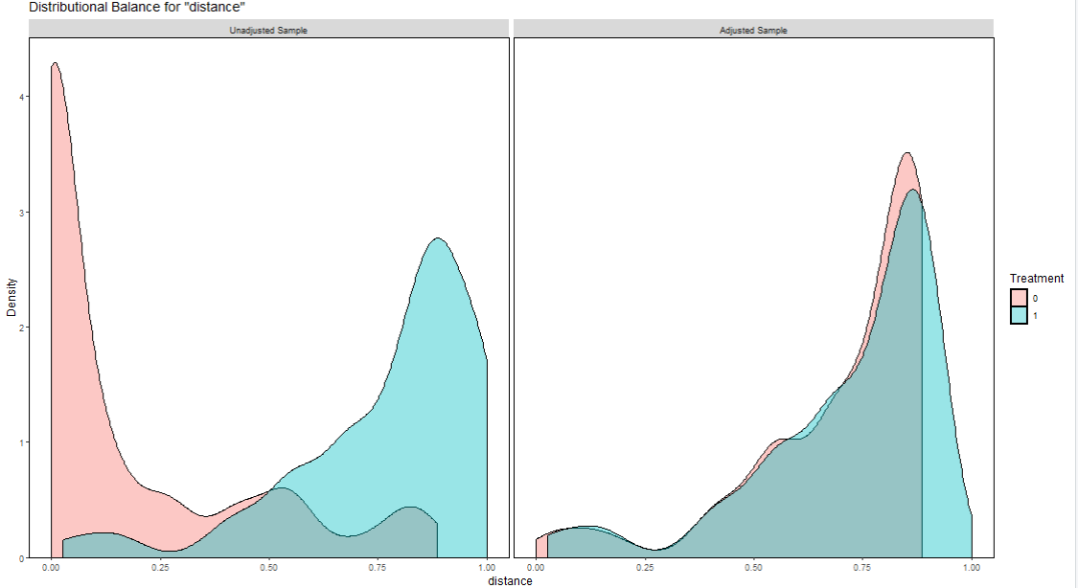
As mentioned earlier, both density curves after matching indicate that the sample was matched to ensure comparability between the two groups. However, a balance had to be achieved between the quality of the matching and the minimum number of observations remaining after the process.
The detail of the covariate balance metrics of the selected specification are shown below:

Table 20: Covariate balance
Metrics | Result
Number of variables whose Standardised Mean Difference higher than 0.05 | 13
Number of variables whose variance ratios +/- 1 from 1 (continuous variables only) | 1
The mean of empirical CDF statistics | 0.01533195
Remaining sample size | 142

We have also considered a matching specification based on the above criteria that it had the minimal number of variables with SMDs above 0.05, variance ratios close to 1, and eCDFs close to 0. These three criteria define the quality of the match and signal higher quality, the closer the scores are to each of the limits.
Our matched data set comprised 84 portfolio firms and 58 counterfactual firms, totalling 142 observations.
Each observation was assigned a weight. The weight was used to adjust for differences in representativeness within the matched sample to control for the fact that some observations were more (or less) representative of the target population than others. While this approach helps mitigate the problem of the matched sample deviating from the initial sample, it does not resolve the underlying issue that the IDBR matched firms are only a subset of the larger population of treated firms. All the key performance indicator data used in the analysis were adjusted for weights prior to calculating the median, median growth rate, and average shown in the main report.
Despite the matching, the portfolio of funded firms is considerably younger than that of the comparison group.
Figure 39: A comparison of the growth stage of the RAP funded firms and the comparison group
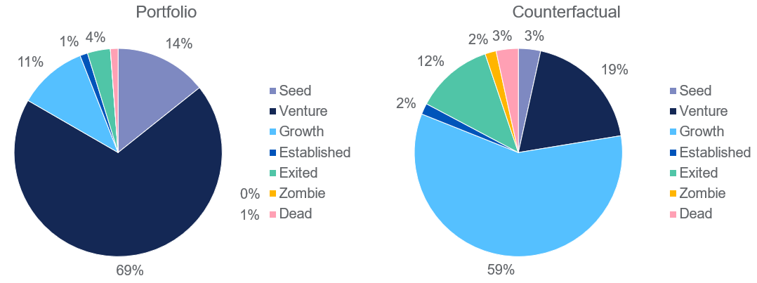
Source: Beauhurst. N = 84 for the funded firms and N = 58 for the comparator group
Assumption
The parallel trend assumption is fundamental to the Difference-in-Differences (DiD) methodology and interpretation. It asserts that, in the absence of treatment, the average trends of the treatment and control groups would have followed parallel paths over time. This assumption is critical because it enables us to attribute any differences in outcomes between the two groups after the treatment solely to the treatment effect, rather than pre-existing differences in trends.
In our analysis, we visually examined the level log fundraising trends between the treatment and counterfactual groups over a period of five years before the first RAP funding (2015 to 2020). Figure 40Figure 40 below suggests an alignment of these trends. The overall levels of fundraising show a consistent pattern of growth, with similar fluctuations and movements observed between the two groups. However, it is worth noting a slight decline in the portfolio group's fundraising in 2020.
Figure 40: Log fundraising trend
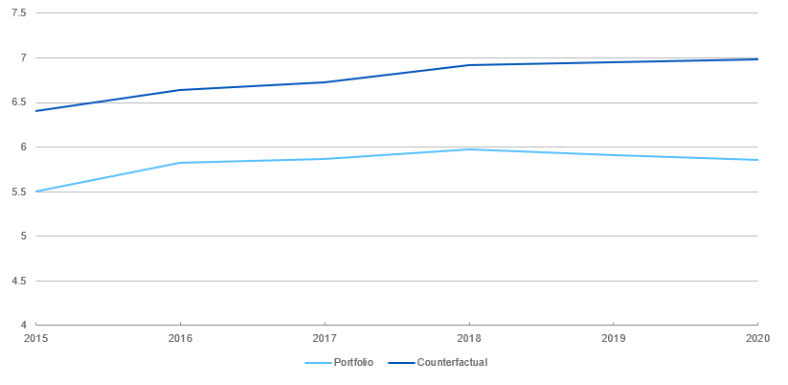

Analysis was also conducted on the growth rate using Figure 41, which illustrates the percentage change in fundraising pre-treatment since 2016. The graph also reveals a broad alignment of trends, with one exception being the rate leading up to 2017 for the portfolio group. During this period, the portfolio group experienced a steeper decline in fundraising compared to the treatment group.

Figure 41: Fundraising trend growth rate

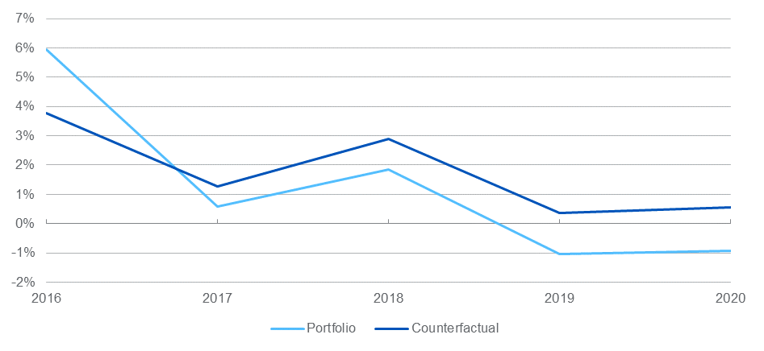
It is important to acknowledge that graphical analysis has its limitations, including subjectivity and the potential for biased interpretation. It is worth also noting that the sample of portfolio firms used for matching and subsequent modelling differs from the original sample used for this trend analysis due to the issues related to firm size retrieved from the IDBR, as explained earlier in the methodology section.
Triple DiD to account for the regional impact of the Programme
We have applied a triple DiD structure to account for the regional component for the RAP Programme. The triple DiD, compared to a standard DiD estimator, has allowed us to include the interaction regional variable in order to estimate the impact of RAP funding on the Rest of the UK compared to a counterfactual group of firms based outside London and the South East. This analysis has been carried out in nominal terms and the impact of inflation is considered as part of background trends and structure of the model.

The difference-in-differences-in-differences (DiDiD) equation can be written as follows:
Y_it = α + β1 * T_i + β2 * P_t + β3 * D_j + δ * (T_i * P_t) + λ * (T_i * D_j) + γ * (P_t * D_j) + θ * (T_i * P_t * D_j) + ε_it
where:
- Y_it is the outcome variable for unit i (e.g., individual, firm, region) at time t (before and after the treatment).
- T_i is an indicator variable that equals 1 for the treatment group (those who received the intervention) and 0 for the control group (those who did not receive the intervention).
- P_t is an indicator variable that equals 1 for the post-treatment period and 0 for the pre-treatment period.
- D_j is an indicator variable that equals 1 for the j-th group (e.g., region) and 0 for all other groups.
- (T_i * P_t), (T_i * D_j), (P_t * D_j) and (T_i * P_t * D_j) are interaction terms between the treatment, time, and group variables.
- α is a constant term.
- β1, β2, and β3 are the coefficients of the treatment, time, and group variables, respectively, which represent the average effect of each variable on the outcome variable.
- δ, λ, γ, and θ are the coefficients of the interaction terms, which represent the additional effect of the treatment variable when combined with time, group, or both.
The DiDiD coefficient (θ) measures the difference in the treatment effect between the treatment and control groups before and after the treatment, taking into account the differences in the outcome variable between the groups and over time. A positive DiDiD coefficient indicates that the treatment effect is greater for the treatment group than for the control group, after adjusting for the differences in the outcome variable between the groups and over time. Conversely, a negative DiDiD coefficient indicates that the treatment effect is smaller for the treatment group than for the control group, after adjusting for the differences in the outcome variable between the groups and over time. The interpretation of our coefficient is highlighted in Table 21 below.
Table 21 presents the fundraising results for both a national standard DiD and a triple DiD model, taking into account the regional component. Both models utilise logarithmic terms for fundraising and incorporate weights obtained from the propensity score matching (PSM).
Table 21: Coefficient for National and Regional level
Model | DiD/ DiDiD coefficient | P-value | Significance | Interpretation
National Level (fundraisings) | 0.76 | 0.13 | Marginally insignificant | Positive impact of RAP funding on relative fundraising. On average, RAP funded firms experienced a 76% funding uplift compared to the counterfactual on a national basis.
Regional Level- Rest of UK (fundraisings) | 1.50 | 0.11 | Marginally insignificant | Positive impact of RAP funding on portfolio firms average fundraising. On average, RAP funded firms that were based in the rest of the UK experienced a 150% increase in funding compared to the counterfactual group of firms based outside London and the South East (Rest of the UK) post RAP financing.

Table 22 below presents the fundraising results for both a national standard DiD and a triple DiD model, considering the regional component after removing the three most influential observations in our dataset. This step was necessary to address the issue of outliers, which had a disproportionate impact on the results due to the small sample size, as discussed in previous sections of the report. To identify these influential observations, we utilised Cook's Distance, a measure that quantifies the extent to which the fitted values in the model change when a specific data point is removed. A high value of Cook's Distance indicates a strong influence on the fitted values. As a general guideline, any data point with a Cook's Distance exceeding 4/n (where n represents the total number of data points) is considered an outlier. Both models utilise logarithmic terms for fundraising and incorporate weights obtained from the propensity score matching (PSM).
The results obtained after removing outliers indicate a positive impact, albeit lower than that of the full sample. However, these results are insignificant.
Table 22: DiD coefficient for National and Regional Level by excluding the three most influential outliers via Cook’s Distance
Model | DiD/ DiDiD coefficient | P-value | Significance | Interpretation
National Level (fundraisings) | 0.67 | 0.34 | Insignificant | Positive impact of RAP funding on relative fundraising. On average, RAP funded firms experienced a 67% funding uplift compared to the counterfactual on a national basis.
Regional Level- Rest of UK (fundraisings) | 1.10 | 0.30 | Insignificant | Positive impact of RAP funding on portfolio firms average fundraising. On average, RAP funded firms that were based in the rest of the UK experienced a 110% increase in funding compared to the counterfactual group of firms based outside London and the South East (Rest of the UK) post RAP financing.
In conclusion, it is important to acknowledge and address several key limitations associated with our methods, as highlighted throughout this note. These limitations should be carefully considered:
- Building a counterfactual sample on Beauhurst: We were unable to specifically target the first fundraising event when applying financial statements to the counterfactual group. This limitation may introduce quality concerns in our analysis. By aligning the specific static time of fundraisings between the counterfactual and funded firms, one can improve the quality of the match by aligning firms that raised the same amount (or in a ballpark of) at the time funded firms received funding through the RAP.
- Data frame construction: The IDBR dataset did not include most of the MI (Micro-Innovation) firms due to their small size. Consequently, our analysis of treated firms may be biased towards larger firms receiving RAP funding. However, this issue was partially controlled through the matching process and balancing in that we compared like for like firms with the same bias applied.
- Matching limitations: Due to the low sample size, the matching process was not as robust as desired. We had to strike a balance between matching metrics and maintaining a sufficiently large sample size for our modelling purposes.

Annex H: Econometric DiD Modelling
Table 23: Results from a Difference-in-Difference analysis estimating the impact on funding raised
Log-amount raised | 1. National DiD model |  | 2. National DiD model – applying Cook’s distance |  | 3. Regional DiD model |  | 4. Regional DiD model – applying Cook’s distance
 | Estimate | Pr(>|t|) | Estimate | Pr(>|t|) | Estimate | Pr(>|t|) | Estimate | Pr(>|t|)
RAP funded | -2.05 | 0.00 *** | -2.07 | 0.00*** | -3.02 | 0.00*** | -2.67 | 0.00***
Time | -0.11 | 0.78 | 0.50 | 0.21 | 0.65 | 0.13 | 1.00 | 0.05
RAP funded * Time | 0.76 | 0.13 | 0.15 | 0.76 | 1.02 | 0.13 | 0.67 | 0.34
Regional dummy |  |  |  |  | -0.69 | 0.15 | 0.10 | 0.87
Region * RAP funded |  |  |  |  | 1.58 | 0.01* | 0.80 | 0.26
Region * Time |  |  |  |  | -2.91 | 0.00*** | -2.51 | 0.00 **
Region * RAP funded * Time |  |  |  |  | 1.50 | 0.11 | 1.10 | 0.30
Adjusted R-squared | 0.23 |  | 0.32 |  | 0.42 |  | 0.39
N | 168 |  | 165 |  | 168 |  | 165

Annex I: Abbreviations
Abbreviation | Full Title
AML | Anti-Money Laundering
BEIS | Department for Business, Energy & Industrial Strategy
BBLS | Bounce Back Loan Scheme
CBILS | Coronavirus Business Interruption Loan Scheme
CDF | Cumulative density functions
CLA | Convertible Loan Agreement
CLA applicants/ non-recipients | Businesses who applied, were successful but did not take up the funding.
CLA funded businesses/ recipients | Businesses who applied and received funding from the Future Fund Scheme.
CLBILS | Coronavirus Large Business Interruption Loan Scheme
CLN | Convertible Loan Note
Covid-19 | Coronavirus disease (Covid-19) is an infectious disease caused by the SARS-CoV-2 virus.
CRN | Company registration number
DCF | Discounted cash-flow
DiD | Difference-in-difference (regression)
EBITDA | Earnings Before Interest, Taxes, Depreciation, and Amortisation
eCDF | Empirical cumulative density functions
EIS | Enterprise Investment Scheme
EDI | Equality, Diversity, and Inclusion
FAQ | Frequently Asked Questions
FCA | Financial Conduct Authority
FF | Future Fund
FPO | Financial Promotion Order
FTE | Full-Time Equivalent
GBP | Great British Pound
GVA | Gross Value Added
HMG | His Majesty's Government
HMRC | His Majesty's Revenue and Customs
HMT | His Majesty's Treasury
H₀ | The null hypothesis
IDBR | Inter-Departmental Business Register
KPI | Key Performance Indicator
KYC/ CCD | Know Your Customer/ Customer Due Diligence
LHS | Left hand side
M4 | M4 money supply is defined as a measure of notes and coins in circulation (M0) + bank accounts
MI | Management Information
N/A | Not applicable
Non-applicant | Business that could have applied and did not.
NPV | Net Present Value
OECD | Organisation for Economic Co-operation and Development
ONS | Office for National Statistics
Private investor (not identified as a business angel) | These are a sub-group of private investors who do not actively invest in start-up firms. Usually, they consist of family, friends, company Directors etc.
PSM | Propensity Score Matching
PwC | PricewaterhouseCoopers LLP
Q | Quarter
Q1 | Quarter 1 (January to March)
Q2 | Quarter 2 (April to June)
Q3 | Quarter 3 (July to September)
Q4 | Quarter 4 (October to December)
R&D | Research and Development
RHS | Right hand side
RLS | Recovery Loan Scheme
SARS-CoV-2 | The virus that causes the coronavirus disease.
SEIS | Seed Enterprise Investment Scheme
SIC | Standard Industrial Classification
SMD | Standardised mean difference
firm | Small and Medium sized Enterprise
Stakeholders | This group consisted of senior civil servants in Government, Arm’s length bodies, government agencies, industry bodies, and non-profit organisations that were involved (directly/ indirectly) with the Future Fund design/ implementation stages.
UK | United Kingdom
VAT | Value Added Tax
VC | Venture Capital
VFM/ VfM | Value for Money

Legal notices and disclaimers

Legal notices and disclaimers

The matters raised in this report are only those which came to our attention during our review and are not necessarily a comprehensive statement of all the weaknesses that exist or all improvements that might be made.

Recommendations for improvements should be assessed by you for their full impact before they are implemented. This report, or our work, should not be taken as a substitute for management’s responsibilities for the application of sound commercial practices. We emphasise that the responsibility for a sound system of internal controls rests with management and our work should not be relied upon to identify all strengths and weaknesses that may exist. Neither should our work be relied upon to identify all circumstances of fraud and irregularity should there be any.

This report is supplied on the understanding that it is solely for the use of the persons to whom it is addressed and for the purposes set out herein. Our work has been undertaken solely to prepare this report and state those matters that we have agreed to state to them. This report should not therefore be regarded as suitable to be used or relied on by any other party wishing to acquire any rights from RSM UK Consulting LLP for any purpose or in any context. Any party other than the Board which obtains access to this report or a copy and chooses to rely on this report (or any part of it) will do so at its own risk. To the fullest extent permitted by law, RSM UK Consulting LLP will accept no responsibility or liability in respect of this report to any other party and shall not be liable for any loss, damage or expense of whatsoever nature which is caused by any person’s reliance on representations in this report.

This report is released to our Client on the basis that it shall not be copied, referred to or disclosed, in whole or in part (save as otherwise permitted by agreed written terms), without our prior written consent.

We have no responsibility to update this report for events and circumstances occurring after the date of this report. RSM UK Consulting LLP is a limited liability partnership registered in England and Wales no. OC397475 at 6th floor, 25 Farringdon Street, London EC4A 4AB.

Disclaimer: The British Business Bank has made every effort to use reliable, up to date and comprehensive information and analysis, but no representation, express or implied, is made by British Business Bank plc and its subsidiaries as to the completeness or accuracy of any facts or opinions contained in this report. Recipients should seek their own independent legal, financial, tax, accounting or regulatory advice before making any decision based on the information contained herein. This report is not investment advice. The British Business Bank accepts no liability for any loss arising from any action taken or refrained from as a result of information contained in this report.

British Business Bank plc
Steel City House
West Street
Sheffield S1 2GQ
t. +44 (0)114 206 2131
e. info@british-business-bank.co.uk
british-business-bank.co.uk
Publication date: May 3rd 2024

British Business Bank – Regional Angels Programme Business Case
A “Partner” in this instance refers to the business angel(s)/ syndicate who was successful in applying to the scheme and disbursed funding to SMEs through a co-investment structure with the BBI (between 50% to 80% of the financing was provided by the private investor(s)).
Interim Evaluation of BPC, February 2023
The Enterprise Investment Scheme (EIS) and the Seed Enterprise Investment Scheme (SEIS) are two Government schemes designed to help small or medium sized companies grow by attracting investment.
The UK Business Angels Market 2020 – UKBAA, British Business Bank
ibid
British Business Bank
British Business Bank
This was noted by the delivery team and within data shared on the RAP Investment Process timelines.
Alternative models are currently being explored to accommodate angels that aren’t currently FCA regulated.
Harrison, R. (2018). Crossing the chasm: the role of co-investment funds in strengthening the regional business angel ecosystem. Small Enterprise Research, 25(1), 3-22
According to Beauhurst stages of evolution definition
This analysis was not conducted by RSM – BBB figure.
BBI_RFP_Regional-Angels-Programme-Sep-2022_v3.docx (live.com)
https://www.british-business-bank.co.uk/wp-content/uploads/2018/06/Business-Angel-Reportweb.pdf - Figure 4.28: “Main challenges that business angels foresee in their role as a business angel in the next 12 months by location”
Modelled impacts are based on outturns of the initial cohort only (received RAP funding between 2020/21).
Now merged into the Department for Business and Trade (DBT)
Angels that did not apply to the scheme.
https://assets.publishing.service.gov.uk/government/uploads/system/uploads/attachment_data/file/1018138/BPE_METHODOLOGY___QUALITY_NOTE_2021.pdf
For more detail on the Methdological approach see Annex G.
The UK Business Angel Market 2020 – UKBAA, British Business Bank
Note that the region is unknown for some of the deals.
Fritsch, M., & Schilder, D. (2008). Does venture capital investment really require spatial proximity? An empirical investigation. Environment and Planning A, 40(9), 2114-2131.
Chen, H., Gompers, P., Kovner, A., & Lerner, J. (2010). Buy local? The geography of venture capital. Journal of Urban Economics, 67(1), 90-102.
Harrison, R., Mason, C., & Robson, P. (2010). Determinants of long-distance investing by business angels in the UK. Entrepreneurship and Regional Development, 22(2), 113-137.
McNaughton, R. B., & Green, M. B. (1989). Spatial patterns of Canadian venture capital investment. Regional Studies, 23(1), 9-18.
Gardiner, B., Martin, R., & Tyler, P. (2012). Competitiveness, productivity and economic growth across the European regions. In Regional competitiveness (pp. 61-84). Routledge.
Enterprise Investment Scheme, Seed Enterprise Investment Scheme and Social Investment Tax Relief statistics: 2023 - GOV.UK (www.gov.uk)
Increasing the limits of the Seed Enterprise Investment Scheme - GOV.UK (www.gov.uk)
COVID-19 lending support and regional levelling up: evidence from UK loan guarantee schemes: Regional Studies: Vol 0, No 0 (tandfonline.com)
Cowling, M., Nightingale, P. and Wilson, N. (2023) COVID-19 lending support and regional levelling up: evidence from UK loan guarantee schemes, Regional Studies, 57:11, 2323-2338, DOI: 10.1080/00343404.2022.2159021
Coronavirus Business Interruption Loan Scheme (CBILS) - British Business Bank (british-business-bank.co.uk)
These are: 1. target market, 2. investment strategy, 3. track record and expertise, 4. Origination, 5. commercial returns and renumeration, 6. Private sector leverage, 7. Portfolio management, 8. Operational structure, legal and regulatory. See BBI_RFP_Regional-Angels-Programme-Sep-2022_v3.docx (live.com)
BBI_RFP_Regional-Angels-Programme-Sep-2022_v3.docx (live.com)
Environmental, Social & Governance factors
BBI – Request for Proposal Regional Angels Programme
The 24 Most Active Angel Networks in the UK | Beauhurst
https://committees.parliament.uk/writtenevidence/109214/pdf/
It must be caveated that there could be several reasons for a delay in the application process. For example, some applicants are put "on hold/ warm decline" so evidence can be provided of their professionalism/ track record or maturity. Alternative cases where an applicant also applies for FCA regulated status can take between 6-12 months which can influence the timing.
Up to June 2022 – since then the figure for RAP + delivery partners' funding might have decreased, as third-party investor funding might have increased since.
It must be noted however, BBI specific investment has sometimes been restricted within contractual agreements for funding flowing to SMEs within Greater London, as well as a minimum investment limit set for firms based outside Greater London to encourage investment in underrepresented areas.
The Enterprise Investment Scheme (EIS) and the Seed Enterprise Investment Scheme (SEIS) are two Government schemes designed to help small or medium sized companies grow by attracting investment.
The UK Business Angels Market 2020 – UKBAA, British Business Bank
Based on 2-digit SIC 2007 classifications
Productivity overview, UK - Office for National Statistics (ons.gov.uk)
Please see the detailed methodology for commentary on the matching process.
Econometric modelling post matching included a national DiD model and a regional DiDiD model.
P-values of 0.76 for the 15% and 0.13 for the 76% funding uplift.
P-values of 0.30 for the 110% and 0.11 for the 150% regional funding uplift.
The Review of Economics and Statistics, February 2011, 93(1): 338–349
£££ indicates that we were not able to calculate Present Value figures as we cannot distinguish yearly allocation of RAP funding from MI data. BBI have an additional £150m commitment which has not been included in this table illustration.
Running costs include staff costs, business expenses, legal fees, and management fees.
British Business Bank - Regional Angels Programme Business Case
https://www.bbinv.co.uk/wp-content/uploads/2022/11/BBI_RFP_Regional-Angels-Programme-1.pdf
British Business Bank – Regional Angels Programme Business Case
BBI – Request for Proposal Regional Angels Programme
Inter-Departmental Business Register (IDBR)
Beauhurst
Orbis
GDP first quarterly estimate, UK - Office for National Statistics (ons.gov.uk)
The first cohort of firms funded through RAP received funding between 2020 and 2021.
https://assets.publishing.service.gov.uk/government/uploads/system/uploads/attachment_data/file/1018138/BPE_METHODOLOGY___QUALITY_NOTE_2021.pdf
We retrieved the fund type filter by downloading MI firms from Beauhurst and examined the distribution of funders who provided funding to the RAP-funded firms listed on BH. The eligibility criteria for the scheme do not specify a particular type of funder that must deliver the funding to firms.
When building the filter for our counterfactual, we only considered a cohort of firms that were funded from the RAP Programme in 2020 and 2021. This is because the RAP funding is still ongoing, and the effects of the funding on turnover and other KPIs may take some time to materialise. Therefore, we excluded the funding from 2022 (and 2023).
The continuous variables that were included consisted of turnover in 2018, fundraisings in 2018, total amount of funds raised by firms since incorporation as of early 2023 (at the time of downloading the data), and the number of days since incorporation (i.e., company age).
NAs refer to Not applicable mening no data was provided.
Propensity scores represent the likelihood of a firm receiving the RAP intervention, given its observed characteristics.
Wilson, N. and Kacer, M. (2019). Equity Finance and the UK Regions Understanding Regional Variations in the Supply and Demand of Equity and Growth Finance for Business
Austin, P.C., 2011. Optimal calliper widths for propensity‐score matching when estimating differences in means and differences in proportions in observational studies. Pharmaceutical statistics, 10(2), pp.150-161 suggests 0.2 of the standard deviation of the logit of the propensity score before the matching exercise however, the plot of distributional balance for “distance” is showing misalignment when using this measure, and to achieve alignment of the two curves, we adjusted the width downwards to 0.165 for the plot to show alignment.
For details on the interpretation of other covariate balance metrics, visit Greifer, N. (2023) Assessing Balance
The SMD is a measure of the difference in means of a covariate between the treatment and control groups, standardised by a standardisation factor to put it on the same scale for all covariates. A low absolute SMD means that the difference in means between the two groups is small relative to the variability of the covariate. For detail, visit Greifer, N. (2023) Assessing Balance cran.r-project.org & Austin, P. C. 2009. “Balance Diagnostics for Comparing the Distribution of Baseline Covariates Between Treatment Groups in Propensity-Score Matched Samples.” Statistics in Medicine 28 (25): 3083–3107
The weights were calculated in R as a result of ‘stratification’, by which multiple strata were created between zero and one. Observations were assigned to respective stratum based on the corresponding propensity score, which is also between zero and one. Some strata would have contained relatively more observations than others based on corresponding propensity scores. The strata with more (or less) observations were assigned a weights according to which stratum they were located in. For detail, see Greifer, N. (2023) Matching with Sampling Weights
We converted the variables back to their original values before the logarithmic transformation by taking the exponential and subtracting 0.01, for those variables that were in logarithmic terms
The triple difference estimator – Olden, Moen (2022)
How to identify influential data points using Cook’s Distance

